PROPOSAL – 1

NEW DEGREE PROGRAM

1. PROPOSED PROGRAM TITLE: Operations Analytics

2. CIP CODE REQUESTED: 14.3701 Operations Research
Link for CIP Codes: http://nces.ed.gov/ipeds/cipcode/resources.aspx?y=55.

3. PROPOSED STARTING DATE:

4. CONTACT PERSON
Name (Provost/Academic Affairs Officer): Dr. Terry Martin
Title: Senior Vice Provost for Academic Affairs
Name of Institution: University of Arkansas Fayetteville
E-mail Address: tmartin@uark.edu
Phone Number: (479) 575-2151

Name (Program Contact Person): Ed Pohl
Title: Professor
E-mail Address: epohl@uark.edu
Phone Number: 479-575-6029

5. PROGRAM SUMMARY
Provide a general description of the proposed program. Include overview of any curriculum additions or modifications; program costs; faculty resources, library resources, facilities and equipment; purpose of the program; and any information that will serve as introduction to the program.

Master of Science in Operations Analytics (M.S.O.A) (OPANMS)

The Department of Industrial Engineering offers a graduate program leading to the Master of Science in Operations Analytics (M.S.O.A.) for engineering, science, and other non-engineering graduates. The Master of Science in Operations Analytics is an intensive program that will guide students through the theory and practice of the quantitative modeling of enterprise operations via descriptive, predictive, and prescriptive analytics. Students will develop knowledge of the principles and practices of analytics modeling methods, such as optimization, statistical modeling, machine learning, simulation, and computing methods, as they apply to the strategic, operational, and tactical control of operations.

Program Objectives

The objective of the M.S. Operations Analytics program is to produce graduates that, within 3-5 years after graduation, will be:

- Successfully applying core operations analytics quantitative modeling skills to the management, control, and improvement of enterprise or public sector organizations.
- Demonstrating professional and intellectual growth as managers and leaders in operations analytics and their organizations.
- Pursuing life-long learning and continued professional development; and undertaking leadership roles in their profession, in their communities, and in the global society.

Four new courses will need to be approved to support the program. Some existing courses will be cross-listed for the program.

List degree programs or emphasis areas currently offered at the institution that support the proposed program.

- Master of Science in Industrial Engineering (INEGMS)
- Master of Science in Engineering Management (EMGTMS)
- Master of Science in Operations Management (OMGTMS)

6. NEED FOR THE PROGRAM
(Submit Employer Needs Survey Forms)
Provide survey data. Submit numbers that show job availability, corporate demands and employment/wage projections, not student interest and anticipated enrollment. Focus mostly on state needs and less on regional and national needs, unless applicable to the program.

Survey data can be obtained by telephone, letters of interest, student inquiry, etc. Focus mostly on state needs for undergraduate programs; for graduate programs, focus on state, regional and national needs.

Workforce Analysis Request Form has also been submitted.

Provide names and types of organizations/businesses surveyed.

- Three occupational groups were reviewed that align to proposed online Master’s in Operations Analytics, including:
  - General & Operations Managers
  - Operations Research Analysts
  - Management Analysts

- All three occupation groups represented positive job growth at the national, regional (border state), and state level – with Operations & Research Analysts representing +18% job growth across these three levels.

- Top industries across these occupation groups included manufacturing, finance, and retail. Arkansas represented a higher representation in transportation and warehousing industries compared to other regions or national level.
- Keywords “Operations Analytics” and “Predictive Analytics” are increasing in frequency for job posting requirements over last 2.5 years.
- The presence of “predictive analytics” in a job posting was often frequented with other requested skills of: machine learning, big data, Python (coding language), data science, and algorithms
Keyword Search: “Operations Analytics”
Arkansas Data – Appearance in Job Postings
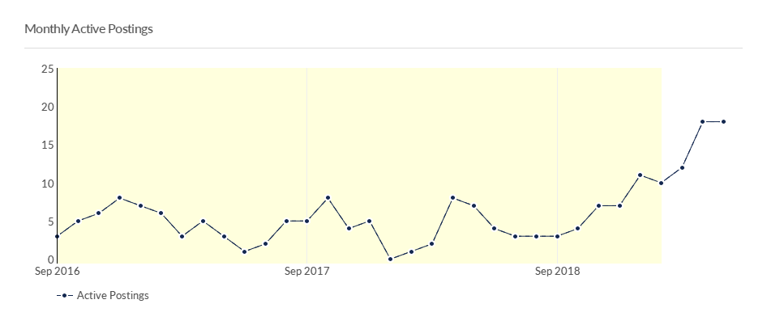
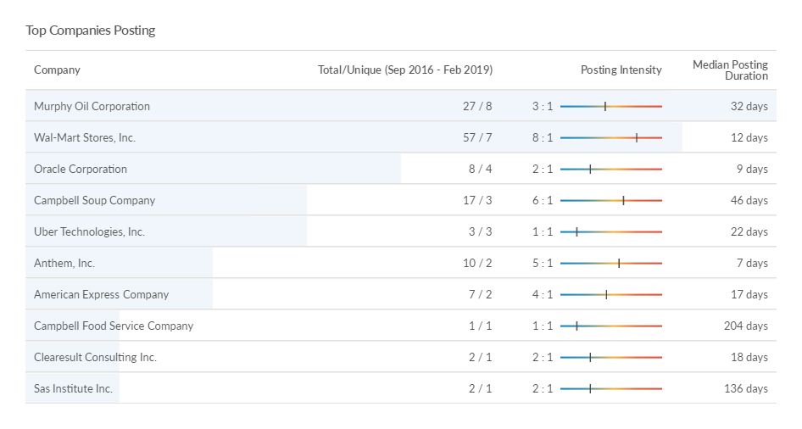

Keyword Search: “Operations Analytics”

National Data – Appearance in Job Postings
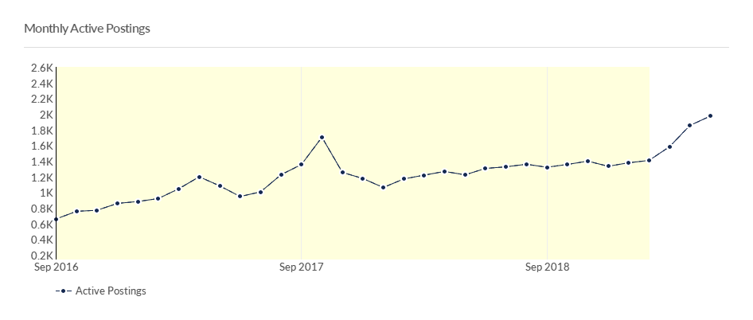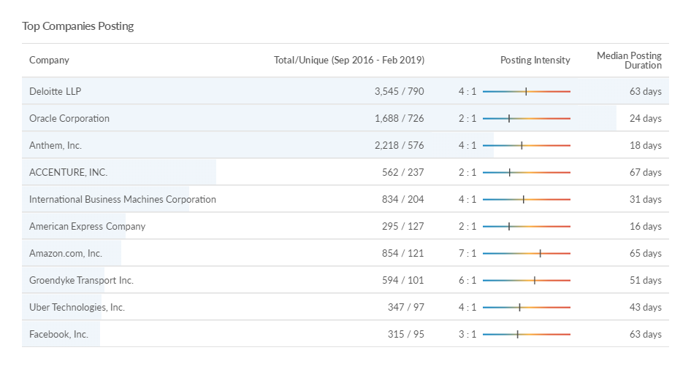
Letters of support should address the following when relevant: the number of current/anticipated job vacancies, whether the degree is desired or required for advancement, the increase in wages projected based on additional education, etc.

NA

Indicate if employer tuition assistance is provided or if there are other enrollment incentives.

Not currently. Some firms have employer tuition assistance programs, on a case-by-case basis.

Describe what need the proposed program will address and how the institution became aware of this need.

The job market for operations research professionals has increased over the years due to the explosion of data that can be found within enterprise organizations. Companies require students that possess the blend of operations knowledge as well as analytics knowledge to be able adequately leverage the vast quantities of data that they need to process. The proposed program will provide students that have a rigorous mathematical/statistical background, as well as functional knowledge of operations.

Indicate which employers contacted the institution about offering the proposed program.

Wal-Mart, JB Hunt, ABF

Indicate the composition of the program advisory committee, including the number of members, professional background of members, topics to be considered by the members, meeting schedule (annually, bi-annually, quarterly), institutional representative, etc.

We will leverage the existing INEG advisory board used for undergraduate and graduate program reviews.

Indicate the projected number of program enrollments for Years 1 - 3.

10 students

Indicate the projected number of program graduates in 3-5 years.

We expect enrollment to grow to 20-25 students per year in 5 years.

7. CURRICULUM

Provide curriculum outline by semester (include course number and title).

(For bachelor’s degree program, submit the 8-semester degree plan.)

In addition to the requirements of the Graduate School and the College of Engineering, the following program requirements must be satisfied by candidates for the M.S. Operations Analytics degree.

- Candidates for the degree are required to complete 30 semester hours of course work.
- All candidates must successfully complete a master’s oral examination that is conducted by the candidate’s faculty committee.

Students must complete 12 hours consisting of the following required courses.

Required Courses (12 hours)

Course Description | Credit Hours
OPAN 5003 Introduction to Operations Analytics*  An introduction to operations analytics providing an understanding of the role of analytics within operational settings. Builds basic skill instruction in descriptive analytics and the communication of analytics. An overview of introductory techniques within the field of analytics and their application. | 3
OPAN 5013 Applied Predictive Analytics*  Methods, algorithms, and techniques for univariate and multi-variate predictive models used in analytics applications. Coverage includes linear and non-linear regression, machine learning, discriminant analysis, and classification. Use of predictive analytics software and its application. | 3
OPAN 5023 Applied Prescriptive Analytics*  Methods, algorithms, and techniques for optimization models used in analytics applications. Coverage includes model formulation, solution methods and the use of optimization software. | 3
OPAN 5903 Analytics Capstone*  Comprehensive analytics project. Conduct background research, data collection, and preliminary analysis; define objectives, performance measures, and deliverables; apply analytics methods, develop recommended solutions, and document solution and benefits. Course should be taken in the term prior to meeting degree requirements. Students cannot receive credit for both OPAN 5903 and OPAN 5913  OR  OPAN 5913 Analytics Industrial Practicum*  Student must apply to enroll in this course. Students must be employed within an analytics organization in industry. Prior approval to use an organization’s analytics project as the basis of the student’s course project must be obtained. A project report documenting the application of analytics performed by the student within the organization is required. An evaluation by the student’s supervisor on the technical aspects of the student’s work will be required in addition to an evaluation by the course instructor. The student’s supervisor must be an analytics professional. Instructor Permission Only. Course should be taken in the term prior to meeting degree requirements. Students cannot receive credit for both OPAN 5903 and OPAN 5913 | 3
 | 12

Electives (18 hours total)

Students must select course electives from both of the following course topic areas for a total of 18 credit hours.

Operations Analytics (choose 4 or 5 courses)

- INEG 5313. Engineering Applications of Probability Theory*. 3 Hours.
- INEG 5323. Engineering Applications of Stochastic Processes*. 3 Hours.
- INEG 5683. Nonlinear Programming*. 3 Hours.
- INEG 5693. Heuristic Optimization*. 3 Hours.
- INEG 5443./OMGT 5443. Decision Models*. 3 Hours.
- INEG 5833. Introduction to Database Concepts for Industrial Engineers*. 3 Hours.
- INEG 5163. Introduction to Modern Statistical Techniques for Industrial Applications*. 3 Hours.
- OPAN 5713. Simulation Analytics*

Engineering and Operations Management (choose 1 or 2 courses)

- EMGT 5033 Introduction to Engineering Management*. 3 Hours
- EMGT 5053 Tradeoff Analytics for Engineering Management*. 3 Hours
- EMGT 5603 Systems Thinking and Systems Engineering*
- OMGT 5373 Quality Management*
- OMGT 5013 Supply Chain Management for Operations Managers*. 3 Hours.
- OMGT 5783 Project Management for Operations Managers*
- OMGT 5983 Advanced Project Management*
- INEG 5423 Advanced Engineering Economy*. 3 Hours.
- INEG 5623 Analysis of Inventory Systems*. 3 Hours.
- INEG 5333 Design of Industrial Experiments*. 3 Hours.
- INEG 5263 Engineering Statistics*. 3 Hours.
- INEG 5803 Simulation*. 3 Hours.

Give total number of semester credit hours required for the program, including prerequisite courses.

30 credit hours

Identify new courses (in italics) and provide course descriptions.

OPAN 5003 Introduction to Operations Analytics*
An introduction to operations analytics providing an understanding of the role of analytics within operational settings. Builds basic skill instruction in descriptive analytics and the communication of analytics. An overview of introductory techniques within the field of analytics and their application.

OPAN 5013 Applied Predictive Analytics*
Methods, algorithms, and techniques for univariate and multi-variate predictive models used in analytics applications. Coverage includes linear and non-linear regression, machine learning, discriminant analysis, and classification. Use of predictive analytics software and its application.

OPAN 5023 Applied Prescriptive Analytics*
Methods, algorithms, and techniques for optimization models used in analytics applications. Coverage includes model formulation, solution methods and the use of optimization software.

OPAN 5903 Analytics Capstone*
Comprehensive analytics project. Conduct background research, data collection, and preliminary analysis; define objectives, performance measures, and deliverables; apply analytics methods, develop recommended solutions, and document solution and benefits. Course should be taken in the term prior to meeting degree requirements. Students cannot receive credit for both OPAN 5903 and OPAN 5913

OPAN 5913 Analytics Industrial Practicum*
Student must apply to enroll in this course. Students must be employed within an analytics organization in industry. Prior approval to use an organization’s analytics project as the basis of the student’s course project must be obtained. A project report documenting the application of analytics performed by the student within the organization is required. An evaluation by the student’s supervisor on the technical aspects of the student’s work will be required in addition to an evaluation by the course instructor. The student’s supervisor must be an analytics professional. Instructor Permission Only. Course should be taken in the term prior to meeting degree requirements. Students cannot receive credit for both OPAN 5903 and OPAN 5913

Identify required general education courses, core courses and major courses.

NA

For each program major/specialty area course, list the faculty member assigned to teach the course.

The courses will be staffed by adjunct faculty members or INEG faculty (if requested).

OPAN 5013 Applied Predictive Analytics*, Adjunct Faculty with PhD in OR or IE, or INEG faculty member
OPAN 5023 Applied Prescriptive Analytics*, Adjunct Faculty with PhD in OR or IE, or INEG faculty member
OPAN 5903 Analytics Capstone*, Adjunct Faculty with PhD in OR or IE, or INEG faculty member
OPAN 5913 Analytics Industrial Practicum*, Adjunct Faculty with PhD in OR or IE, or INEG faculty member

Identify courses currently offered by distance technology (with an asterisk*) and endnote at the end of the document.

All courses are proposed to be offered by distance technology.

Indicate the number of contact hours for internship/clinical courses.

NA

State the program admission requirements.

Prerequisites to the M.S. Operations Analytics. Degree Program:

- There are no prerequisites for students with an undergraduate degree from an ABET-accredited industrial engineering program.
- For students with a degree other than an ABET-accredited industrial engineering degree, a number of prerequisite courses may be required. Students are expected to have completed mathematics courses through differential and integral calculus of several variables and vector calculus and linear algebra. Students are expected to have completed a calculus-based probability and statistics course. In addition, students are expected to have completed a computer programming course. Specific University of Arkansas courses that meet these pre-requisites are available on-line through the INEG departmental web-pages.

Accelerated Master of Science in Operations Analytics

High-achieving current undergraduate students seeking a BS degree at the University of Arkansas who choose to pursue graduate studies in Operations Analytics may participate in the accelerated M.S.O.A. program. Provided that 6 credit hours of 5000 OPAN course work can be taken as electives in the student’s current undergraduate program, students may also count those 6 hours towards their M.S.O.A. degree. In addition, students take another 6 credit hours of graduate degree credit as undergraduate students in order to apply them to their M.S.O.A. degree. These additional 6 hours of courses may not have been used towards the BS undergraduate degree and must meet M.S.O.A. degree requirements. The total of 12 credit hours of graduate courses taken as an undergraduate student must be taken during the final 12 month period of their undergraduate degree.

Once fully admitted to the M.S.O.A. program, students request that up to twelve hours of 5000 level or above courses taken in the final 12 month period of their undergraduate degree count toward their graduate degree, if these courses were taken on the University of Arkansas, Fayetteville campus. Students then take an additional 18 credit hours of approved OPAN graduate level courses in order to meet the M.S.O.A. degree requirements.

Undergraduate students interested in the accelerated M.S.O.A. degree should apply to the program prior to starting the 2nd to last semester of their undergraduate program. To be eligible students must have a 3.5 cumulative GPA or higher and submit the normal application materials required by the graduate school for the M.S.O.A. degree program. For students that have a cumulative GPA of 3.5 or higher, the submission of GRE scores is waived.

Describe specified learning outcomes and course examination procedures.

Program Outcomes

The outcomes of the program are those skills and abilities that students are expected to be able to demonstrate after completing the degree requirements. The M. S. Operations Analytics. program outcomes include:

- An ability to use information systems, statistics, and computing principles and apply state-of-the-art technologies for data representation, data retrieval, data manipulation, computational analytics, data analysis, visualization as they apply analytics within enterprise operations.
- An ability to develop descriptive, predictive, and prescriptive mathematical and statistical models and to apply those models through computational methods to problems of controlling and improving enterprise operations.
- An ability to use foundational knowledge and apply critical thinking skills to problem identification, problem solving, and decision making, within the context of controlling and improving enterprise operations.
- An ability to adapt analytics concepts to interpret and communicate findings and implications to senior decision makers.

Include a copy of the course evaluation to be completed by the student.

Standard UA course evaluations will be used. See Appendix A.

Include information received from potential employers about course content.

NA

Provide institutional curriculum committee review/approval date for proposed program.

January 15, 2020
8. FACULTY
List the names and credentials of all faculty teaching courses for the proposed program. Include college/university awarding degree; degree level; degree field; subject area of courses faculty currently teaching and/or will teach. (For associate degrees and above: A minimum of one full-time faculty member with appropriate academic credentials is required.)

Indicate lead faculty member or program coordinator for the proposed program.

Ed Pohl, Department Head, Industrial Engineering

Total number of faculty required for program implementation, including the number of existing faculty and number of new faculty. For new faculty, provide the expected credentials/experience and expected hire date.

All tenure track and adjunct faculty with faculty status in the college of engineering. No new or additional tenure track faculty are needed for the program. Curriculum vitas are on file for all faculty.

Adjunct faculty with a PhD in Industrial Engineering, Operations Research, Analytics, or related fields will be used. Current INEG faculty interested in teaching within the program will be used.

List of Current INEG faculty who have expressed an interest in teaching within the program:

Cassady, Richard, Ph.D., M.S.I.S.E., B.S.I.S.E. (Virginia Polytechnic Institute and State University), Professor, 2000.
Liu, Xiao, Ph.D. (National University of Singapore), B.S.M.E. (Harbin Institute of Technology, China), Assistant Professor, 2017.
Milburn, Ashlea R., Ph.D. (Georgia Institute of Technology), M.S.I.E. (Virginia Polytechnic Institute and State University), B.S.I.E. (University of Arkansas), Associate Professor, 2010.
Nurre, Sarah, Ph.D., M.Eng., B.S. (Rensselaer Polytechnic Institute), Assistant Professor, 2015.
Parnell, Gregory S., Ph.D. (Stanford University), M.S. (University of Southern California), M.E.I.S.E. (University of Florida), B.S. (University of New York at Buffalo), Research Professor, 2013.
Pohl, Edward A., Ph.D., M.S.R.E. (University of Arizona), M.S.S.E. (Air Force Institute of Technology), M.S.E.M. (University of Dayton), B.S.E.E. (Boston University), Professor, 2004.
Rossetti, Manuel D., Ph.D., P.E., M.S.I.S. (The Ohio State University), B.S.I.E. (University of Cincinnati), Professor, 1999.
Sullivan, Kelly M., Ph.D. (University of Florida), M.S.I.E., B.S.I.E. (University of Arkansas), Associate Professor, 2012.
Zhang, Shengfan, Ph.D., M.I.E. (North Carolina State University), B.M. (Fudan University, Shanghai), Associate Professor, 2011.

For proposed graduate programs: Provide the curriculum vita for faculty teaching in the program, and the expected credentials for new faculty and expected hire date. Also, provide the projected startup costs for faculty research laboratories, and the projected number of and costs for graduate teaching and research assistants.

Adjunct faculty with a PhD in Industrial Engineering, Operations Research, Analytics, or related fields will be hired by Summer 2020 and throughout life of the program based on demand and availability. Curriculum vita for related INEG faculty have been attached as an addendum.

There are no faculty startup costs associated with faculty or other administrative requirements.

9. DESCRIPTION OF RESOURCES
Current library resources in the field
Current instructional facilities including classrooms, instructional equipment and technology, laboratories (if applicable)
New instructional resources required, including costs and acquisition plan

All current library resources, facilities, classrooms, equipment and technology may be used for the program. There are no additional requirements.

10. NEW PROGRAM COSTS – Expenditures for the first 3 years
New administrative costs (number and position titles of new administrators)
Number of new faculty (full-time and part-time) and costs
New library resources and costs
New/renovated facilities and costs
New instructional equipment and costs
Distance delivery costs (if applicable)
Other new costs (graduate assistants, secretarial support, supplies, faculty development, faculty/students research, program accreditation, etc.)

Existing resources on campus will be used. Existing faculty in INEG or adjunct faculty will teach the courses.

All administrative cost will be absorbed into the current structure of Industrial Engineering and Operations Management. No new tenure track faculty or other costs, including distance delivery are needed.

For new courses, the department will pay from existing resources for course development costs for on-line delivery. Generally, the costs for developing a new course ranges from $2500-$3000.
As a result, based on current faculty resources the department’s capabilities are aligned with the ability to offer the new courses.

Marketing and recruiting costs for the program will be supported by the Department.

If no new costs required for program implementation, provide explanation.

11. SOURCE OF PROGRAM FUNDING – Income for the first 3 years of program operation

If there will be a reallocation of funds, indicate from which department, program, etc.

The program will be initially funded using INEG departmental operational funds and, eventually, program revenues as they are generated. Start-up marketing and recruiting costs will initially be supported by INEG. Administrative responsibilities will be handled by the INEG Graduate Coordinator.

As noted above, for the four new courses, the department has plans to hire adjunct faculty to assist with the development of the courses or permit INEG faculty (interested in developing the courses) to develop the courses.

Provide the projected annual student enrollment, the amount of student tuition per credit
hour, and the total cost of the program that includes tuition and fees.

Expected total annual student enrollment 25 students.

Tuition and Fees based on current rates for MS INEG – 30 hours

Assuming a $430.69/credit hour for tuition and $50/credit hours for a technology fee. These are the same tuition and fee rates as per the graduate school.

Total student cost of program: 30*$480.69= $14,420.70

All program costs will be supported from tuition and fees.

Faculty teaching within the program will be compensated via the following model:

- $450 per student for the first 10 students and $50 per student thereafter.

Thus, a single course offering of 3 credit hours with 1 student will break even if the tuition cost is as low as $450/3 = $150 per credit hour.

Indicate the projected annual state general revenues for the proposed program (Provide the amount of state general revenue per student).

 | Year 1 | Year 2 | Year 3
# Courses offered/Year | 10 | 20 | 20
#Students/Year | 10 | 30 | 50
#Courses/Year/Student | 5 | 5 | 5
# Students/course | 2 | 6 | 10
Instructional Cost/course | $900.00 | $2,700.00 | $4,500.00
Instructional Cost/Year | $9,000.00 | $54,000.00 | $90,000.00
Enrollment hours/Year | 150 | 450 | 750
Tuition & Fee/Year | $72,103.50 | $216,310.50 | $360,517.50
Revenue/Year | $63,103.50 | $162,310.50 | $270,517.50
Global Campus | $12,620.70 | $32,462.10 | $54,103.50
College | $31,551.75 | $81,155.25 | $135,258.75
General Revenue | $18,931.05 | $48,693.15 | $81,155.25
Annual General Revenue per student | $1,893.11 | $1,623.11 | $1,623.11

Number of courses offered per year is based on offering required courses per term (five, 8-week terms per year) and electives per term in order for the student to complete the degree taking 1 course per term for 10 terms. Number of students enrolled per course is based on typical enrollments in EMGT courses. Revenue split is 20% Global Campus, 30% General Revenue, 50% College/Department.

Using Year 2 as steady state, annual general revenue per student = $1,052.46 per student.

Other (grants [list grant source & amount of grant], employers, special tuition rates,
mandatory technology fees, program specific fees, etc.).

12. ORGANIZATIONAL CHART REFLECTING NEW PROGRAM
Proposed program will be housed in (department/college)

13. SPECIALIZED REQUIREMENTS
If specialized accreditation is required for program, list the name of accrediting agency.

Indicate the licensure/certification requirements for student entry into the field.

Provide documentation of Agency/Board review/approvals (education, nursing—initial
approval required, health-professions, counseling, etc.)

NA

14. BOARD OF TRUSTEES APPROVAL
Provide the date that the Board approved (or will consider) the proposed program.

March 19, 2020

Provide a copy of the Board meeting agenda that lists the proposed program, and written documentation of program/unit approval by the Board of Trustees prior to the Coordinating Board meeting that the proposal will be considered.

15. SIMILAR PROGRAMS

List institutions offering program:

Proposed undergraduate program – list institutions in Arkansas
Proposed master’s program – list institutions in Arkansas and region
Proposed doctoral program – list institutions in Arkansas, region, and nation
State why proposed program needed if offered at other institutions in Arkansas or region.

There are no Operations Analytics programs within Arkansas. Analytics has become an important knowledge area for companies that need to leverage information technology for improving operations.

List institution(s) offering a similar program that the institution used as a model to
develop the proposed program.

- University of Missouri, M.S. in Data & Analytics
- Texas A&M, M.S. Analytics
- Georgia Tech, M.S. Operations Research
- Worcester Polytechnic Institute, MS Operations Analytics and Management
- North Carolina State University, MS Analytics

Provide a copy of the e-mail notification to other institutions in the state notifying them of the proposed program. Please inform institutions not to send the response to “Reply All”. If you receive an objection/concern(s) from an institution, reply to the institution and copy ADHE on the email. That institution should respond and copy ADHE. If the objection/concern(s) cannot be resolved, ADHE may intervene.

Note: A written institutional objection/concern(s) to the proposed program/unit may delay Arkansas Higher Education Coordinating Board (AHECB) consideration of the proposal until the next quarterly AHECB meeting.

16. DESEGREGATION
State the total number of students, number of black students, and number of other minority students enrolled in related degree programs, if applicable.

NA

- INSTITUTIONAL AGREEMENTS/MEMORANDUM OF UNDERSTANDING (MOU)
If the courses or academic support services will be provided by other institutions or organizations, include a copy of the signed MOU that outlines the responsibilities of each party and the effective dates of the agreement.

NA

- ACADEMIC PROGRAM REVIEW
Provide scheduled program review date (within 10 years of program implementation date).

2028-2029

- PROVIDE ADDITIONAL INFORMATION IF REQUESTED BY ADHE STAFF

- INSTRUCTION BY DISTANCE TECHNOLOGY
If the proposed program will be offered by distance technology, provide the following information:
Summarize institutional policies on the establishment, organization, funding and management of distance courses/degrees.

An academic department intending to propose new distance programs are required to identify the program’s anticipated costs, funding sources, demand, and need for library resources, and to present plans to address the increased workload. The proposal needs to be approved by Vice Provost for Distance Education, Academic College, University Course and Programs Committee, Graduate Council (if at the graduate level), Faculty Senate, Provost, Board of Trustees, and Arkansas Department of Higher Education. Change requests for existing distance courses and programs follow similar approval processes. Global Campus assists programs during the conceptualization, market research, and planning stage. Once programs are approved, it provides start-up capital and course development funds as well as in-kind support by Global Campus’s instructional designers, academic technologists, and marketing and recruitment teams. Global Campus also supports compliance with interstate regulatory requirements. All distance courses are certified to be complete only when they meet appropriate quality standards.

Describe the internal organizational structure that coordinates (development, technical support, oversight) distances courses/degrees.

Global Campus is a supporting unit that provides assistance in course development and maintenance, technical support for both faculty and students, quality assurance, and compliance to all online programs across the campus.

Summarize the policies and procedures to keep the technology infrastructure current.

IT Services maintains the technology infrastructure to ensure the security and compatibility of enterprise systems as guided by the Computer and Network Security Policy, Data Management Use and Protection Policy, and Acquisition of Enterprise Systems Policy. The Computer Activities Council (CAC), the information technology governance structure at the University, facilitates participation of students, faculty, staff, and administrators in long-range planning and setting of priorities for IT Services.

Updates to applications (learning management system, video conferencing software, web conferencing software, etc.) are reviewed by application administrators and stakeholder representatives on a regular basis to ensure continuity of operation, security, and high levels of performance and support.

The Global Campus Instructional Design and Support Services team, along with the IT Services Director of Academic Technology and Innovation, work with faculty to identify, evaluate, pilot, and deploy emerging technology solutions that will enhance teaching and learning.

Summarize the procedures that assure the security of personal information.

Procedures are in accordance with the Computer and Network Security Policy, Code of Computing Practices, and Privacy Policy. The IT Security group monitors university systems and performs security audits of resources. IT Services also provides security services such as security information, anti-virus software, and security alerts.

University systems (student information system, learning management system, etc.) require authentication. Privileged supervisory accounts are limited and managed by system administrators.
Users must agree to the Code of Computing Practices and take a security quiz when setting up their UARK accounts. Users agree to comply with security mechanisms and to keep login credentials private.

Links to the privacy policies of third-party tools used in online instruction are provided in the information section of online courses and support sites

Provide a list of services that will be outsourced to other organizations (course materials, course management and delivery, technical services, online payment, student privacy, etc.).

The only service outsourced is online proctoring service. The University of Arkansas partners with ProctorU for online test proctoring services for some online exams.

Appendix A: Course Evaluation Form

ENGR - 8W1- 1199 (Fall 2019) Survey 8W1 - 1199 (2019)
Course:
Department: | Department of Indust Engr
Faculty:

The University of Arkansas provides online instructor/course evaluations for all end of course evaluations. Please note the following as you complete this online course evaluation:
- Evaluations are located on a confidential evaluation site.
- Your instructor will not see the evaluations until after final grades have been submitted. Your instructor's department chair and college dean will receive the composite results.
- There is one open-ended question. If you provide a response, it is anonymous and the instructor and his/her department chair and/or college dean, will be able to view your comments.
- Your evaluations will be confidential. Your responses to scaled questions will be simply part of the composite data reported to your Instructor. Also the instructor will not be able to attribute any comments you make in the open-ended questions to you unless you write something that identifies you either directly or indirectly.

If you have questions or comments about this survey, click here to send a message to the survey administrator.

Demographics

UofA Student Demographics

Your class
Freshman Sophomore Junior Senior Graduate Other

Expected grade
A/PASS B C D F/FAIL

Your College:
College of Education and Health Professions
College of Engineering
Dale Bumpers College of Agricultural, Food and Life Sciences
Fay Jones School of Architecture and Design
J. William Fulbright College of Arts and Sciences
Sam M. Walton College of Business
School of Law
Graduate School
UNDECLARED

Course required
Yes No

ENGR College Core: Instructor Questions

Instructor Based Questions

My instructor gives appropriate/timely feedback on each student's performance.
Strongly Agree Agree Undecided Disagree Strongly Disagree

My instructor is readily available for consultation.
Strongly Agree Agree Undecided Disagree Strongly Disagree

My instructor is fair and impartial when dealing with students.
Strongly Agree Agree Undecided Disagree Strongly Disagree

My instructor seems well-prepared for class.
Strongly Agree Agree Undecided Disagree Strongly Disagree

My instructor is effective in teaching the subject matter of this course.
Strongly Agree Agree Undecided Disagree Strongly Disagree

ENGR INEG: Course Based Questions

Course Based Questions

The content of this course is consistent with the objectives of the course.
Strongly Agree Agree Undecided Disagree Strongly Disagree

Course activities/assignments help me learn the material.
Strongly Agree Agree Undecided Disagree Strongly Disagree

Successful performance in this course requires that I understand the material.
Strongly Agree Agree Undecided Disagree Strongly Disagree

I developed a greater appreciation for this subject.
Strongly Agree Agree Undecided Disagree Strongly Disagree

This course improves my understanding of concepts and principles in this field.
Strongly Agree Agree Undecided Disagree Strongly Disagree

University Core Course

Course Based Questions

Overall, I would rate this course as:
Excellent Good Fair Poor Very Poor

University Core Instructor

Instructor Based Questions

Overall, I would rate this instructor as:
Excellent Good Fair Poor Very Poor
My Instructor is fluent in English
Strongly Agree Agree Undecided Disagree Strongly Disagree

Faculty Comment Questions
Please use the box below to provide additional comments regarding your instructor or this course. All comments are seen by the instructor and are viewable by department heads, chairs or deans.

Comments:

Comments:
If you have questions or comments about this survey, click here to send a message to the survey administrator.

Thank you for your time and participation in the University of Arkansas online instructor and course evaluations.

Appendix B Faculty Vita

See attached addendum.

Appendix C: Workforce Analysis

See attached addendum.

