PROPOSAL – 1

NEW DEGREE PROGRAM

- PROPOSED PROGRAM TITLE: Master of Professional Accounting

2. CIP CODE REQUESTED
Link for CIP Codes: http://nces.ed.gov/ipeds/cipcode/resources.aspx?y=55.

52.0301 - Accounting

3. PROPOSED STARTING DATE
Fall 2020

4. CONTACT PERSON
Name (Provost/Academic Affairs Officer): Dr. Terry Martin
Title: Vice Provost for Academic Affairs
Name of Institution: University of Arkansas
E-mail Address: tmartin@uark.edu
Phone Number: 479-575-2151

Name (Program Contact Person): Dr. Gary Peters
Title: Professor and Department Chair, Accounting
E-mail Address: peters@uark.edu
Phone Number: 479-575-4117

5. PROGRAM SUMMARY
Provide a general description of the proposed program. Include overview of any curriculum additions or modifications; program costs; faculty resources, library resources, facilities and equipment; purpose of the program; and any information that will serve as introduction to the program.

The Master of Professional Accounting (MPACC) provides rigorous preparation at the graduate level for students to achieve success in their chosen professional accounting career path in public practice, industry, or government. The MPACC core includes coursework related to accounting professionalism, analytic skillsets, and advanced financial accounting. Students may concentrate in one of three areas: Analytics & Assurance, Taxation, or Corporate Accounting. All concentrations provide the opportunity for professional internship credit and lead to qualification for the Certified Public Accounting exam.

List degree programs or emphasis areas currently offered at the institution that support the proposed program.

- Enterprise Systems Graduate Certificate (Business Analytics Concentration)
- Master of Information Systems (INSYMI)
- Master of Accountancy (MACC)

6. NEED FOR THE PROGRAM
(Submit Employer Needs Survey Forms)
Provide survey data. Submit numbers that show job availability, corporate demands and employment/wage projections, not student interest and anticipated enrollment. Focus mostly on state needs and less on regional and national needs, unless applicable to the program.

Survey data can be obtained by telephone, letters of interest, student inquiry, etc. Focus mostly on state needs for undergraduate programs; for graduate programs, focus on state, regional and national needs.

Provide names and types of organizations/businesses surveyed.

Workforce Analysis Form Attached – Appendix A

Letters of support should address the following when relevant: the number of current/anticipated job vacancies, whether the degree is desired or required for advancement, the increase in wages projected based on additional education, etc.

See Addendum for Letters of Support from the following Employers:

- Ernst & Young LLP
- KPMG LLP
- JB Hunt
- BKD LLP

Indicate if employer tuition assistance is provided or if there are other enrollment incentives.

Not currently. Some firms have employer tuition assistance programs, on a case-by-case basis. An example includes KPMG LLP.

Describe what need the proposed program will address and how the institution became aware of this need.

The MPACC is responsive to the shifting skillset and additional demands within the Accounting Profession. More Universities are adapting specialized content into their graduate accounting degrees. Whereas past accounting Master degrees tended to be general in nature, more specialized degree paths and skills are being sought by career entrants. Emerging technology is changing the core ways that the accounting profession is providing services. As a result, new skills that involve data & analytics are needed. Complementing these technical skills, the workplace has increased its emphasis on the development of soft skills, such as leadership and professionalism. The complexity of business environments that accounting professionals face has also increased the demand for richer content, including complex tax issues, technology environments, regulatory reporting requirements among others. The importance of Internships has also increased. We are also seeing a greater number of our students take initial accounting employment outside of traditional public accounting roles.

Our Accounting Advisory Board have communicated and confirmed the need for the analytical skills and training this program will provide. In addition, we have had meetings with executives from several firms, such as Walmart, KPMG, and Ernst & Young who have emphasized the need for employees with this training.

Indicate which employers contacted the institution about offering the proposed program.

Ongoing conversation with our major student employers have expressed interest, including Deloitte LLP, KPMG LLP, Ernst & Young, LLP, PWC LLP, Arvest, Tyson, Walmart and P66.

Indicate the composition of the program advisory committee, including the number of members, professional background of members, topics to be considered by the members, meeting schedule (annually, bi-annually, quarterly), institutional representative, etc.

Our programs receive guidance from the Accounting Executive Advisory Board. The Board is comprised of 25-30 members of alumni, employers, and industry advocates. Senior leadership and experience is emphasized in membership, including Chief Accounting Officers, Chief Audit Executives, Chief Financial Officers, Partners, Senior Managers, Directors. The Board meeting twice a year. Ongoing communication and recruiting also takes place over the course of the year. The Board provides feedback and suggestions on the curriculum content and career services.

Indicate the projected number of program enrollments for Years 1 - 3.

40 students

Indicate the projected number of program graduates in 3-5 years.

70 students

7. CURRICULUM

Provide curriculum outline by semester (include course number and title).

(For bachelor’s degree program, submit the 8-semester degree plan.)

The 30 Credit Hour MPACC includes the following Required Core Courses:
- ACCT 5123: Corporate Governance and Professionalism
- ACCT 5523 Advanced Accounting Information Systems
- ACCT 5413 Advanced Financial Accounting

Students select from 3 Specialized Concentrations: 1) Assurance & Analytics Concentration; 2) Taxation Concentration; 3) Corporate Accounting Concentration. Each Concentration also allows for students to incorporate 3 credit hours of Professional Accounting Internship although Internships are not required.

Assurance & Analytics Concentration

 | SUMMER
1 | ACCT 535V | Professional Accounting Internship - Elective | 3
 | FALL
2 | ACCT 5123 | Corporate Governance and Professionalism | 3
3 | ACCT 5953 | Advanced Audit | 3
4 | ACCT 5523 | Advanced Accounting Information Systems | 3
5 | Elective | Specialized Concentration Elective | 3
6 | Elective | Specialized Concentration Elective | 3
 | SPRING
7 | ACCT 5463 | Financial Statement Analysis | 3
8 | ACCT 5413 | Advanced Financial Accounting | 3
9 | ACCT 5463 | Fraud Detection & Prevention | 3
10 | Elective | Specialized Concentration Elective | 3
 |  |  | 30

Students Choose 3 from the following Specialized Electives for the Assurance & Analytics Concentration:

- ISYS 5503 Decision Support and Analytics
- ISYS 5833 Data Management Systems
- ISYS 5843 Seminar in Business Intelligence and Knowledge Management
- ISYS 5213 ERP Fundamentals
- ISYS 5223 ERP Configuration and Implementation
- ISYS 5233 Seminar in ERP Development
Professional Internship Credits are highly encouraged, but not required. If students do not participate in an internship experience, they can utilize 3 Credit Hours of general Graduate Business Electives.

Taxation Concentration

 | SUMMER
1 | ACCT 535V | Professional Accounting Internship - Elective | 3
 | FALL
2 | ACCT 5123 | Corporate Governance and Professionalism | 3
3 | ACCT 5873 | Advanced Taxation | 3
4 | ACCT 5883 | Tax Planning | 3
5 | ACCT 5893 | Multi-jurisdictional Taxation | 3
6 | ACCT 5523 | Advanced Accounting Information Systems | 3
 | SPRING
7 | ACCT 5413 | Advanced Financial Accounting | 3
8 | BLAW 5003 | Commercial Transactions | 3
9 | ACCT 5863 | Taxation of Flow-Through Entities | 3
10 | ACCT 5853 | State and Local Taxation | 3
 |  |  | 30

Professional Internship Credits are highly encouraged, but not required. If students do not participate in an internship experience, they can utilize 3 Credit Hours of general Graduate Business Electives.

Corporate Accounting Concentration

 | Summer
1 | ACCT 535V | Professional Accounting Internship - Elective | 3
 | FALL
2 | ACCT 5123 | Corporate Governance and Professionalism | 3
3 | ACCT 5873 | Advanced Taxation | 3
4 | ACCT 5523 | Advanced Accounting Information Systems | 3
5 | Elective | Specialized Concentration Elective | 3
6 | Elective | Specialized Concentration Elective | 3
Spring
7 | ACCT 5463 | Financial Statement Analysis | 3
8 | ACCT 5413 | Advanced Financial Accounting | 3
9 | ACCT 5433 | Fraud Prevention & Detection | 3
10 | Elective | Specialized Concentration Elective | 3
 |  |  | 30

Students Choose 3 from the following Specialized Electives for the Corporate Accounting Concentration:

- ACCT 5953 Advanced Audit
- ACCT 5443 Asset Management
- BLAW 5003 Commercial Transactions
- FINN 5223 Financial Markets & Valuation
- FINN 5303 Advanced Corporate Finance
- ISYS 5213 ERP Fundamentals
- SCMT 5633 Introduction to Supply Chain Management

Professional Internship Credits are highly encouraged, but not required. If students do not participate in an internship experience, they can utilize 3 Credit Hours of general Graduate Business Electives.

Give total number of semester credit hours required for the program, including prerequisite courses.

Total number of Semester Credit Hours: 30 hours.

Identify new courses (in italics) and provide course descriptions.

ACCT 5853: State and Local Taxation
This course provides an overview of the basic principles of state and local taxation and the federal constitutional limits for state and local taxing authorities. Emphasis will be on the impact on individuals and multistate entities of income tax, sales tax, property taxes and hybrid tax systems. Prerequisites: ACCT 4203 or graduate standing.

Identify required general education courses, core courses and major courses.

The 30 Hour Professional Curriculum includes three Specialized Concentrations: 1) Assurance & Analytics; 2) Taxation; 3) Corporate Accounting.

Each concentration shares the following same Required Core Courses:

- ACCT 5123: Corporate Governance and Professionalism
- ACCT 5523 Advanced Accounting Information Systems
- ACCT 5413 Advanced Financial Accounting

Each concentration also allows for students to incorporate 3 credit hours of Professional Accounting Internship although Internships are not required.

For each program major/specialty area course, list the faculty member assigned to teach the course.

ACCT 5123: Corporate Governance and Professionalism
Faculty Member: Dr. Gary Peters

ACCT 5523 Advanced Accounting Information Systems
Faculty Member: Katie Terrell

ACCT 5413 Advanced Financial Accounting
Faculty Member: Dr. Charles Leflar

ACCT 5463 Financial Statement Analysis
Faculty Member: Dr. Michael Crawley

ACCT 5953 Auditing Standards
Faculty Member: Dr. Thomas Hayes

ACCT 5433 Fraud Prevention & Detection
Faculty Member: Local Professional Practitioner

ACCT 5873 Advanced Taxation
Faculty Member: Dr. TJ Atwood

ACCT 5863 Taxation of Flow-Through Entities
Faculty Member: Robyn Jarnagin

ACCT 5883 Tax Planning
Faculty Member: Robyn Jarnagin

ACCT 5893 Multi-jurisdictional Taxation
Faculty Member: TJ Atwood

ACCT 5853 State and Local Taxation
Faculty Member: Jalynn Thomas

ACCT 5443 Asset Management
Faculty Member: Dr. Charles Leflar

ACCT 535V Professional Accounting Internship
Faculty Member: Dr. Gary Peters

BLAW 5003 Commercial Transactions*
Faculty Member: Kim Petrone

ISYS 5503 Decision Support and Analytics*
Faculty Member: Dr. Paul Cronan

ISYS 5833 Data Management Systems*
Faculty Member: Dr. Jeff Mullins

ISYS 5843 Seminar in Business Intelligence and Knowledge Management*
Faculty Member: Elizabeth Kieffer

ISYS 5213 ERP Fundamentals*
Faculty Member: Dr. Susan Bristow

ISYS 5223 ERP Configuration and Implementation*
Faculty Member: Dr. Susan Bristow

FINN 5223 Financial Markets & Valuation
Faculty Member: Dr. Scott Hsu

FINN 5303 Advanced Corporate Financial Management
Faculty Member: Dr. Tomas Jandik

SCMT 5633 Introduction to Supply Chain Management
Faculty Member: Dr. Chris Hofer

Identify courses currently offered by distance technology (with an asterisk*) and endnote at the end of the document.

Indicate the number of contact hours for internship/clinical courses.

3 Credit Hours of ACCT 535V - Professional Internship Credit is highly encouraged, but not required. In the event that students do not participate in an internship experience, they are allowed to utilize 3 Credit Hours of general Graduate Business Electives.

3-Credit Internship Courses include 6-8 weeks of full-time contact. Contact hours are expected to include a minimum of 240 hours.

State the program admission requirements.

The MPACC Program is open to students who have earned a bachelor’s degree from an accredited institution and who can present evidence of their ability to do graduate work. In addition, they are expected to have already mastered basic accounting concepts or, demonstrated, with an official GMAT test score, the ability to master accounting concepts taught in the program. International applicants must submit an acceptable TOEFL or IELTS score or complete the Intensive English Language Program (Spring International Language Center) and receive an English proficiency recommendation for admission. Other admissions criteria can be considered on a case by case basis. Students entering the program are expected to have completed undergraduate business and accounting coursework. Prior courses must either have been successfully completed within the five years prior to entry to the MPACC Program, or the student must provide other evidence of current knowledge in these areas. Otherwise, applicants may be required to repeat or complete selected courses, in addition to their degree coursework. Students from all academic backgrounds are encouraged to apply.

Describe specified learning outcomes and course examination procedures.

The Assurance & Analytics concentration provides students with a foundation for applying technology and analytical methodologies to data-centric accounting environments. Students will be able to navigate data environments, employ analytical tools, and apply them to business decisions and risk analysis.

The Tax concentration provides students a broad foundation for understanding the taxation of entities and the relationship of taxes to the overall business decision process. Students will be able to analyze tax problems, interpret the relevant tax code, and identify tax strategies for complex tax situations and business scenarios.

The Corporate Accounting concentration provides students a broad foundation for understanding the production and use of accounting information in corporate business environments. Students in this concentration will acquire skills to navigate public reporting environments, internal business operations, and financial decision making.

Courses will include ongoing examinations, including cumulative final exams. Exam structure will vary depending upon nature of course and hands-on learning tasks. Examinations will also complement pursuits of professional certifications.

Include a copy of the course evaluation to be completed by the student.

The Standard Purdue Course Evaluation form will be used – see Appendix B.

Include information received from potential employers about course content.

Potential employers expressed the need for specialized skills, especially in analytics, taxation, and advanced corporate accounting areas. These will be taught in the program.

Provide institutional curriculum committee review/approval date for proposed program.

December 11, 2019

8. FACULTY
List the names and credentials of all faculty teaching courses for the proposed program. Include college/university awarding degree; degree level; degree field; subject area of courses faculty currently teaching and/or will teach. (For associate degrees and above: A minimum of one full-time faculty member with appropriate academic credentials is required.)

Faculty Member | Degree, Subject | Institution
TJ Atwood | PhD Taxation | Illinois, Urbana-Champaign
Susan Bristow | EdD Human Resources | Arkansas - Fayetteville
Michael Crawley | PhD Accounting | Texas-Austin
Paul Cronan | DBA Information Systems | Louisiana Tech
Thomas Hayes | PhD Accounting | Arkansas-Fayetteville
Chris Hofer | PhD Supply Chain | Maryland
Scott Hsu | PhD Finance | North Carolina – Chapel Hill
Tomas Jandik | PhD Finance | Pittsburgh
Robyn Jarnagin | JD, LLM Taxation | New York University
Elizabeth Kieffer | PhD Education | Arkansas-Fayetteville
Charles Leflar | PhD Accounting | Missouri-Columbia
Jeff Mullins | PhD Information Systems | Arkansas-Fayetteville
Gary Peters | PhD Accounting | Oregon-Eugene
Kimberly Petrone | JD, Business Law | Northwestern-Chicago
Vernon Richardson | PhD Accounting | Illinois, Urbana-Champaign
Jonathan Shipman | PhD Accounting | Tennessee- Knoxville
Katie Terrell | MBA Information Systems | Arkansas-Fayetteville
Jalynn Thomas | BSBA, CPA, Accounting | Louisiana Tech
Tim Yaeger | PhD Finance | Washington University

Indicate lead faculty member or program coordinator for the proposed program.

Co-Director Jalynn Thomas, Assistant Dept Chair, Accounting Department

Co-Director Jonathan Shipman, Associate Professor, Accounting Department

Total number of faculty required for program implementation, including the number of existing faculty and number of new faculty. For new faculty, provide the expected credentials/experience and expected hire date.

19 Existing Faculty.

For proposed graduate programs: Provide the curriculum vita for faculty teaching in the program, and the expected credentials for new faculty and expected hire date. Also, provide the projected startup costs for faculty research laboratories, and the projected number of and costs for graduate teaching and research assistants.

CV’s Attached as Appendix C.

There will not be any additional lab or graduate assistantship costs.

9. DESCRIPTION OF RESOURCES
Current library resources in the field
Current instructional facilities including classrooms, instructional equipment and technology, laboratories (if applicable)
New instructional resources required, including costs and acquisition plan

Existing resources on campus will be used.

10. NEW PROGRAM COSTS – Expenditures for the first 3 years
New administrative costs (number and position titles of new administrators)
Number of new faculty (full-time and part-time) and costs
New library resources and costs
New/renovated facilities and costs
New instructional equipment and costs
Distance delivery costs (if applicable)
Other new costs (graduate assistants, secretarial support, supplies, faculty development, faculty/students research, program accreditation, etc.)

If no new costs required for program implementation, provide explanation.

Existing resources on campus will be used. Existing faculty in Accounting, Finance, Supply Chain Management, and Information Systems will teach the courses. Except for the new proposed courses, the other courses are already offered on a regular basis.

For the new Tax courses, the department has plans to re-organize faculty teaching to be able to fully staff these.

Marketing and recruiting costs for the program will be supported by the College.

11. SOURCE OF PROGRAM FUNDING – Income for the first 3 years of program operation.
If there will be a reallocation of funds, indicate from which department, program, etc.

The program will be initially funded using Walton College operational funds and, eventually, program revenues as they are generated. Start-up marketing and recruiting costs will initially be supported by the College.

Provide the projected annual student enrollment, the amount of student tuition per credit hour, and the total cost of the program that includes tuition and fees.

Indicate the projected annual state general revenues for the proposed program (Provide the amount of state general revenue per student).

Other (grants [list grant source & amount of grant], employers, special tuition rates, mandatory technology fees, program specific fees, etc.).
Expected student enrollment for the first 3 years is 40.

Tuition and Fees based on current rates for MPACC – 30 hours

In-State Tuition & Fees: $642.10/hour, Total=$19,263

Out-of-State Tuition & Fees: $1620.61/hour, Total=$48,618.30

International Tuition & Fees: $1694.48/hour, Total=$50,834.30

12. ORGANIZATIONAL CHART REFLECTING NEW PROGRAM
Proposed program will be housed in (department/college)

Proposed program will be housed in (department/college): Department of Accounting

13. SPECIALIZED REQUIREMENTS
If specialized accreditation is required for program, list the name of accrediting agency.

AACSB International

Indicate the licensure/certification requirements for student entry into the field.

The MPACC degree will address requirements for the Certified Public Accounting Examination. Specific requirements vary from State to State. However, the following is required in general:
- Baccalaureate Degree from an accredited institution
- 150 Hours of University Credit
- 30 Hours of Upper-level Accounting Coursework

Provide documentation of Agency/Board review/approvals (education, nursing--initial approval required, health-professions, counseling, etc.)

N/A

14. BOARD OF TRUSTEES APPROVAL
Provide the date that the Board approved (or will consider) the proposed program.
March 19, 2020

Provide a copy of the Board meeting agenda that lists the proposed program, and written documentation of program/unit approval by the Board of Trustees prior to the Coordinating Board meeting that the proposal will be considered.

15. SIMILAR PROGRAMS

List institutions offering program:

Arizona State University
University of Texas – Austin
Texas A&M University
University of Washington
University of Georgia
University of Mississippi
North Carolina State University

List institution(s) offering a similar program that the institution used as a model to develop the proposed program.

University of Texas – Austin
North Carolina State University
Texas A&M University
University of Georgia

Provide a copy of the e-mail notification to other institutions in the state notifying them of the proposed program. Please inform institutions not to send the response to “Reply All”. If you receive an objection/concern(s) from an institution, reply to the institution and copy ADHE on the email. That institution should respond and copy ADHE. If the objection/concern(s) cannot be resolved, ADHE may intervene.

Note: A written institutional objection/concern(s) to the proposed program/unit may delay Arkansas Higher Education Coordinating Board (AHECB) consideration of the proposal until the next quarterly AHECB meeting.

16. DESEGREGATION
State the total number of students, number of black students, and number of other minority students enrolled in related degree programs, if applicable.

N/A

- INSTITUTIONAL AGREEMENTS/MEMORANDUM OF UNDERSTANDING (MOU)
If the courses or academic support services will be provided by other institutions or organizations, include a copy of the signed MOU that outlines the responsibilities of each party and the effective dates of the agreement.

N/A

- ACADEMIC PROGRAM REVIEW
Provide scheduled program review date (within 10 years of program implementation date).

The Department of Accounting is separately accredited by the AACSB. Continuous Improvement Reviews for re-accreditation take place on 5 year cycles. Next scheduled review is scheduled for 2021-2022.

- PROVIDE ADDITIONAL INFORMATION IF REQUESTED BY ADHE STAFF

- INSTRUCTION BY DISTANCE TECHNOLOGY
If the proposed program will be offered by distance technology, provide the following information:

Summarize institutional policies on the establishment, organization, funding and management of distance courses/degrees.

Global Campus assists programs during the conceptualization, market research, and planning stage. Once programs are approved, it provides start-up capital and course development funds as well as in-kind support by Global Campus’s instructional designers, academic technologists, and marketing and recruitment teams. Global Campus also supports compliance with interstate regulatory requirements. All distance courses are certified to be complete only when they meet appropriate quality standards.

Describe the internal organizational structure that coordinates (development, technical support, oversight) distances courses/degrees.

Global Campus is a supporting unit that provides assistance in course development and maintenance, technical support for both faculty and students, quality assurance, and compliance to all online programs across the campus.

Summarize the policies and procedures to keep the technology infrastructure current.

IT Services maintains the technology infrastructure to ensure the security and compatibility of enterprise systems as guided by the Computer and Network Security Policy, Data Management Use and Protection Policy, and Acquisition of Enterprise Systems Policy. The Computer Activities Council (CAC), the information technology governance structure at the University, facilitates participation of students, faculty, staff, and administrators in long-range planning and setting of priorities for IT Services.

Updates to applications (learning management system, video conferencing software, web conferencing software, etc.) are reviewed by application administrators and stakeholder representatives on a regular basis to ensure continuity of operation, security, and high levels of performance and support.

The Global Campus Instructional Design and Support Services team, along with the IT Services Director of Academic Technology and Innovation, work with faculty to identify, evaluate, pilot, and deploy emerging technology solutions that will enhance teaching and learning.

Summarize the procedures that assure the security of personal information.
Provide a list of services that will be outsourced to other organizations (course materials, course management and delivery, technical services, online payment, student privacy, etc.).

Procedures are in accordance with the Computer and Network Security Policy, Code of Computing Practices, and Privacy Policy. The IT Security group monitors university systems and performs security audits of resources. IT Services also provides security services such as security information, anti-virus software, and security alerts.

University systems (student information system, learning management system, etc.) require authentication. Privileged supervisory accounts are limited and managed by system administrators. Users must agree to the Code of Computing Practices and take a security quiz when setting up their UARK accounts. Users agree to comply with security mechanisms and to keep login credentials private. Links to the privacy policies of third-party tools used in online instruction are provided in the information section of online courses and support sites.

Provide a list of services that will be outsourced to other organizations (course materials, course management and delivery, technical services, online payment, student privacy, etc.).

The only service outsourced is online proctoring service. The University of Arkansas partners with ProctorU for online test proctoring services for some online exams.

ADDENDUM

Letters of Support
Master of Professional Accounting Proposal
Department of Accounting, University of Arkansas, Fayetteville

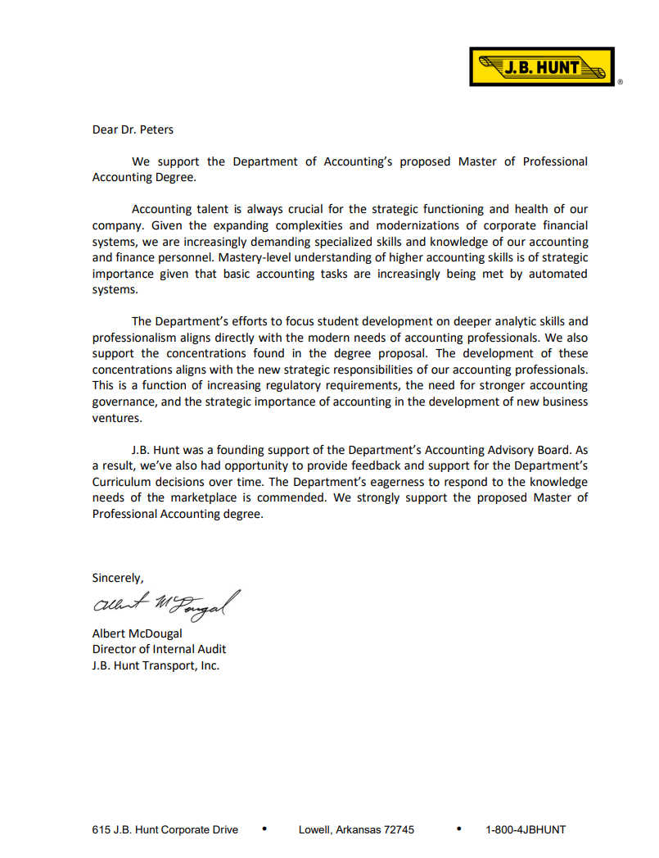
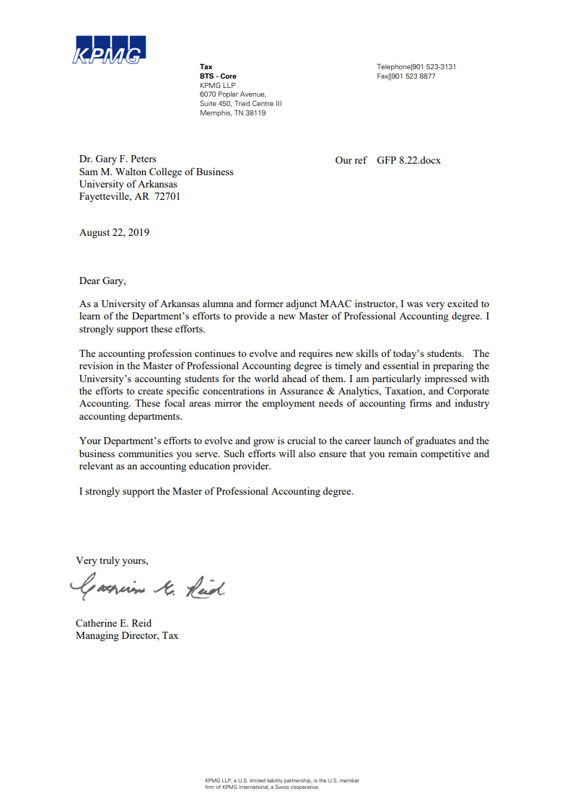
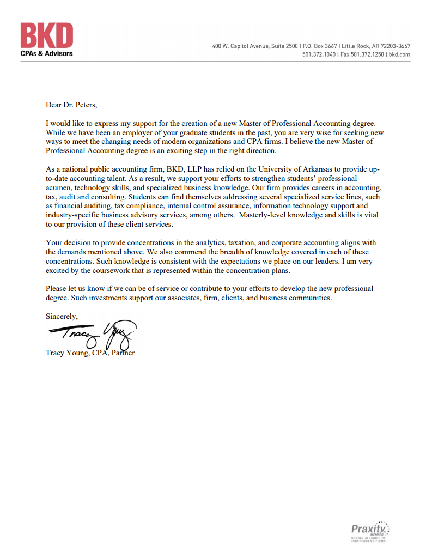

Faculty C.V.s

See Attached

