Modifications to “New”/”Modify” Program Forms and Functionality--Fall 2019
- New and Modify Forms
  - Lock the question “Are you adding a concentration?” on both the New and Modify forms so that this field is view only going forward. Campus users will now use the “New” form to add a concentration, while modifications or deletions of an existing concentration will continue to be submitted via the “Modify” form for the specific concentration CIM program block (e.g. AREDBFA-CMPR).
  - Adjust functionality behind the “Is this program interdisciplinary?” question so that it triggers the appropriate approval from the colleges indicated on the form. This update matches the current functionality when users answer yes to the “Does this proposal impact any courses from another College/School?” question.

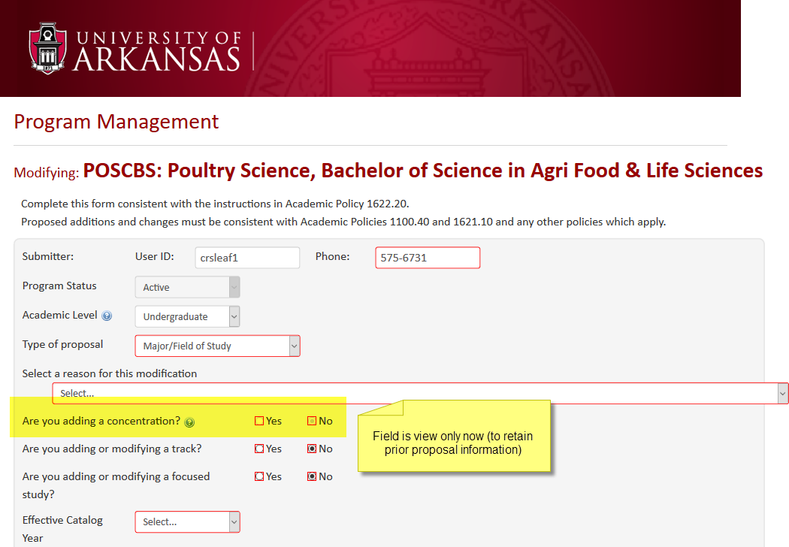

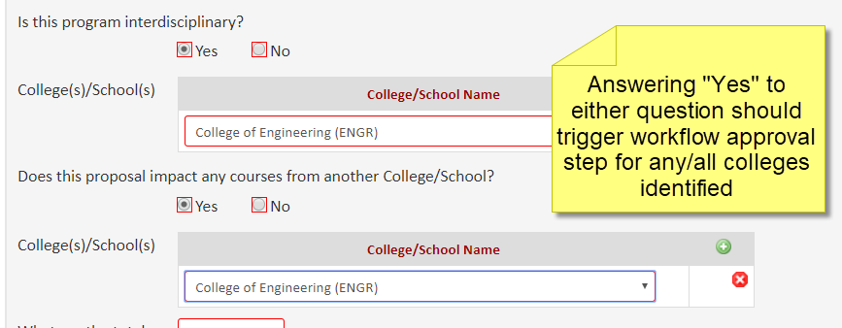

Modifications to “Inactivate Program” Form/Functionality—Fall 2019
- Inactivate Program Form
  - Add “Type of proposal” field/dropdown
  - Add the ability to upload/attach documentation for program inactivations. Campus users will begin submitting program inactivations using this form, rather than doing so via the “Modify” form.
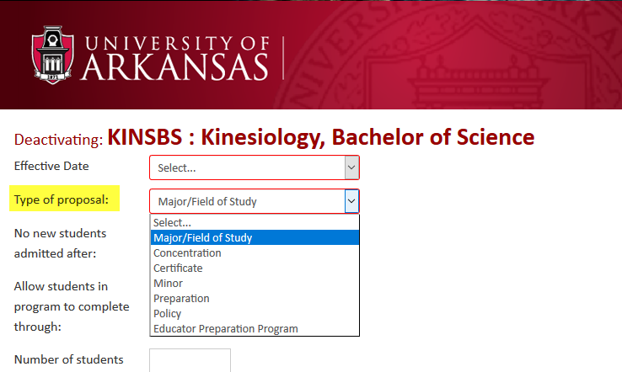

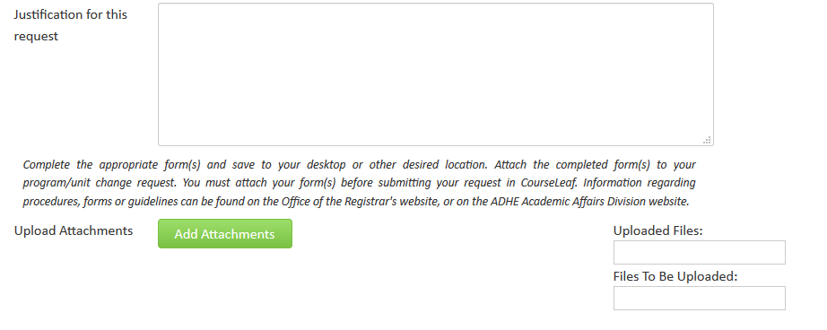

There are a few important things to note about migrating these changes to our production environment. For proposals already in workflow, new fields will be there but blank. If any new blank fields are set as required, one of a few options will happen:
- If the proposal is in workflow, and no one edits it, it will complete workflow like normal with a blank value.
- If the proposal is edited in workflow, the new required field must be completed before it can be saved and approved.
- If the proposal is not in workflow, the field will need to be completed like usual before submission to workflow.
Additionally, approval steps will not adjust automatically, based on responses to new questions, if a proposal has already been submitted to workflow.

