APPENDIX I

Employer Needs Survey

The need for the BRKD program at the University of Arkansas is demonstrated with institutional surveys, internal data, and requests made by individuals. These data are summarized here, and complete results of the Employer Needs Survey are provided in Appendix A.

Respondents to the Employer Needs Survey, conducted October-December 2014 via Survey Monkey, reported interest and support for a degree program dedicated to preparing teachers to work with children aged birth through kindergarten. Several themes emerged from the data that are reflective of and have shaped the BRKD program. Respondents reflected on the current workforce teaching young children, saying, “Currently, there are many licensed teachers who have no clue when it comes to early childhood issues.” Others noted the need for specialized training for birth through kindergarten, stating that BRKD candidates “will be better prepared teachers to meet the needs of our students.” Respondents also recognized the need for integrated training to meet the needs of children with special needs, noting that the BRKD program will “bring more awareness and implementation of therapy and modifications in the classroom to build skills, confidence, and help the children who need help before they reach the school setting.” Taken together, the needs survey data, along with the many, continuous requests we receive from students and agencies, indicate that there is pressing need in Arkansas for qualified teachers to work with young children. This need comes from not only public school kindergartens, but also the many early childhood settings serving children birth through kindergarten. The BRKD program at the University of Arkansas Fayetteville will meet this need.

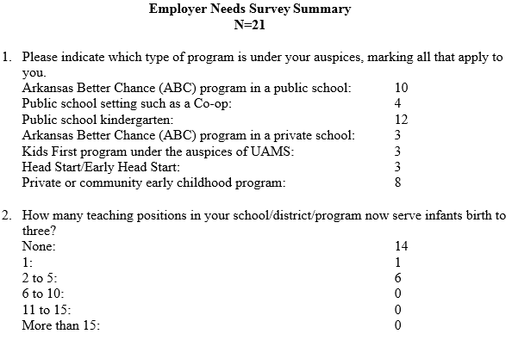

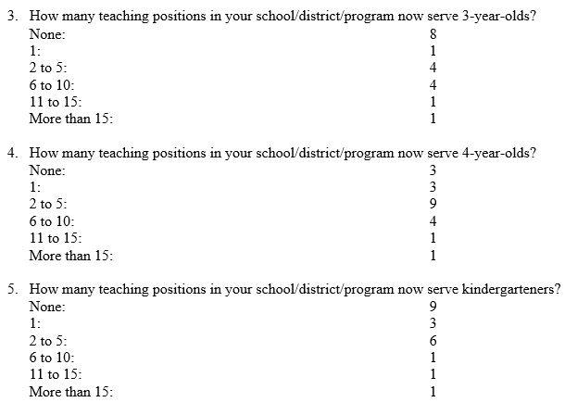
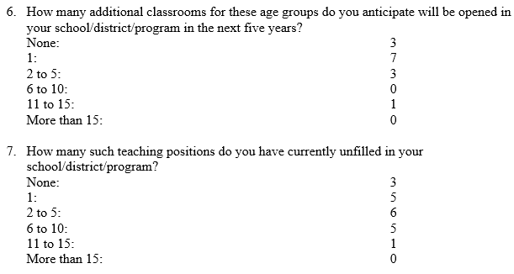
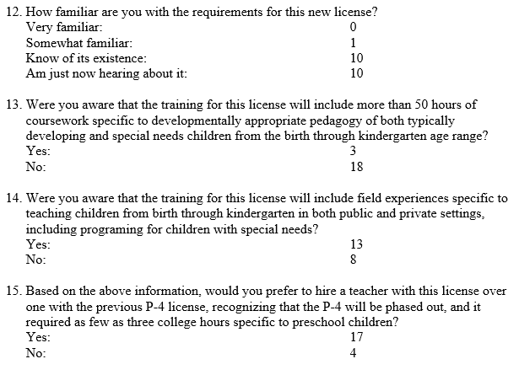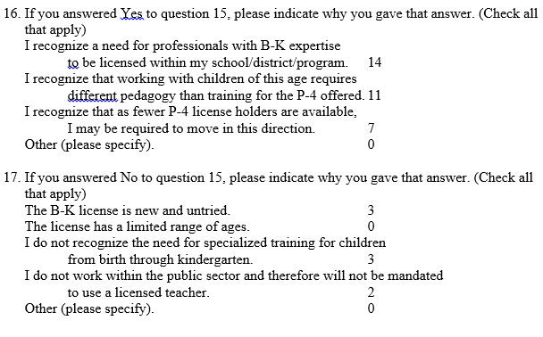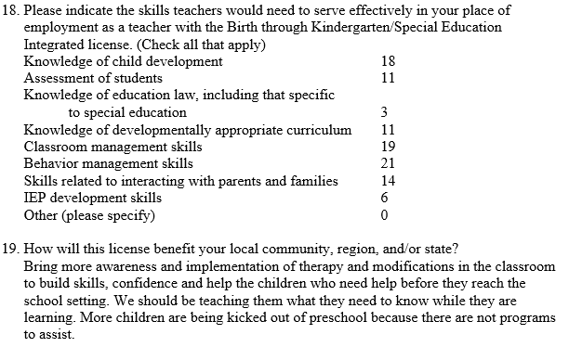

APPENDIX II

Student Demand

Estimates of the number of candidates expected to enter (both as freshman and as transfer students) and complete the proposed program each year for a five-year period are provided in the table below:

Number of Candidates | 2017 | 2018 | 2019 | 2020 | 2021
Entry as Freshman | 2 | 5 | 10 | 20 | 25
Entry as Transfer | 4 | 6 | 10 | 10 | 10
Completed |  |  | 4 | 6 | 15

APPENDIX III

Dale Bumpers College of Agricultural, Food & Life Sciences
EIGHT-SEMESTER DEGREE COMPLETION PROGRAM
B.S.H.E.S. – Human Development, Family Sciences (HDFS) –Birth through Kindergarten (BRKD)
2016-2017

HDFS Requirements: 3-9 hours Communication; 1 hour University perspectives; 3 hours History; 3 hours Mathematics; 8 hours Sciences; 6 hours Fine Arts/Humanities; 9 hours Social Sciences; 71 hours Birth Through Kindergarten Concentration; 10-17 hours general electives. See catalog for candidacy and retention requirements for initial teacher licensure.
Bold – Course meets University Core Pre-requisites, co-requisites, or recommended courses are in parentheses.

Fall Semester Year 1 |  |  | Spring Semester Year 1
Course | Hours |  | Course | Hours
ENGL 1013 Composition I – unless exempt | 3 |  | HESC 2413 Family Relations | 3
HESC 1501 Issues and Trends in HESC | 1 |  | ENGL 1023 Composition II (Pre-ENGL 1013) – unless  Exempt | 3
MATH Core Elective | 3 |  | PSYC 2003 General Psychology | 3
UNIV 1001 University Perspectives | 1 |  | Science Core Elective | 4
Fine Arts Core Elective | 3 |  | NUTR 1213 Fundamentals of Nutrition | 3
HESC 1423 Observation and Foundations for Teaching Young Children | 3
General Electives | 1
Total Semester Hours | 15 |  | Total Semester Hours | 16
Fall Semester Year 2 |  |  | Spring Semester Year 2
Course | Hours |  | Course | Hours
HESC 2403/2401L Infant & Toddler Development & Lab | 4 |  | HESC 2433 Child Development (Pre-HESC 1403 OR  PSYC 2003) | 3
History Core Elective | 3 |  | General Elective | 3
SOCI 2013 General Sociology or HESC 2603 Rural  Sociology | 3 |  | COMM 1313 Public Speaking or Comm intensive | 3
General Elective | 2 |  | Science Core Elective | 4
Humanities Core Elective | 3 |  | CIED 3023 Survey of Exceptionalities | 3
Total Semester Hours | 15 |  | Total Semester Hours | 16
Fall Semester Year 3 |  |  | Spring Semester Year 3
Course | Hours |  | Course | Hours
CIED 3103 Children and Adolescent Literature (Co- 3113) | 3 |  | HESC 4332/4332L Curriculum & Assessment Birth to  Three Years and Lab (Pre- HESC 2403/2401L) | 4
CIED 3113 Emergent & Developmental Literacy (Co –3103) | 3 |  | HESC 4773 Analytical Approaches to Research in HDFS II | 3
SCWK 3633 Child Welfare: 21st Century Perspectives | 3 |  | HESC 3453 Parenting and Family Dynamics (Pre-HESC  1403 or PSYC 2003) | 3
HESC 2473/2471L Child Guidance and lab (Pre-HESC 2433) | 4 |  | General Elective | 2
HESC 4763 Analytical Approaches to Research in HDFS I | 3 |  | CIED 499v Special Topics in Curriculum & Instruction Education | 3
Total Semester Hours | 16 |  | Total Semester Hours | 15
Fall Semester Year 4 |  |  | Spring Semester Year 4
Course | Hours |  | Course | Hours
HESC 4463 Administration and Leadership in the Helping  Professions (Pre–HESC 2473/2471L and junior standing,  COMM 1313) | 3 |  | HESC 4373 Field Experience in Birth Through  Kindergarten Programs (Pre-HESC 4332/4332L,  HESC 4342/4342L) | 3
SPED 4413 ABA and Classroom Management | 3 |  | HESC 4313 Building Family and Community Relations | 3
HIST 3383 Arkansas & The Southwest | 3 |  | HESC 4383 Field Experience in Birth through Kindergarten Programs 2 (pre-HESC 4332/4332L, HESC 4342/4342L) | 3
HESC 4342/4342L Curriculum & Assessment Three Years  through Kindergarten and Lab (Pre- HESC  2473/2471L ) | 4 |  | SPED 4493 Introduction to Students with Autism Spectrum Disorders | 3
General Electives | 2
Total Semester Hours | 15 |  | Total Semester Hours | 12
 |  |  | TOTAL HOURS | 120
For teacher licensure candidacy, students must complete a CIED 499V in which the topic is in the area of Special Education.
APPENDIX IV

Dale Bumpers College of Agricultural, Food & Life Sciences
EIGHT-SEMESTER DEGREE COMPLETION PROGRAM
B.S.H.E.S. – Human Development, Family Sciences (HDFS) – Child Development (CDEV)
2016-2017

HDFS Requirements: 3-9 hours Communication; 3 hours History; 3 hours Mathematics; 8 hours Sciences; 6 hours Fine Arts/Humanities; 9 hours Social Sciences; 51 hours Child Development Concentration; 6 hours Child Development Concentration Electives; 25-31 hours general electives.
Bold – Course meets University Core Pre-requisites, co-requisites, or recommended courses are in parentheses.

Fall Semester Year 1 |  |  | Spring Semester Year 1
Course | Hours |  | Course | Hours
ENGL 1013 Composition I – unless exempt | 3 |  | HESC 2413 Family Relations (Pre-HESC 1501) | 3
HESC 1501 Issues & Trends in HESC | 1 |  | ENGL 1023 Composition II (Pre-ENGL 1013) – unless  exempt | 3
Math Core Elective | 3 |  | PSYC 2003 General Psychology | 3
COMM 1313 Public Speaking | 3 |  | Science Core Elective | 4
Fine Arts Core Elective | 3 |  | Humanities Core Elective | 3
History or Government Core Elective  UNIV 1001 University Perspectives | 3  1
Total Semester Hours | 17 |  | Total Semester Hours | 16
Fall Semester Year 2 |  |  | Spring Semester Year 2
Course | Hours |  | Course | Hours
NUTR 1213 Fundamentals of Nutrition | 3 |  | HESC 2403/2401L Infant and Toddler Development and Lab | 4
HESC 2433 Child Development (Pre-HESC 1403 OR  PSYC 2003; Instructor Consent) | 3 |  | HESC 2473/2471L Child Guidance/Lab | 4
SOCI 2013 General Sociology OR HESC 2603 Rural  Sociology | 3 |  | General Electives | 3
General Elective | 3 |  | Science Core Elective | 4
HESC 2483 Family Financial Management | 3
Total Semester Hours | 15 |  | Total Semester Hours | 15
Fall Semester Year 3 |  |  | Spring Semester Year 3
Course | Hours |  | Course | Hours
CIED 3113 Emergent & Developmental Literacy | 3 |  | HESC 3423 Adolescent Development (Pre-HESC 1403 OR  PSYC 2003) | 3
SCWK 3633Child Welfare: 21st Century Perspectives | 3 |  | CIED 3023 Survey of Exceptionalities | 3
General Elective | 3 |  | General Elective | 3
CIED 3103 Children’s Literature | 3 |  | CDEV Elective | 3
CDEV Elective | 3 |  | HESC 3453 Parenting/Family Dynamics | 3
Total Semester Hours | 15 |  | Total Semester Hours | 15
Fall Semester Year 4 |  |  | Spring Semester Year 4
Course | Hours |  | Course | Hours
HESC 4463 Administration and Leadership in the Helping  Professions (Pre-HESC 3402/3401L and junior standing  and COMM 1313) | 3 |  | HESC 4413 Infancy: Brain Learning & Social Cognition | 3
General Electives | 5 |  | General Elective | 7
HESC 4423 Adult Development (Pre-HESC 1403 OR PSYC  2003 and junior standing) | 3 |  | HESC 4773 Analytical Approaches Res HDFS II | 3
HESC 4763 Analytical Approaches Res HDFS I | 3
Total Semester Hours | 14 |  | Total Semester Hours | 13
 |  |  | TOTAL HOURS | 120

APPENDIX V

Dale Bumpers College of Agricultural, Food & Life Sciences
EIGHT-SEMESTER DEGREE COMPLETION PROGRAM
B.S.H.E.S. – Human Development, Family Sciences (HDFS) – Lifespan (LSPN)
2016-2017

HDFS Requirements: 3-9 hours Communication; 3 hours History; 3 hours Mathematics; 8 hours Sciences; 6 hours Fine Arts/Humanities; 9 hours Social Sciences; 49 hours Lifespan Concentration Requirements; 6 hours Lifespan Concentration Electives; 27-33 hours general electives.
Bold – Course meets University Core Pre-requisites, co-requisites, or recommended courses are in parentheses.

Fall Semester Year 1 |  |  | Spring Semester Year 1
Course | Hours |  | Course | Hours
ENGL 1013 Composition I – unless exempt | 3 |  | HESC 2413 Family Relations (Pre-HESC 1501) | 3
HESC 1501 Issues & Trends in HESC | 1 |  | ENGL 1023 Composition II (Pre-ENGL 1013) – unless exempt | 3
MATH Core Elective | 3 |  | COMM 1313 Public Speaking | 3
HESC 1403 Lifespan Development | 3 |  | Science Core Elective | 4
Fine Arts Core Elective | 3 |  | Humanities Core Elective | 3
General Elective  UNIV 1001 University Perspectives | 3  1
Total Semester Hours | 17 |  | Total Semester Hours | 16
Fall Semester Year 2 |  |  | Spring Semester Year 2
Course | Hours |  | Course | Hours
NUTR 1213 Fundamentals of Nutrition | 3 |  | HESC 2433 Child Development (Pre-HESC 1403 OR PSYC  2003; Instructor Consent) | 3
History Core Elective | 3 |  | SOCI 2013 General Sociology OR HESC 2603 Rural Sociology | 3
Science Core Elective | 4 |  | HESC 3423 Adolescent Development (Pre-HESC 1403 OR  PSYC 2003) | 3
PSYC 2003 General Psychology | 3 |  | General Electives | 6
HESC 2483 Family Financial Management | 3
Total Semester Hours | 16 |  | Total Semester Hours | 15
Fall Semester Year 3 |  |  | Spring Semester Year 3
Course | Hours |  | Course | Hours
HESC 3443 Families in Crisis | 3 |  | SCWK 3163 On Death and Dying (Pre-junior standing) | 3
HESC 4473 Multicultural Families | 3 |  | LSPN Elective | 3
LSPN Elective | 3 |  | General Elective | 8
General Elective | 6
Total Semester Hours | 15 |  | Total Semester Hours | 14
Fall Semester Year 4 |  |  | Spring Semester Year 4
Course | Hours |  | Course | Hours
HESC 4423 Adult Development (Pre-HESC 1403 OR PSYC  2003 and junior standing) | 3 |  | HESC 4443 Gerontology (Pre-HESC 1403 OR HESC 2413  OR PSYC 2003 OR SCWK 2133 and junior standing) | 3
HESC 4463 – Administration and Leadership in the Helping  Professions (Pre-HESC 3402/3401L and junior standing and  COMM 1313, HESC 2433) | 3 |  | CNED 3053 The Helping Relationship | 3
HESC 4493 Public Policy Advocacy for Children & Families | 3 |  | HESC 3453 Parenting/Family Dynamics | 3
HESC 4763 Analytical Approaches to Research in HDFS I | 3 |  | HESC 4773 Analytical Approaches to Research in HDFS II | 3
General Electives | 2
Total Semester Hours | 14 |  | Total Semester Hours | 12
 |  |  | TOTAL HOURS | 120

APPENDIX VI

Dale Bumpers College of Agricultural, Food & Life Sciences
EIGHT-SEMESTER DEGREE COMPLETION PROGRAM
B.S.H.E.S. –Birth through Kindergarten (BRKD)
2017-2018

HDFS Requirements: 10 hours Communication; 1 hour University perspectives; 3 hours History; 3 hours Mathematics; 8 hours Sciences; 6 hours Fine Arts/Humanities; 9 hours Social Sciences; 74 hours Birth Through Kindergarten Concentration; 7 hours general electives. See catalog for candidacy and retention requirements for initial teacher licensure.
Bold – Course meets University Core Pre-requisites, co-requisites, or recommended courses are in parentheses.

Fall Semester Year 1 |  |  | Spring Semester Year 1
Course | Hours |  | Course | Hours
ENGL 1013 Composition I* | 3 |  | HESC 2413 Family Relations* | 3
HESC 1501 Issues and Trends in HESC | 1 |  | ENGL 1023 Composition II (Pre-ENGL 1013)* | 3
MATH Core Elective* | 3 |  | PSYC 2003 General Psychology* | 3
UNIV 1001 University Perspectives | 1 |  | Science Core Elective* | 4
Fine Arts Core Elective* | 3
HESC 1423 Observation and Foundations for Teaching Young Children | 3 |  | COMM 1313 Public Speaking or Comm intensive | 3
General Electives | 1
Total Semester Hours | 15 |  | Total Semester Hours | 16
Fall Semester Year 2 |  |  | Spring Semester Year 2
Course | Hours |  | Course | Hours
HESC 2403/2401L Infant & Toddler Development & Lab | 4 |  | HESC 2433 Child Development (Pre-HESC 1403 OR  PSYC 2003) | 3
NUTR 1213 Fundamentals of Nutrition  History Core Elective* | 3 3 |  | HESC 3453 Parenting and Family Dynamics (Pre-HESC 1403 or Psych 2003) | 3
SCWK 3633 Child Welfare: 21st Century Perspectives | 3 |  | SOCI 2013 General Sociology or HESC 2603 Rural  Families and Communities* | 3
Humanities Core Elective* | 3 |  | Science Core Elective*  CIED 3023 Survey of Exceptionalities | 4  3
Total Semester Hours | 16 |  | Total Semester Hours | 16
Fall Semester Year 3 |  |  | Spring Semester Year 3
Course | Hours |  | Course | Hours
CIED 3103 Children and Adolescent Literature | 3 |  | HESC 4332/4332L Curriculum & Assessment Birth to  Three Years and Lab (Pre- HESC 2403/2401L) | 4
CIED 3113 Emergent & Developmental Literacy | 3 |  | HESC 4773 Analytical Approaches to Research in HDFS II | 3
HESC 4763 Analytical Approaches to Research in HDFS I | 3 |  | General Elective | 4
HESC 2473/2471L Child Guidance and lab (Pre-HESC 2433) | 4 |  | CIED 499v Special Topics in Curriculum & Instruction Education | 3
HESC 3333 Language and Literacy Pedagogy for Birth Through Kindergarten Educators | 3
Total Semester Hours | 16 |  | Total Semester Hours | 14
Fall Semester Year 4 |  |  | Spring Semester Year 4
Course | Hours |  | Course | Hours
HESC 4463 Administration and Leadership in the Helping  Professions (Pre–HESC 2473/2471L and junior standing,  COMM 1313) | 3 |  | HESC 4373 Field Experience in Birth Through  Kindergarten Programs (Pre-HESC 4332/4332L,  HESC 4342/4342L) | 3
SPED 4493 Introduction to Students with Autism Spectrum Disorders | 3 |  | HESC 4313 Building Family and Community Relations | 3
HIST 3383 Arkansas & The Southwest | 3 |  | HESC 4383 Field Experience in Birth through Kindergarten Programs 2 (pre-HESC 4332/4332L, HESC 4342/4342L) | 3
HESC 4342/4342L Curriculum & Assessment Three Years  through Kindergarten and Lab (Pre- HESC  2473/2471L ) | 4 |  | SPED 4413 ABA and Classroom Management | 3
General Electives | 2
Total Semester Hours | 15 |  | Total Semester Hours | 12
 |  |  | TOTAL HOURS | 120
Students must complete a CIED 499V (3 hours) in which the topic is in the area of Special Education.

APPENDIX VII

Dale Bumpers College of Agricultural, Food & Life Sciences
EIGHT-SEMESTER DEGREE COMPLETION PROGRAM
B.S.H.E.S. – Human Development, Family Sciences (HDFS-BS)
2017-2018

HDFS Requirements: 9 hours Communication; 3 hours History; 3 hours Mathematics; 8 hours Sciences; 6 hours Fine Arts/Humanities; 9 hours Social Sciences; 55 hours HDFS Core Courses; 12 hours Focused Electives; 14 hours general electives.
Bold – Course meets University Core Pre-requisites, co-requisites, or recommended courses are in parentheses.

Fall Semester Year 1 |  |  | Spring Semester Year 1
Course | Hours |  | Course | Hours
ENGL 1013 Composition I* | 3 |  | HESC 2413 Family Relations (Pre-HESC 1501)* | 3
HESC 1501 Issues & Trends in HESC | 1 |  | ENGL 1023 Composition II (Pre-ENGL 1013)* | 3
MATH Core Elective* | 3 |  | COMM 1313 Public Speaking | 3
HESC 1403 Lifespan Development | 3 |  | Science Core Elective* | 4
Fine Arts Core Elective* | 3 |  | PHIL 2103 Introduction to Ethics* | 3
General Elective  UNIV 1001 University Perspectives | 3  1
Total Semester Hours | 17 |  | Total Semester Hours | 16
Fall Semester Year 2 |  |  | Spring Semester Year 2
Course | Hours |  | Course | Hours
NUTR 1213 Fundamentals of Nutrition | 3 |  | HESC 2433 Child Development (Pre-HESC 1403 OR PSYC  2003; Instructor Consent) | 3
History Core Elective* | 3 |  | SOCI 2013 General Sociology* | 3
Science Core Elective* | 4 |  | HESC 3423 Adolescent Development (Pre-HESC 1403 OR  PSYC 2003)  HESC 2603 Rural Families and Communities | 3  3
PSYC 2003 General Psychology* | 3 |  | General Electives | 3
SCWK 3633 Child Welfare: 21st Century Persp. | 3
Total Semester Hours | 16 |  | Total Semester Hours | 15
Fall Semester Year 3 |  |  | Spring Semester Year 3
Course | Hours |  | Course | Hours
HESC 3443 Families in Crisis | 3 |  | SCWK 3163 On Death and Dying (Pre-junior standing)  HESC 3453 Parenting and Family Dynamics | 3  3
HESC 4473 Multicultural Families | 3 |  | HESC 4603 Environmental Sociology | 3
HDFS Elective | 3 |  | HDFS Elective | 3
HESC 2483 Family Fin Management  General Elective | 3  3 |  | General Elective | 2
Total Semester Hours | 15 |  | Total Semester Hours | 14
Fall Semester Year 4 |  |  | Spring Semester Year 4
Course | Hours |  | Course | Hours
HESC 4423 Adult Development (Pre-HESC 1403 OR PSYC  2003 and junior standing) | 3
HESC 4463 – Administration and Leadership in the Helping  Professions (Pre-HESC 3402/3401L and junior standing and  COMM 1313, HESC 2433) | 3 |  | General Elective  HDFS Electives | 3  3
HESC 4493 Public Policy Advocacy for Children & Families | 3 |  | HESC 4483 Internship in HDFS | 3
HESC 4763 Analytical Approaches to Research in HDFS I | 3 |  | HESC 4773 Analytical Approaches to Research in HDFS II | 3
HDFS Electives | 3
Total Semester Hours | 15 |  | Total Semester Hours | 12
 |  |  | TOTAL HOURS | 120

Appendix VIII

APPENDIX IX

From: Laura Kathleen Matters Herold
To: "csmith19@harding.edu"
Cc: Timothy Scott Killian; Betsy Garrison
Subject: Reconfiguring the Birth through Kindergarten concentration at the University of Arkansas, Fayetteville
Date: Monday, September 12, 2016 3:31:00 PM
Attachments: BRKD-BS checksheet 9_6_16.docx
HDFS Checksheet --- Proposed_9_7_16.doc

Dear Cheri,

The faculty at the University of Arkansas in Fayetteville are reconfiguring our major in Human Development and Family Sciences. The program currently offers a single major (Human Development and Family Sciences) with three concentrations (Birth through Kindergarten, Child Development, and Lifespan). The Birth through Kindergarten concentration was recently approved to offer the Arkansas BK/SPED teaching license.

The faculty are proposing to reconfigure our current program so that two majors are offered (Birth through Kindergarten and Human Development and Family Sciences), with no concentrations. I have attached the two proposed checksheets that will be presented to the curriculum committee this week.

The reconfiguration of the major requires us to notify local institutions with similar programs about our proposed changes, which is a primary reason for this email. I would also like to wish you continued success in your BK/SPED undergraduate licensure program. Perhaps someday soon we might meet to exchange ideas about offering our licensure programs to undergraduates in Arkansas. Will any BK/SPED faculty be attending the AECA conference in Little Rock in October?

Meanwhile, please let me know if you would like more information about our Birth through
Kindergarten program or if there is anything else I can help with.

Sincerely,

Laura Herold

