CourseLeaf Advice: Topics for January 2016 UCPC Committee Meeting

General Considerations:
- Certain fields are un-editable once a proposal has been submitted into workflow. This means even the Registrar’s Office cannot update them; the only way to update these is to roll the proposal back to the submitter (which takes the proposal out of workflow)
  - Courses—academic level, course #, core inclusion/exclusion, delivery method
  - Programs—academic level, although there are other fields that should not be changed; anything that impacts workflow
- Everyone can find where a specific proposal is in workflow—you have the power!!
  - Look up the proposal in either Course Inventory or Program Management; approval history on RH side shows steps approved (green), step where it’s at currently (yellow) and remaining steps (grey)
  - Using the * wildcard for searching makes things easier if you are unsure of a course number or a program code
- You can view past proposals submitted in the system in their entirety.
  - Go to the course or program you want to view, and look for the “History” log along the RH side
  - Click on the date(s) you want to view and a new window will open, displaying the proposal information that was submitted
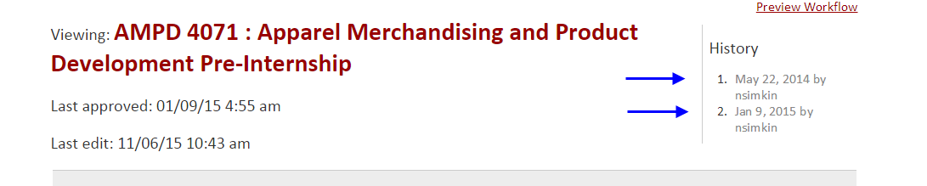
- Ecosystem notifications are your friend—now that we’ve verified this is functionality is working the way it should; the ecosystem exists for both courses and programs
  - Located in the blue box area of the screen when viewing a course or program
  - Designed to send emails to the chair of the department under which courses or programs are housed, and are meant to alert you that someone is proposing a change to a course or program that references the course/program being changed
  - Emails can be a source of confusion when someone in AFLS gets a notification about a course proposal for WCOB and wonders why
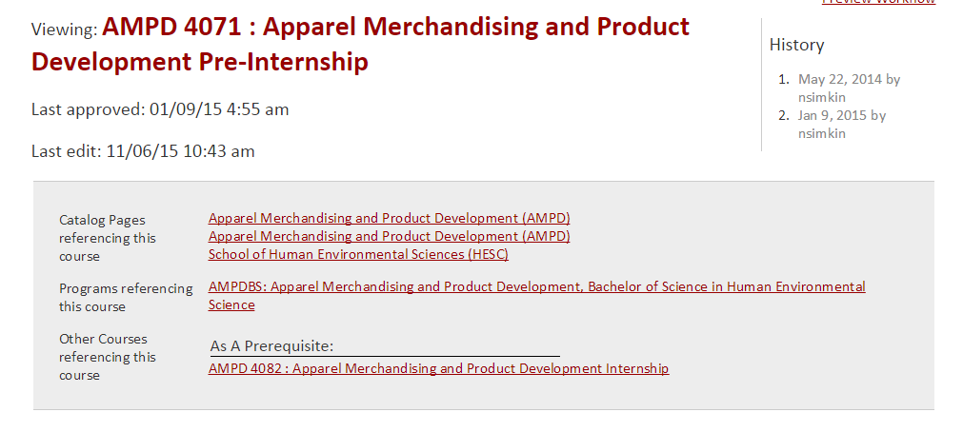
- Notification emails in general—we now have the ability to adjust the message in the body of the email, so we’ll try to put more informative verbiage to help eliminate confusion
  - for example, the Campus Notification email sent at final approval has a pretty generic message that could be updated to reflect that a proposal has completed the approval process
- Stalled proposals can now be identified—either ones saved but not submitted OR proposals stuck at a certain approval step for a number of days
  - Any interest in receiving reports on these?

Course-Specific Considerations:
- Issues creating Honors courses by using the “Create Honors Course” checkbox from an existing non-honors course
  - If you want requisites attached to the new honors version of the course, please include specifics in the “Additional Notes” field when submitting your proposal
- Course requisites—please be specific in how you state these, as often we find they are open to interpretation
  - For example, this requisite can be interpreted several ways: “WCOB 1120 or ISYS 1123, and MATH 2053 or MATH 2554, and WCOB 1111 with a grade of C or better.” One way would be that each of the classes listed requires a grade of C or better; another way would be that only WCOB 1111 needs the grade of C. Inserting some punctuation and/or words can clarify it: “WCOB 1120 or ISYS 1123, and MATH 2053 or MATH 2554, and WCOB 1111, each with a grade of C or better.”
- Cross-listed courses must be the same EXCEPT FOR subject (and sometimes catalog #)

Program-Specific Considerations:
- Deleting a concentration v. adding a concentration
  - Submit a “Modify” request for an existing degree program (AGBSBS) in order to add a new concentration, rather than using the “Propose New Program” option
  - Use the concentration-specific program code (AGBSBS-PRLW) in order to
    - Change an existing concentration
    - Delete an existing concentration
  - How many proposals you end up submitting for changes to programs/concentrations depends a lot on how your departmental page is set up
    - If your general program page (AGBSBS) references the concentrations and/or concentration requirements, you’ll probably end up submitting a proposal to update it, along with the proposal for each concentration being modified
- Free-format fields v. drop-down menus
  - Program code and program title fields are free-format, but we do have certain naming conventions in place, so don’t be alarmed if we edit those to comply
  - The degree field is a drop-down list, so if you are proposing a brand new degree and don’t see it in the list, email us—we’ll add it to the system so that you can select it before you submit your proposal

The Registrar’s Office is more than happy to set up individual training sessions for new and experienced CourseLeaf users alike, so please pass this on to your departments, faculty and staff.

