Proposal – Institute for Advanced Data Analytics¹
- Name of the College, School, Department, or Unit in which the Center will be housed.
The Institute will report to a Dean’s Steering Committee – see number 5 below. The physical location of the Institute will be JB Hunt 404.

- Name and title of the person(s) proposing creation of the Center.
The institute is being proposed by
Matt Waller, Dean and Sam M. Walton Leadership Chair, Sam M. Walton College of Business
John English, Dean and Irma F. and Raymond F. Giffels Endowed Chair, College of Engineering
Todd Shields, Dean, Fulbright College of Arts and Sciences

- The Center type (research, service, or instructional) that is requested.

The focus of the Institute will be research and service. The figure below highlights the vision for the institute with regard to serving the university and its constituents.
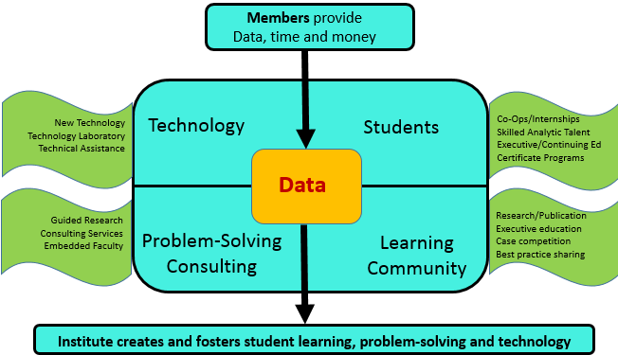

- The unique value of the program to the University, and the distinction to any similar programs in Arkansas.

The unique value of the Institute focuses on two highly significant value propositions—greatly advancing the statistics and analytics curricula and programs at the University of Arkansas in support of the universities goal of becoming a top 50 public research institution and supporting the growing needs of industry for talent, tools, education, and solutions in the analytics space. Based on the success of its SAS endorsed Business Intelligence Certificate programs at both the undergraduate and graduate programs, the UA recently implemented its 12 hour graduate credential Business Analytics Certificate program. Recently, SAP AG announced its launch of a SAP University Alliances Innovation Lab at the University of Arkansas to research and teach Big Data concepts. Moreover, the University of Arkansas has created a campus-wide interdisciplinary Statistics and Analytics degree programs consisting of dedicated tracks in statistics, computation analytics, business analytics, bioanalytics, operations analytics, quantitative social science, and education statistics and psychometrics. The Institute will be exceptionally helpful in support of the UA statistics and analytics curricula focus. Recognizing the critical need for analytics in curricula, the UA has hired and plans to hire several faculty in the area of analytics. The Walton College of Business has hired one clinical and plans to hire another clinical faculty member this year to support the analytics curriculum; the College of Engineering has plans to hire three research faculty in this area, one Endowed Chair Professor and one junior faculty member in Industrial Engineering and another Professor in the Computer Science and Computer Engineering Department; the Department of Mathematical Sciences in the Fulbright College has recently hired several statisticians and has plans to hire two additional statistics faculty who can support the Advanced Data Analytics Institute.

A 2013 survey of Fortune 1000 C-Suite Executives conducted by New Vantage Partners indicated that 91% of these companies have big data initiatives planned or in progress.¹ Many of these initiatives focus on volume, variety and analytical velocity of data. The focus is on integrating the large volume of structured and unstructured data from a growing number of new sources. By 2020 it is estimated that the internet of things will hit 26 billion units which present unique data issues.² As the volume and variety of data increase industry must find ways to accelerate the speed at which this information can be used to support their critical business decisions.

The University of Arkansas in Fayetteville is uniquely positioned to partner with industry on statistics and analytics given their strong existing ties to Fortune 500 companies in Northwest Arkansas. JB Hunt, Tyson and Walmart are heavily data driven companies and the UA has had many long standing partnerships with them. Further, a disproportionality large number of vendors working with Walmart have a physical presence in NW Arkansas. Vendors such as Colgate, Kellogg’s and Procter and Gamble, to name a few, are leaders in the data and analytics space. Even though all these are leaders in analytics, large opportunities in analytics still remain. The Institute will be the bridge to address their many issues and problems and be the source for continuing education and talent as they continue to grow their analytic capabilities.

The UA has and continues to acquire some impressive hardware/software and data to support analytics. These include high performance computing, an IBM z10, to be upgraded soon to support high volume transactions and analytics applications, SAP, SAS Visual Analytics and Teradata. Large data sets include Acxiom demographics data, Dillard’s and Sam’s Club retail transaction data.

Based on the above, the Institute will be complementary to the UALR Emerging Visual Analytics Center.

- http://newvantage.com/wp-content/uploads/2013/09/Big-Data-Survey-2013-Executive-Summary.pdf
- http://www.gartner.com/newsroom/id/2684616

- Information on the Director position and the organizational structure.
Dr. David E. Douglas, Co-Director and University Professor, Information Systems, Sam M. Walton College of Business

Dr. Edward A. Pohl, Co-Director, Professor and Department Head, Industrial Engineering, College of Engineering

Dr. Mark Arnold, Co-Director, Associate Professor, Department of Mathematical Sciences, Director STAN

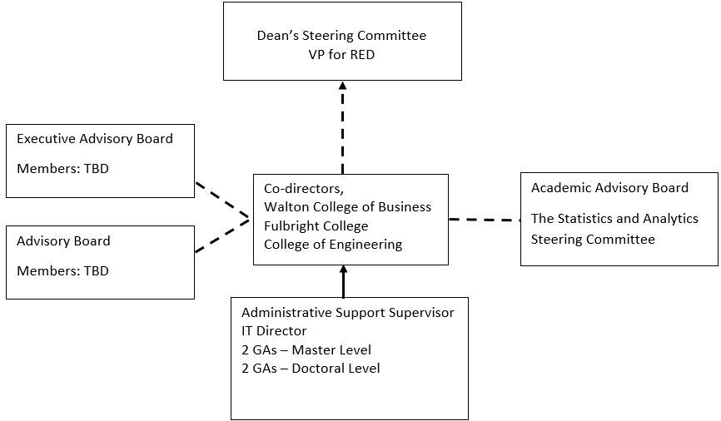

- Identification of faculty (or qualifications of type of faculty), other personnel, and academic units that will be involved with the Center.

The Institute is designed to be inclusive in terms of involvement by faculty across the university that has interest in analytics and analytics projects. Requests for research are anticipated to be varied and require knowledge and skills from various disciplines. As a minimum, the institute will include faculty and students associated with the interdisciplinary program in statistics and analytics. Extensive involvement is expected from WCOB, Fulbright and Engineering faculty. We currently have over 50 university faculty affiliated with the STAN program.

- Student involvement, if any.

Institute projects will include students at all levels from undergraduates, honors students, masters and doctoral students. Moreover, the Institute will support a minimum of four graduate assistants at all times to support ongoing projects and assist in the development of new institute proposals.

- Annual budget for the Unit or the estimated expenditures per year. (Estimate)

- Estimated fiscal resources and potential sources of funding (e.g., state, private, endowment, grant, contract, or other).

- Space and equipment needs of the Center and a description of how they will be met.

Space: JB Hunt 404
Equipment: one time setup expense of computer, software, office equipment estimated to be $10,000

- Description of administrative control and lines of authority for the Center.

See 5 above

- Description of the advisory board including its size, the method of its selection, and length of terms.

The Institute Board would consist of two levels. The target number for the Executive level will be 6 to 8 members and the target for the Advisory members will be 15 to 30 members. Executive members will be industry leaders who bring significant experience and resource support to the institute. Advisory members will include project sponsors and donors at lower levels. Executive level sponsors will serve for 3 years while advisory members will be selected annually. The advisory board members will be nominated by the institute co-directors and approved by the Dean’s Advisory Council.

- The metrics to be used to evaluate the Center’s feasibility at its five-year review.

Vision
To be the premier academic Institute for elevating statistics and analytics research, innovation and practice

Mission
The University of Arkansas Institute for Statistics and Analytics leverages its faculty and expertise to promote the following areas:

- Serve as the bridge between academia and industry for finding solutions to industry issues and problems
- Discover new Statistics and Analytics methodologies and techniques
- Encourage and support faculty lead research
- Encourage and support curricula development

Metrics for measuring the Institute’s success include:
- Number of Executive Board Members
- Number of Advisory Board Members
- Dollar amount of projects
- Value of solutions to problems
- Dollar amount of funded research outside of projects
- Journal publications as a result of involvement with the Institute
---------------------------------------------
Information within the document includes thoughts and summaries taken from a preliminary meeting of potential Advisory Board Members and in particular the graphic in article 3 from Gary Whicker of JB Hunt.

