Approved by UCPC 2/28/20 (emphasis added)
A shortened approval process is available for program changes that meet [all] these criteria:
- Changes are to existing programs and certificates, including parts of programs such as minors and concentrations
- Changes do not affect other colleges
- Changes do not modify the total required hours
- Changes do not add or delete admission or degree requirements other than course changes
- Changes conform to all University and (if relevant) Graduate School policies

Program changes meeting these criteria will be approved by the faculty offering the degree, the college curriculum committee and the college dean, although the academic college may modify that approval process if it chooses. In the workflow, the graduate dean (if relevant), Provost, Director of Program Assessment and Review, Registrar and Institutional Research will review the proposal before it is available for the department/program to approve. After college dean approval, the Global Campus, Dean of the University Libraries and Provost will again review the proposal before it is finally approved.

Here are the current routing options. Other routes may exist and are up for discussion, but may be limited based on software capabilities.

Shortened approval example | Full on-campus approval example
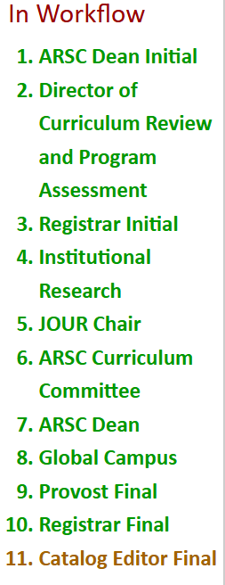 | 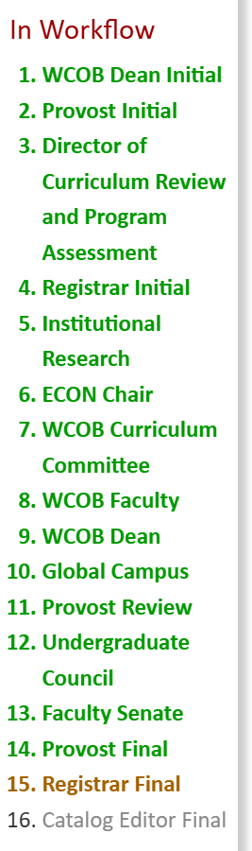

Matter at hand:
What approval should occur for changes to an 8-semester plan when there are no other proposed changes to the program?

Scenario # | Description | Example | Current routing (full or shortened)
1 | Moving/changing specific classes within a college with no effect to another college. | JOURBA swaps the timing of two JOUR classes. Makes one in the fall and the other in the spring. | Shortened
2 | Moving the timing of a specific class that affects another college | EXSCBS moves EXSC 26603 from Fall Freshman year to Spring Freshman year. This, in turn moves PSYC 20003 from Spring Freshman year to Fall Freshman year. | Full
3 | Changing a non-specific SMC class* or the timing of it in a degree program that is not in the same college as the SMC.  *assuming the degree program course does not specify a specific SMC course | BECOBS lists “Fine Arts/Humanities - State Minimum Core (Satisfies General Education Outcome 3.1 or 3.2)” for the Fall of freshman year and wants to change this to Spring of the freshman year. | Full
4 | Changing a specific SMC suggested class* or the timing of it in a degree program that is not in the same college as the SMC.  *assuming the degree program course does not specify a specific SMC course | CHEDBS degree list just says “SMC 35 hours” but in the 8-semester plan suggests MATH 11003 in fall freshman year and now wants to change the suggestion to MATH 21003. | Full
Others..

