Workforce Analysis Request Form

Directions: An institution shall use this form to request workforce data analysis of a proposed degree program. In completing the form, the institution should refer to the document AHECB Policy 5.11 Approval of New Degree Programs and Units, which prescribes specific requirements for new degree programs. Note: This form is required to be submitted by the Chief Academic Officer or individual(s) they designate. Answers need not be confined to the space allotted but may extend to several pages.

Program Information for Analysis
1. Institution:
University of Arkansas, Fayetteville

2. Program Name – Show how the program would appear on the Coordinating Board’s program inventory (e.g., Bachelor of Business Administration or Associate of Science in Accounting):

Master of Science in Product Innovation

3. Proposed CIP Code: If the proposed program does not fit easily into one CIP Code, provide the code it most closely falls into and explain differences / nuances of your program

[50.0404-Industrial and Product Design]

4a. Standard Occupational Classification (SOC) from CIP-SOC Crosswalk:

Take SOC codes from NCES Crosswalk of CIP to SOC, ranked in order of relevance (i.e., the degree to which program graduates are expected to desire and/or be qualified to work in each occupation) (See Appendix A)

27-1021 | Commercial and Industrial Designers
15-1252 | Software Developers
27-1022 | Fashion Designers

4b. Standard Occupational Classification (SOC) from Expert/Staff Opinion (optional): If you think the standard NCES crosswalk accurately represents the list of occupations in which graduates of the proposed program will be qualified to work, leave this blank. If you think the list of target occupations is longer, shorter, or different, please provide an alternative list here, ranked in order of relevance. Feel free to add qualitative information about the variety of jobs and pay scales that may exist within target occupations, and where you expect graduates to fit in. (See Appendix A)

Other occupational areas relevant to the MSPI:
- Technology Commercialization: Translating intellectual property—including IP developed in research settings such as universities—into commercial products and services
- Product Management: Ushering products and services from idea to launch in corporate settings
- Entrepreneurship and New Venture Creation

5. Brief Program Description – Describe the proposed program, the costs and investments involved in implementing it, the students you expect to recruit into it, and its educational objectives.

The Master of Science in Product Innovation degree program will address the growing need for employees and entrepreneurs who know how to take products from idea to commercialization. A widely cited McKinsey survey show that over 90% of corporate executives are dissatisfied with their companies’ innovation performance, and a large proportion of start-ups fail. The program aims to equip students with the knowledge, skills and abilities to dramatically improve these odds. The skill set required is recognizable and in short supply in Arkansas. These valuable employees are adept at problem identification, curious and willing to learn anything, focused on the needs of users and customers, and able to bridge communication and strategy gaps between highly technical and core business teams. These same abilities are essential for entrepreneurs who want to successfully establish innovative, high-growth ventures.

The Master of Science in Product Innovation (MSPI) program will fill this gap with a 12-month, 30-hour program including full summer, fall and spring terms. MSPI students will select from one of two primary tracks in the program electives: 1) a practicum-based product incubation track, in which they will participate in a product incubator program to develop and test new prototypes or 2) a new venture development track, in which they will develop a business model, plan, and pitch around an existing product idea, refining and testing the product in tandem with this work as part of an interdisciplinary team.

The curriculum will cover the following subject matter domains:
- Needs-based product design
- Prototype development and testing
- Business model development and validation
- Project and product management

In addition to [99] hours of coursework, students will enroll in [99] hours of experiential classes. Incubation programs overseen by the Office of Entrepreneurship and Innovation will be at the heart of the Practicum experience for students in track 1; the primary coursework in the Graduate Certificate in Entrepreneurship will provide that substance for students in track 2.

This program will appeal to recent STEM graduates (especially those from engineering disciplines) whose undergraduate work has yielded early-stage prototypes, and/or who are seeking the fundamental business skills needed to succeed in an industry innovation role. It will also be relevant for mid-career professionals who are interested in developing products to solve problems they have witnessed in their careers, or who are seeking to gain the skillset needed to enter into a product management or similar role in an existing enterprise. These roles routinely provide an annual salary of $120,000 or more at the entry level because the market demand far exceeds the available supply of talent.

Although the program will be open to students with an interest in any relevant industry, we will initially focus on three areas of particular interest to the University of Arkansas: biomedical devices, outdoor recreation products, and digital products. UA’s College of Engineering has developed a robust population of students with commercializable biomedical product ideas for which there are ready markets. Northwest Arkansas is rapidly developing a national reputation as a destination for outdoor recreation which is attracting the interest of manufacturers of outdoor gear. And finally, Walmart and other companies in the area are seeing more opportunities in the development of digital products that supplement and support their existing business strategies.

6. North American Industry Classification System (NAICS) – List some industries and/or companies which graduates would be most likely and/or qualified to work in (optional), and feel free to comment on why/in what capacity. Also, a description of the target industry in your region, its relative strength or weakness relative to other regions, and the reasons for that relative strength or weakness, is welcome. Lookup NAICS Code

General -
- Outdoor Products Manufacturers
- Consumer Goods Manufacturers
- Medical Device Manufacturers
- Retailers

Some possible NAICS Codes that could be applicable:
54142-Industrial design services
336991-Bicycles and parts manufacturing
333-Machinery manufacturing
334-Computer and electronic product manufacturing
335-Electrical equipment, appliance, and component manufacturing
315-Apparel manufacturing
44-Retail Trade

7. Region of Possible Position(s) – Describe the region where you think graduates are most likely to work, e.g., in terms of a list of counties, a metropolitan statistical area, or a commuting radius:

Northwest Arkansas
State of Arkansas
Region – Arkansas, Texas, Oklahoma, Missouri, Kansas, & Louisiana
National

8. Existing Data – Describe any existing anecdotes or data you have that would shed light on the job prospects of graduates from the proposed academic program. This data can be helpful to ADFA in conducting labor market analysis.

- Information that led to the development of the Master of Science in Product Innovation program came from several sources. The McMillon Innovation Studio was created by a gift from Doug McMillon, CEO of Walmart, with an eye to preparing undergraduate students for careers in product and service innovation. Mr. McMillon has shared with the Dean and others in the Walton College Walmart’s demand for students trained in product management and innovation.
- The University of Arkansas recently received a $194.7M grant from the Walton Family Foundation to create the Institute for Integrative and Innovative Research (I3R), which will fund commercializable interdisciplinary research in support of the region and the state. The MSPI will directly support this effort.
- The Walton College recently received a $4.13M grant from the Walton Family Foundation to create curriculum that supports the development of outdoor products and services industries in the region. The MSPI will offer a concentration in outdoor products in service to these programs.
- The Walton College has several advisory boards—including the Executive Advisory Board, the Alumni Advisory Board, and the DREAM Board (focused on entrepreneurship)—each of which has expressed strong support for developing programs that promote entrepreneurship and innovation in the state and the region. The Department of Strategy, Entrepreneurship and Venture Innovation was created in January 2020 accelerate these objectives, which includes the creating and offering the MSPI.

9. Proposed Implementation Date – (MM/DD/YY):

- Summer, 2023 (05/15/2023)

10. Contact Person – Provide contact information for the person who can answer specific questions about the program:

Name: Jonathan Johnson

Title: Professor

E-mail: jonjohn@uark.edu

Phone: (479) 575-6227

Email the completed form: Dr. Nicolas Aguelakakis (Nicolas.Aguelakakis@arkansas.gov).

After the labor market analysis has been completed, the institution will be invited to respond, providing further information that might shed light and help to interpret the data provided.

APPENDIX A. CIP-SOC MATCHING AND THE NCES CROSSWALK (Question 4a & 4b)
Labor market analysis for academic program requires the combination of diverse data sources. The National Center for Education Statistics (NCES) and the Bureau of Labor Statistics (BLS) developed a “CIP-SOC crosswalk” linking fields of study, classified by a well-established classification scheme called Classification of Instructional Programs (CIP), with occupations, classified by a well-established classification scheme called Standard Occupational Classifications (SOC). The CIP-SOC crosswalk is available here, and guidelines on how to use the scheme are posted online here.

In question 4a of the form, institutions are asked to copy and paste a list of occupations that match with their instructional programs, taken directly from the NCES CIP-SOC crosswalk, which can be downloaded here: https://static.ark.org/eeuploads/adhe/CIP-SOC_Crosswalk_for_Workforce_Analysis_Form.xls

To use this file to answer question 4a:
- Select Column A.
- In the Home ribbon, Editing section of the toolbar, click Find & Select to get a drop-down menu, and select the Find command. As you do this, your screen should look something like this.
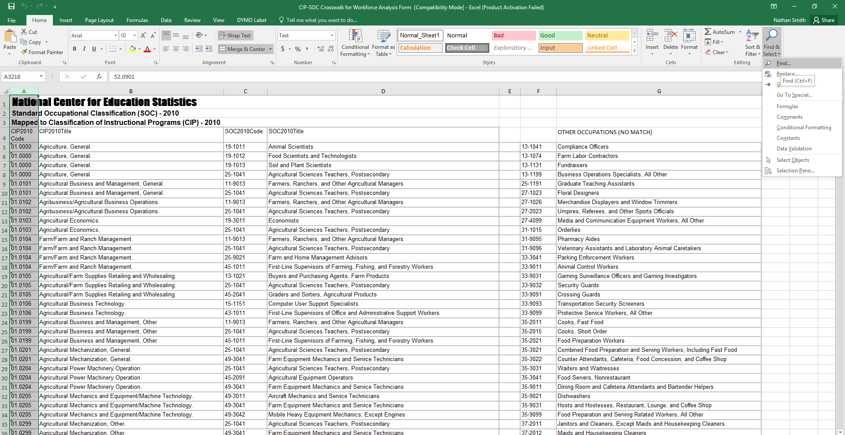

- In the Find and Replace dialog box, enter the CIP code that you’re interested in, and click “Find Next.” Your screen should then look like this:

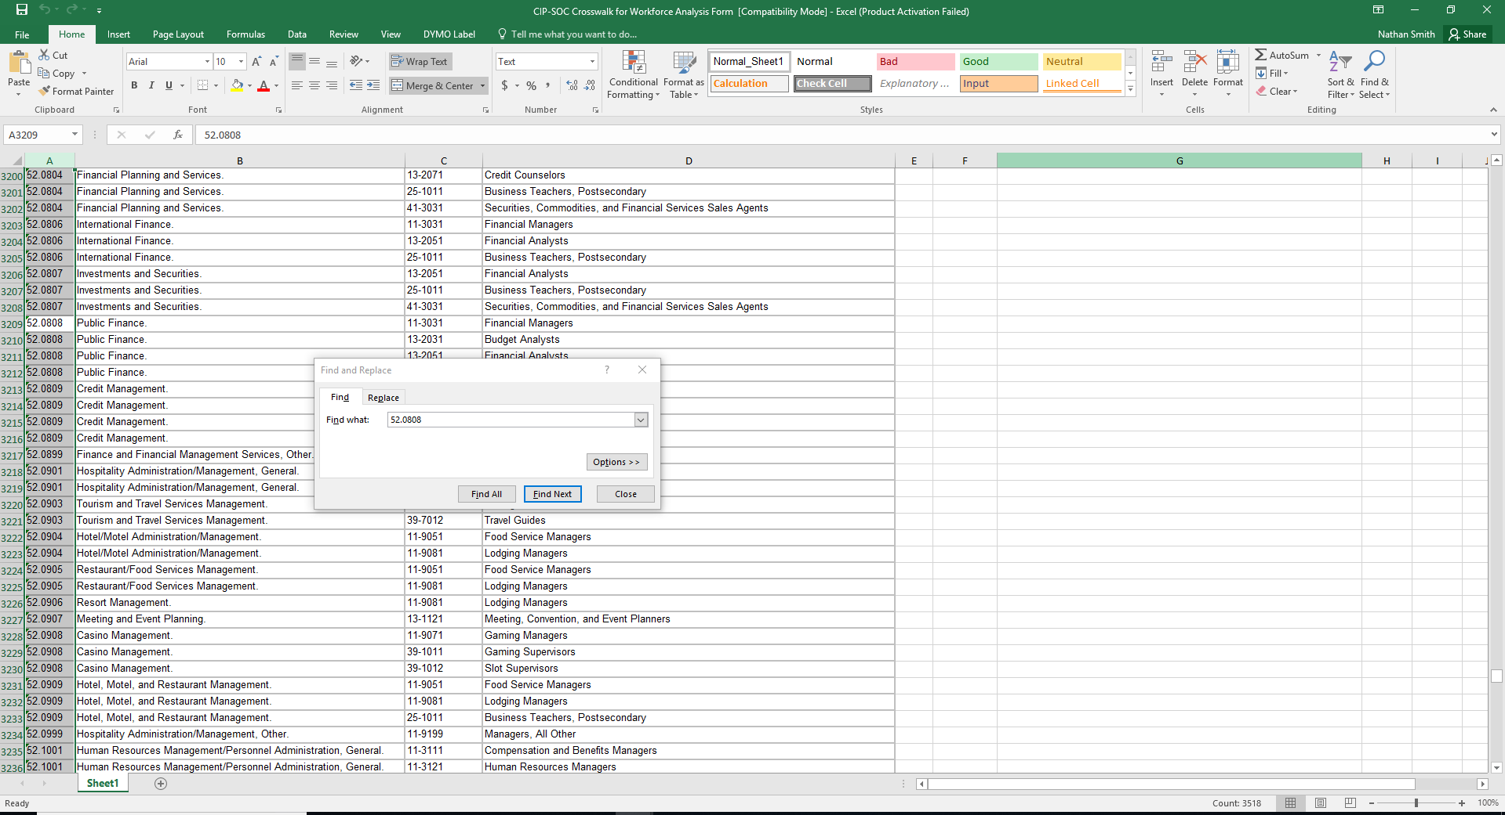

- Since the CIP-SOC crosswalk file is already sorted by row, you can find all the rows corresponding to your CIP simply by starting from the first cell selected and then reading down in column A until you encounter a different CIP code.
- Select all of these rows, columns A through D, this will form a table that can be pasted directly into the response field for question 4a.

52.0808 | Public Finance. | 11-3031 | Financial Managers
52.0808 | Public Finance. | 13-2031 | Budget Analysts
52.0808 | Public Finance. | 13-2051 | Financial Analysts
52.0808 | Public Finance. | 25-1011 | Business Teachers, Postsecondary

- If desired, ask a faculty or staff member to sort the matched occupations from the CIP-SOC crosswalk by relevancy/importance, with the occupations that seem most likely to employ your graduates ranked first.
- Missing occupations from the list should be addressed in question 4b.

Question 4b, is requesting information from your local staff/workforce experts at your institution on the applicability of the NCES list. We are aware that the NCES might be “globally” wrong—the CIP/SOC match may never have been very accurate, or may become obsolete as fields and occupations evolve—or “locally” wrong—the CIP/SOC match may be reasonably robust in general, but fail to capture the role your particular program plays in students’ career paths. Graduates of a particular program may be over or underqualified for some of the matched occupations. Also, there may be SOCs not matched to your CIP by NCES for which, however, your program does help to prepare students, and which are likely to provide gainful employment for your graduates. Question 4b is the place to tell us about those as well.

