Workforce Analysis Request Form

Directions: An institution shall use this form to request workforce data analysis of a proposed degree program. In completing the form, the institution should refer to the document AHECB Policy 5.11 Approval of New Degree Programs and Units, which prescribes specific requirements for new degree programs. Note: This form is required to be submitted by the Chief Academic Officer or individual(s) they designate. Answers need not be confined to the space allotted but may extend to several pages.

Program Information for Analysis
1. Institution:
University of Arkansas- Fayetteville

2. Program Name – Show how the program would appear on the Coordinating Board’s program inventory (e.g., Bachelor of Business Administration or Associate of Science in Accounting):

Adult-Gerontology Acute Care Nurse Practitioner Post-Master’s Certificate
3. Proposed CIP Code: If the proposed program does not fit easily into one CIP Code, provide the code it most closely falls into and explain differences / nuances of your program

51.3803
4a. Standard Occupational Classification (SOC) from CIP-SOC Crosswalk:

Take SOC codes from NCES Crosswalk of CIP to SOC, ranked in order of relevance (i.e., the degree to which program graduates are expected to desire and/or be qualified to work in each occupation) (See Appendix A)

29-1171

4b. Standard Occupational Classification (SOC) from Expert/Staff Opinion (optional): If you think the standard NCES crosswalk accurately represents the list of occupations in which graduates of the proposed program will be qualified to work, leave this blank. If you think the list of target occupations is longer, shorter, or different, please provide an alternative list here, ranked in order of relevance. Feel free to add qualitative information about the variety of jobs and pay scales that may exist within target occupations, and where you expect graduates to fit in. (See Appendix A)

5. Brief Program Description – Describe the proposed program, the costs and investments involved in implementing it, the students you expect to recruit into it, and its educational objectives.
The EMSON Post-Graduate Certificate program empowers advanced practice nursing professionals to advance their careers and pursue board certification in one of two Advanced Practice Registered Nurse (APRN) specializations: Family Nurse Practitioner (FNP), Adult Gerontology Acute Care Nurse Practitioner (AG-ACNP).
Adult Gerontology Acute Care Nurse Practitioner (AG-ACNP)
21 minimum credits | 495 clinical hours
Students complete this post-doctoral/post-master’s certificate program on a part-time basis. Applicants must hold a bachelor's degree from an accredited college or university in the United States or the equivalent from an international college or university, maintain a current registered nurse (RN) license, and have earned either (1) a Master of Science degree in Nursing 1 from a CCNE- or ACEN-accredited program, or (2) a doctoral degree (DNAP, DNP, or PhD) to be eligible for consideration. Other requirements include:
- Evidence of at least two years of strong professional nursing experience.
- Evidence of clinical placement commitments (necessary to fulfill the clinical objectives of the certificate) for master's or DNP prepared nurse practitioners.
- Evidence of national certification in advanced practice nursing specialty.
- Evidence of Advanced Practice licensure
These courses are already offered in a web-based format through the DNP program and this certificate would allow for an increased student population (those who are already nurse practitioners) to be able to take the courses and certify as Adult-Gerontological Acute Care Nurse Practitioners (AGACNPs). Many hospitals are requiring nurse practitioners to hold this certification in order to see patients in the inpatient settings, especially acute and intensive care settings. This program would increase student population using resources already in existence without having to create any new courses.

All courses currently exist and are offered with enrollment. No additional costs will be expected until exceed 25 student limit for course enrollment.

Program Goals and Objectives: Graduates who earn their post-doctoral/post-masters AG-ACNP certificate will be qualified to serve adult and older adult patients in acute and complex care settings. Students who pursue this specialization will learn how to effectively communicate with families and manage multifaceted acute care situations.

6. North American Industry Classification System (NAICS) – List some industries and/or companies which graduates would be most likely and/or qualified to work in (optional), and feel free to comment on why/in what capacity. Also, a description of the target industry in your region, its relative strength or weakness relative to other regions, and the reasons for that relative strength or weakness, is welcome. Lookup NAICS Code
621399 Nurse practitioners' offices (e.g., centers, clinics)
621399 Advanced practicing registered nurses' (APRNs) offices (e.g., centers, clinics)
622110 General medical and surgical hospitals
622110 Hospitals, general medical and surgical
621111 Physicians' (except mental health) offices (e.g., centers, clinics

621493 Urgent medical care centers and clinics (except hospitals), freestanding

7. Region of Possible Position(s) – Describe the region where you think graduates are most likely to work, e.g., in terms of a list of counties, a metropolitan statistical area, or a commuting radius:

Nurse Practitioners are recognized and employed in all 50 states in both rural and urban healthcare facilities

8. Existing Data – Describe any existing anecdotes or data you have that would shed light on the job prospects of graduates from the proposed academic program. This data can be helpful to ADFA in conducting labor market analysis.

Job Outlook
“Overall employment of nurse anesthetists, nurse midwives, and nurse practitioners is projected to grow 26 percent from 2018 to 2028, much faster than the average for all occupations. Growth will occur primarily because of an increased emphasis on preventive care and demand for healthcare services from an aging population.”
-US Bureau of Labor Statistics (https://www.bls.gov/ooh/healthcare/nurse-anesthetists-nurse-midwives-and-nurse-practitioners.htm)
9. Proposed Implementation Date – (MM/DD/YY):
08/23/21
10. Contact Person – Provide contact information for the person who can answer specific questions about the program:

Name: Susan Patton

Title: Director, Eleanor Mann School of Nursing

E-mail: skpatton@uark.edu

Phone: 479-575-3907

Email the completed form: Dr. Nathan Smith (Nathan.Smith@adfa.arkansas.gov)

After the labor market analysis has been completed, the institution will be invited to respond, providing further information that might shed light and help to interpret the data provided.

APPENDIX A. CIP-SOC MATCHING AND THE NCES CROSSWALK (Question 4a & 4b)
Labor market analysis for academic program requires the combination of diverse data sources. The National Center for Education Statistics (NCES) and the Bureau of Labor Statistics (BLS) developed a “CIP-SOC crosswalk” linking fields of study, classified by a well-established classification scheme called Classification of Instructional Programs (CIP), with occupations, classified by a well-established classification scheme called Standard Occupational Classifications (SOC). The CIP-SOC crosswalk is available here, and guidelines on how to use the scheme are posted online here.

In question 4a of the form, institutions are asked to copy and paste a list of occupations that match with their instructional programs, taken directly from the NCES CIP-SOC crosswalk, which can be downloaded here: https://static.ark.org/eeuploads/adhe/CIP-SOC_Crosswalk_for_Workforce_Analysis_Form.xls

To use this file to answer question 4a:
- Select Column A.
- In the Home ribbon, Editing section of the toolbar, click Find & Select to get a drop-down menu, and select the Find command. As you do this, your screen should look something like this.
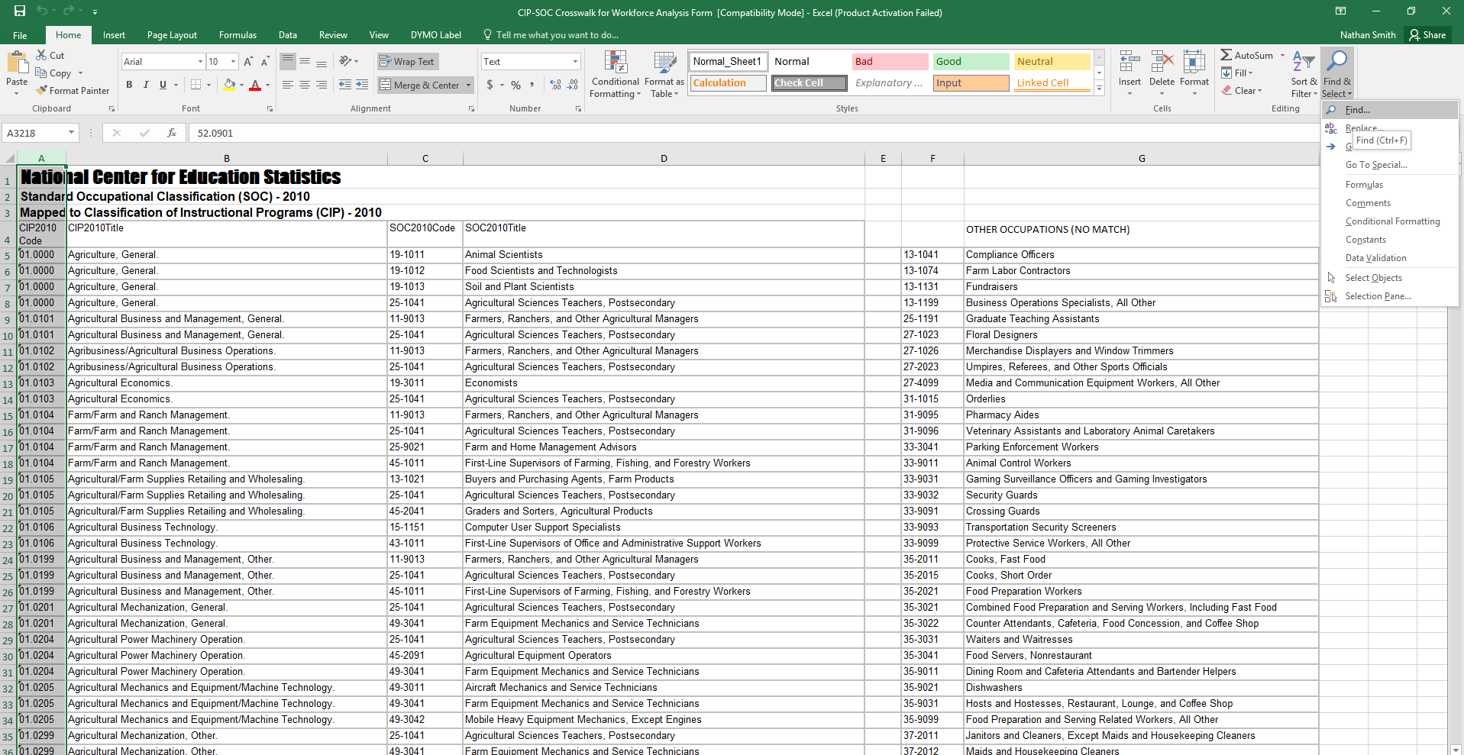

- In the Find and Replace dialog box, enter the CIP code that you’re interested in, and click “Find Next.” Your screen should then look like this:

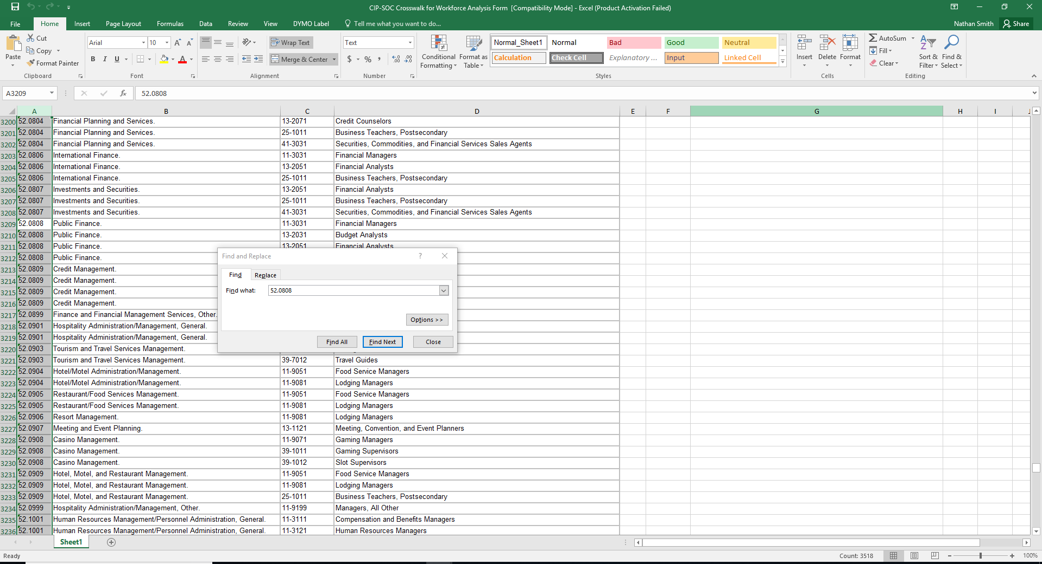

- Since the CIP-SOC crosswalk file is already sorted by row, you can find all the rows corresponding to your CIP simply by starting from the first cell selected and then reading down in column A until you encounter a different CIP code.
- Select all of these rows, columns A through D, this will form a table that can be pasted directly into the response field for question 4a.

52.0808 | Public Finance. | 11-3031 | Financial Managers
52.0808 | Public Finance. | 13-2031 | Budget Analysts
52.0808 | Public Finance. | 13-2051 | Financial Analysts
52.0808 | Public Finance. | 25-1011 | Business Teachers, Postsecondary

- If desired, ask a faculty or staff member to sort the matched occupations from the CIP-SOC crosswalk by relevancy/importance, with the occupations that seem most likely to employ your graduates ranked first.
- Missing occupations from the list should be addressed in question 4b.

Question 4b, is requesting information from your local staff/workforce experts at your institution on the applicability of the NCES list. We are aware that the NCES might be “globally” wrong—the CIP/SOC match may never have been very accurate, or may become obsolete as fields and occupations evolve—or “locally” wrong—the CIP/SOC match may be reasonably robust in general, but fail to capture the role your particular program plays in students’ career paths. Graduates of a particular program may be over or underqualified for some of the matched occupations. Also, there may be SOCs not matched to your CIP by NCES for which, however, your program does help to prepare students, and which are likely to provide gainful employment for your graduates. Question 4b is the place to tell us about those as well.

