Revision to Masters in Education in Special Education

Rationale

The Master of Education (MEd) program leading to the following licensure options: an initial licensure in K-12 Special Education and an endorsement in special education. These have been previously approved by the Arkansas Department of Education. The initial licensure track of the MED is designed for individuals with or without a teaching license in another field; the endorsement track is designed for those with a previous education license in field other than special education. The purpose of the program across the two licensure options is to address the severe teacher shortage in special education.

This current proposed program application includes the following changes:

For the MEd in Special Education leading to initial license we propose the following:
1. To change the approved course SPED 5673 Teaching Social Science, Health and PE to Students with Disabilities to a course entitled Teaching Students in the Content Areas by merging with the previously approved SPED 5663. This change will allow a more focused curriculum on designing curriculum and evidence-based instruction across core instructional areas with an emphasis on core subjects (e.g., reading, writing, mathematics, science, social studies). Issues related to health will continue to be covered in courses such as Students with Severe Disabilities and the proposed Teaching Students with Autism Spectrum Disorder. The field experiences for SPED 5673 will include those already approved under SPED 5663.

2. To eliminate SPED 5663 Teaching Science and Math to Students with Disabilities, as this content will be covered in the previously mentioned SPED 5673. In its place we propose SPED 6803 Teaching Students with Autism Spectrum Disorder. Given the prevalence of autism spectrum disorder among school age children, as well as the continuing poor outcomes of adults with autism this course covers characteristics of autism, evidence-based instructional practices specific to autism, and predictors for positive transition outcomes to support future special education teachers who are likely to encourage children and youth on the spectrum.

For the MEd in Special Education leading to endorsement we propose the following changes:

1. To provide option for students to take one of three research courses to replace SPED 5633 Curriculum Development and Instructional Planning. The three courses are 2 statistics courses (ESRM 5393 Research in Education and Health Professions or ESRM 5013 Research Methods in Education) or SPED 6873 Measurement and Experimental Design. SPED 6873 specifically will allow students to expand their understanding of research to single subject design which is a common, rigorous research design in special education and applicable to strategies used in classrooms to assess and measure student progress.

2. To replace the above proposed SPED 6803 Teaching Students with Autism Spectrum with SPED 5883 Research in Inclusive Education, which exposes students to case study research in education in order to understand research utilizing this methodology and applying the principles of case study research to their work with individual students with disabilities.

Students in the MEd with endorsement licensure track will have already completed a licensure program in education (e.g., childhood education, secondary education) that would have exposed them to curriculum design. Students who understand the principles of research are that much more prepared to identify and use evidence based practices. To expand student competencies related to understanding, critiquing, and applying research methods we propose that MEd with endorsement students have deepen exposure to research methods courses.

Documentation of Revisions

4ai. Current Plan of Study with Proposed Changes Indicated

Current MEd Plan of Study | Proposed MEd leading to initial licensure | Proposed MEd leading to endorsement
SPED 5413 ABA & Classroom Management for Teachers | No change | No change
SPED 5633 Curriculum Development and Instructional Planning | No change | Replace with one of the following:  SPED 6873 Measurement and Experimental Design  ESRM 5013 Research Methods in Education  ESRM 5393 Statistics in Education and Health Professions
SPED 5663 Teaching Science and Math to Students with Disabilities | Replace with SPED 6803 Teaching Students with Autism Spectrum Disorder | Replace with SPED 5883 Research in Inclusive Education
SPED 5673 Teaching Social Science, Health and PE to Students with Disabilities | Change Name to SPED 5673 Teaching Students in the Content Areas | Same as MEd With Initial
SPED 5683 Teaching Literacy Skills to Students with Disabilities | No change | No change
SPED 5733 Inclusive Practices for Diverse Populations | No change | No change
SPED 5673 Teaching Students with Disabilities in the Content Areas | No change | No change
SPED 5763 Teaching Individuals with Severe Disabilities | No change | No change
SPED 5783 Professional and Family Partnerships | No change | No change
SPED 5873 Assessment and Programming for Students with Disabilities | No change | No change
SPED 6433 Legal Aspects of Special Education | No change | No change
SPED 532V Practicum in Special Education | No change | No change

41ii. Revised Curriculum Matrix across Special Education Teacher Competencies/Arkansas Teaching Standards for Initial Licensure (Grades K-12)
MEd Leading to Initial License in Special Education

 | 5413 ABA | 5633 CURR | 5673 CONT | 5683 LIT | 5733 INCL | 5763 SEV | 5783 FAM | 5873 ASSE | 6803 ASD | 6433 LAW | 532v PRAC  2X
1. Learner Development and Individual Learning Differences
1.1 |  | X | X | X | X | X | X | X |  |  | X
1.2 |  | X | X | X | X | X |  | X | X |  | X
2. Learner Development and Individual Learning Differences
2.1 | X | X | X | X | X | X | X | X | X | X | X
2.2 | X | X | X | X | X | X |  |  | X |  | X
2.3 | X |  |  |  | X | X | X | X | X | X | X
3. Curricular Content Knowledge
3.1 |  | X | X |  |  |  |  |  | X
3.2 |  | X | X | X |  | X |  |  | X
3.3 |  | X | X | X | X | X |  |  | X
3.4 |  |  |  | X
3.5 |  |  | X | X
3.6 |  |  | X
3.7 |  |  | X
3.8 |  |  | X
4. Assessment
4.1 | X |  |  | X |  | X |  | X | X | X | X
4.2 | X | X | X |  |  |  |  | X | X
4.3 | X | X |  |  |  | X |  | X | X |  | X
4.4 | X |  | X | X | X | X |  | X | X |  | X
4.5 | X | X | X |  | X | X | X | X | X | X | X
4.6 |  |  |  | X |  |  |  | X
4.7 |  |  |  | X
5. Instructional Planning Strategies
5.1 | X | X | X | X |  | X | X |  | X |  | X
5.2 | X |  |  |  |  | X |  | X | X |  | X
5.3 |  |  |  |  |  | X |  |  | X
5.4 | X |  |  |  | X | X |  |  | X |  | X
5.5 |  | X | X |  |  | X | X | X | X |  | X
5.6 | X | X | X | X |  | X |  | X | X
5.7 |  | X | X |  |  |  |  |  |  |  | X
5.8 |  | X | X | X | X | X | X |  | X |  | X
6. Professional Learning and Ethical Practice
6.1 | X | X | X | X | X | X | X | X | X | X | X
6.2 | X | X | X | X | X | X | X | X | X | X | X
7. Collaboration
7.1 | X |  |  |  | X | X | X | X | X | X | X
7.2 | X | X | X | X | X | X | X | X | X | X | X
7.3 | X |  | X | X | X | X | X | X | X | X | X
8. Disciplinary Literacy
8.1 |  |  | X | X |  |  |  |  |  |  | X
8.2 |  |  | X | X
8.3 |  |  | X | X |  |  |  |  |  |  | X
8.4 |  |  | X | X |  |  |  |  |  |  | X
8.5 |  |  | X | X
8.6 |  |  | X | X
8.7 |  |  | X | X
8.8 |  |  | X | X

MEd Leading to Endorsement in Special Education

 | 5413 ABA | X SPED 6873, $ ESRM 5013 or $ ESRM 5393 | 5673 CONT | 5683 LIT | 5733 INCL | 5763 SEV | 5783 FAM | 5873 ASSE | 5883 RESEARCH | 6433 LAW | 532v PRAC  2X
1. Learner Development and Individual Learning Differences
1.1 |  |  | X | X | X | X | X | X | X |  | X
1.2 |  |  | X | X | X | X |  | X | X |  | X
2. Learner Development and Individual Learning Differences
2.1 | X | X | X | X | X | X | X | X | X | X | X
2.2 | X | X | X | X | X | X |  |  | X |  | X
2.3 | X |  |  |  | X | X | X | X | X | X | X
3. Curricular Content Knowledge
3.1 |  | X | X |  |  |  |  |  | X
3.2 |  | X | X | X |  | X
3.3 |  | X | X | X | X | X
3.4 |  |  |  | X
3.5 |  |  | X | X
3.6 |  |  | X
3.7 |  |  | X
3.8 |  |  | X
4. Assessment
4.1 | X |  |  | X |  | X |  | X | X | X | X
4.2 | X | X $ | X |  |  |  |  | X | X
4.3 | X | X $ |  |  |  | X |  | X | X |  | X
4.4 | X | X | X | X | X | X |  | X | X |  | X
4.5 | X | X | X |  | X | X | X | X | X | X | X
4.6 |  |  |  | X |  |  |  | X | X
4.7 |  |  |  | X
5. Instructional Planning Strategies
5.1 | X | X | X | X |  | X | X |  | X |  | X
5.2 | X | X |  |  |  | X |  | X |  |  | X
5.3 |  |  |  |  |  | X
5.4 | X |  |  |  | X | X |  |  |  |  | X
5.5 |  |  | X |  |  | X | X | X |  |  | X
5.6 | X | X | X | X |  | X |  | X
5.7 |  |  | X |  |  |  |  |  |  |  | X
5.8 |  |  | X | X | X | X | X |  |  |  | X
6. Professional Learning and Ethical Practice
6.1 | X |  | X | X | X | X | X | X |  | X | X
6.2 | X | X | X | X | X | X | X | X | X | X | X
7. Collaboration
7.1 | X |  |  |  | X | X | X | X | X | X | X
7.2 | X | X | X | X | X | X | X | X | X | X | X
7.3 | X |  | X | X | X | X | X | X | X | X | X
8. Disciplinary Literacy
8.1 |  |  | X | X |  |  |  |  |  |  | X
8.2 |  |  | X | X
8.3 |  |  | X | X |  |  |  |  |  |  | X
8.4 |  |  | X | X |  |  |  |  |  |  | X
8.5 |  |  | X | X
8.6 |  |  | X | X
8.7 |  |  | X | X
8.8 |  |  | X | X

iv. TESS Standards and v. SPED 101 Academy Competencies
The table below illustrations how both TESS Standards and professional Council for Exceptional Children (CEC) standards are embedded across the coursework.

Courses | TESS Domains | Foundations for Reading Competencies | CEC Standards/SPED 101 Academy Competencies
5413 ABA | 1 – Plan & Prep  2 – Classrm Env  3 – Instruction  4 – Prof Respon |  | 1 – Learner Dev & Diff  2 – Learning Environ  4 – Assessment  5 - Instruction  6 - Prof Learn & Ethics  7 - Collaboration
5633 Curr | 1 – Plan & Prep  3 – Instruction  4 – Prof Respon |  | 1 – Learner Dev & Diff  3 – Curriculum  4 – Assessment  5 - Instruction  6 - Prof Learn & Ethics  7 - Collaboration
6873 Measurement | 1 – Plan & Prep  3 – Instruction  4 – Prof Respon |  | 1 – Learner Dev & Diff  4 – Assessment  5 - Instruction  6 - Prof Learn & Ethics  7 - Collaboration
5673 Content | 1 – Plan & Prep  2 – Classrm Env  3 – Instruction  4 – Prof Respon | 1 – Science of Reading  5 – Development of Reading Comprehension  6 – Reading Assessment/Instruction | 1 – Learner Dev & Diff  2 – Learning Environ  3 – Curriculum  4 – Assessment  5 - Instruction  6 - Prof Learn & Ethics  7 - Collaboration
5683 Lit | 1 – Plan & Prep  3 – Instruction  4 – Prof Respon | (Included in previously approved course)  1 – Science of Reading  2 – Concepts of Print  3 – Phonology  4 – Phonics and Word Study  5 – Development of Reading Comprehension  6 – Reading Assessment/Instruction | 1 – Learner Dev & Diff  2 – Learning Environ  3 – Curriculum  4 – Assessment  5 - Instruction  6 - Prof Learn & Ethics  7 - Collaboration
5733 Inclusive | 1 – Plan & Prep  2 – Classrm Env  3 – Instruction  4 – Prof Respon |  | 1 – Learner Dev & Diff  2 – Learning Environ  4 – Assessment  5- Instruction  6- Prof Learn & Ethics  7 - Collaboration
5763 Severe | 1 – Plan & Prep  2 – Classrm Env  3 – Instruction  4 – Prof Respon |  | 1 – Learner Dev & Diff  2 – Learning Environ  3 – Curriculum  4 – Assessment  5 - Instruction  6 - Prof Learn & Ethics  7 - Collaboration
5783 Families | 2 – Classrm Env  4 – Prof Respon |  | 1 – Learner Dev & Diff  4 - Assessment  6 - Prof Learn & Ethics  7 - Collaboration
5873 Assessm’t | 1 – Plan & Prep  3 – Instruction  4 – Prof Respon |  | 1 – Learner Dev & Diff  2 – Learning Environ  3 – Curriculum  4 – Assessment  6 - Prof Learn & Ethics  7 - Collaboration
5883 Research in Inclusive | 1 – Plan & Prep  2 – Classrm Env  3 – Instruction  4 – Prof Respon |  | 1 – Learner Dev & Diff  4 – Assessment  5 - Instruction  6 - Prof Learn & Ethics  7 - Collaboration
6803 ASD | 1 – Plan & Prep  2 – Classrm Env  3 – Instruction  4 – Prof Respon |  | 1 – Learner Dev & Diff  2 – Learning Environ  3 – Curriculum  4 – Assessment  5 - Instruction  6 - Prof Learn & Ethics  7 - Collaboration
6433 Law | 4 – Prof Respon |  | 1 – Learner Dev & Diff  4 – Assessment  6 - Prof Learn & Ethics  7 - Collaboration
532v Practicum  K-6; 7-12 | 1 – Plan & Prep  2 – Classrm Env  3 – Instruction  4 – Prof Respon |  | 1 – Learner Dev & Diff  2 – Learning Environ  3 – Curriculum  4 – Assessment  5 - Instruction  6 - Prof Learn & Ethics  7 - Collaboration

V. Syllabi
Below find syllabi for:
SPED 5673 Teaching in the Content Areas
SPED 6803 Teaching Students with ASD
SPED 5883 Research in Inclusive Education
SPED 6873 Measurement and Experimental Design
ESRM 5013 Research Methods in Education
ESRM 5393 Statistics in Education and Health Professions

University of Arkansas, College of Education and Health Professions
Department of Curriculum and Instruction
“The Scholar-Practicum Model”

Program Aﬃliation: Special Education

Course Number and Title: SPED 5673 Teaching Students with Disabilities in the Content Areas
Catalog Description: A study of content, methods, and materials for teaching content courses to students with diverse learning needs and how to adapt curriculum to meet diverse needs.
Prerequisites: Admission to Graduate School

Oﬃce Hours: By appointment
Response Time and Feedback: Emails will be responded to within 48 hours . Grades for assignments are usually available within 72 hours after the due date, but large projects or complex activities could take longer.

Relationship to Knowledge Base

ADVANCE LEVEL (M.Ed.)
This course is an advanced course at the graduate level in the specialty studies. The Scholar Practitioner model at this level will pursue an in-depth study of the assessment of individuals with disabilities while emphasizing advance learning in the specialty studies and the social and behavioral studies in the substantive areas.

Goal

The goal of this course is to prepare scholars who will be teaching students with disabilities across the content areas in k-12 classrooms. In order to be an eﬀective special education teacher, scholars must have a basic understanding of the common core standards, how to teach reading across content areas, how to support learners in an inquiry-based general education classroom, and how to ensure that all children have access to the general education curricula. Students will learn strategies to support diverse learners across the continuum of placement in special education services.

Critique special education service delivery models that support learners in the content. (TESS 1, 2, 3, 4; CEC 1, 5, 6)
- Describe the role of the special education teacher in the inclusive setting.
- Describe models for supporting students with special needs across the school setting. Discuss issues regarding implementation of IDEA in the content areas.
- Describe the diﬀerence between accommodations and modiﬁcations. Diﬀerentiate between accommodations and modiﬁcations.
- Individualize accommodations and modiﬁcations to meet the needs of the learner. Support others in implementing accommodations and modiﬁcations.

Analyze the outcomes for student with special needs based upon service delivery options. (TESS 4; CEC 1, 6)
- Explore Annual Report to Congress on IDEA to determine where students with disabilities are served. Analyze the outcomes of students with disabilities compared to typical peers in the content area.

Create a collaboration setting for serving students with special needs across learning environments. (TESS 2; CEC 1, 2, 7)
- Diﬀerentiate the role of the special education teacher based upon student characteristics and service delivery model.
- Diﬀerentiate the role of the general education teacher based upon student characteristics and service delivery model.
- Analyze student needs within diﬀerent contexts to build collaborative support plans.

Adapt Lessons based upon teaching pedagogy. (TESS 3; CEC 5)
- Describe direct, explicit, and inquiry instruction. Diﬀerentiate between direct, explicit, and inquiry instruction.
- Adapt lessons from inquiry to direct or explicit based upon student needs. Plan explicit lessons.
- Teach explicit lessons.

Analyze the impact of reading on the content areas. (TESS 3; CEC 5)
- Explore the literature on the impact of reading in the content area. Identify evidence-based practices to support reading in the content areas.
- Build a resource library for support students reading in the content area.

Create student support plans in science of reading. (Foundations of Reading Competencies 1, 5, 6; TESS 3; CEC 4, 5)
- Identify the ELA Common Core Standards Identify strategies to support learners in reading. Embed reading strategies into lesson plans.
- Implement strategies to support learners in basic reading, vocabulary, and comprehension.
- Implement strategies to support a diverse population of learners (severe to mild).

Develop Standards Driven IEPs. (TESS 1; CEC 1, 4, 5, 6, 7)

Describe the importance of standards-based IEPs.

Complete a gap analysis.

Write a standard based IEP goal.

Use data to drive IEP goal development.

Create student support plans in science. . (TESS 1, 3; CEC 1, 4, 5)

Describe the scope and sequence of science.

Create accommodations and modiﬁcations appropriate for the science content area.

Collaborate with general education teachers to support children with special needs in science. Identify resources to support children with special needs in the science content.

Develop lesson plans for teaching students with disabilities science concepts using evidence-based strategies.

Develop IEP supports for children with special needs in the science content.

Create student support plans in mathematics. (TESS 1, 3; CEC 1, 4, 5)

Describe the scope and sequence of mathematics.

Create accommodations and modiﬁcations appropriate for the mathematics content area.

Collaborate with general education teachers to support children with special needs in Mathematics.

Identify resources to support children with special needs in the mathematics content.

Develop lesson plans for teaching students with disabilities mathematic concepts using evidence-based strategies.

Develop IEP supports for children with special needs in the mathematics content.

Create student support plans in social studies. . (TESS 1, 3; CEC 1, 4, 5)

Describe the scope and sequence of social studies.

Create accommodations and modiﬁcations appropriate for the social studies content area.

Collaborate with general education teachers to support children with special needs in social studies.

Content

  - Special Education Service Delivery
  - Academic Achievement outcomes
  - Collaboration
  - Types of Instructional programming
  - Common Core ELA
  - Teaching Reading
  - Science Standards
  - Teaching Science
  - Social Studies Standards
  - Teaching Social Studies
  - Mathematics Standards
  - Teaching Mathematics
  - Collaboration with Special Teachers-Art, Music, and PE
  - Putting it all together

Evaluation

All written assignments are to be prepared on a computer or typewriter. Typos, misspellings, and grammar errors will result in a lower grade. APA (6th ed.) format is to be used when preparing and citing materials. Avoid language that is sexist, cultural biased, reinforcing of stereotypes, or oﬀensive to persons with disabilities. The instructor will assess the content of each chapter and its assigned readings through products and examinations. Products must be submitted by the due date published in the syllabus. Assignments will be completed; otherwise, the student will earn an “F” in the course.

Discussion Questions

Students will participate in discussions on a regular basis. Students must post a response and comment on two peer posts for full credit. All discussions must be cited with references listed for full credit.

Observation Assignment

Conduct a 1-2 hour observations of a teacher teaching a content course. The classroom must include children with disabilities. Complete the classroom observation checklist and reﬂect upon your observations. (50 points)

Explicit Lesson Plans

Adapted inquiry lessons into the explicit teaching model. Students will adapt three lessons-Science, Mathematics, and Social Studies- into an explicit lesson. The student will choose one evidence-based strategy from the readings to embed into the lesson. Each lesson will be script so the instructor can understand how the student would teach the lesson. (150 points)

Teaching Project

Upon completion of designing the explicit lessons (above), students will choose one of their lessons and teach it in an authentic learning environment. Students will prepare a 3-minute video of their teacher (2 minutes best teaching, 1 minute worst teaching) and prepare a reﬂection on their teaching. (100 points)

Exams

Students will complete two essay exams that demonstrate the application of their knowledge to teaching situations. (100 points)

Syllabus Change

The Instructor reserves the right to make changes as necessary to this syllabus. If changes are made, advance notiﬁcation will be given to the class.

Grading Scale

In this course, the following represents the weighting of points:

Activity Points Possible
Discussions 200
Observation 5
Science Lesson Plan 50
Social Studies Lesson 50
Mathematics Lesson 50
Teaching Project 100

Tests (2 X 50 points each) 100
TOTAL # points available 600 points

The following grading will apply:
A (93-100%)

B (85-92%)

C (77-84%)

D (70-76%)

F (0-69%)

Academic Honesty

The application of the University of Arkansas Academic Honesty Policy as stated in the Student Handbook will be fully adhered to in this course. Grades and degrees earned by dishonest means devalue those earned by all students; therefore, it is important that students are aware of the University of Arkansas Academic Honesty Policy. Academic dishonesty involves acts that may subvert or compromise the integrity of the educational process and includes plagiarism. To view the Academic Integrity for Students video on the Academic Initiatives and Integrity website at the University of Arkansas.
As a core part of its mission, the University of Arkansas provides students with the opportunity to further their educational goals through programs of study and research in an environment that promotes freedom of inquiry and academic responsibility. Accomplishing this mission is only possible when intellectual honesty and individual integrity prevail.
Each University of Arkansas student is required to be familiar with and abide by the University's 'Academic Integrity Policy'.
Students with questions about how these policies apply to a particular course or assignment should immediately contact their instructor.

Accommodations

Students with disabilities requesting reasonable accommodations must ﬁrst register with the Center for Academic Access (CEA). The CEA is located in the Arkansas Union and on the web at cea.uark.edu. The CEA provides documentation to students with disabilities who must then provide this documentation to their course instructors. Students with disabilities must then provide this documentation to their course instructors. Students with disabilities should notify their course instructors of their need for reasonable accommodation in a timely manner to ensure suﬃcient time to arrange reasonable accommodations in a timely manner to ensure suﬃcient time to arrange reasonable accommodation implementation and eﬀectiveness. A typical time frame for arranging reasonable accommodations for students who are registered with the CEA is approximately one to two weeks. Email your professor if you wish to speak to him or her conﬁdentially.

Classroom Behavior

Appropriate classroom behavior is expected of the instructor and all students. Inappropriate and disruptive classroom behavior (inappropriate language and gestures, class disruptions, disrespect to other students or instructor, and other behavior as determined by the instructor) will not be tolerated and will result in possible removal from the class and /or disciplinary action as per the student handbook. IN online classes, the posting of inappropriate communications or inappropriate materials will be considered disruptive behavior.

Emergency Procedures

Many types of emergencies can occur on campus; instructions for speciﬁc emergencies such as severe weather, active shooter, or ﬁre can be found at emergency.uark.edu.

Severe Weather (Tornado Warning):

Follow the directions of the instructor or emergency personnel
Seek shelter in the basement or interior room or hallway on the lowest ﬂoor, putting as many walls as possible between you and the outside If you are in a multi-story building, and you cannot get to the lowest ﬂoor, pick a hallway in the center of the building
Stay in the center of the room, away from exterior walls, windows, and doors

Violence / Active Shooter (CADD):

CALL- 9-1-1
AVOID- If possible, self-evacuate to a safe area outside the building. Follow directions of police oﬃcers.
DENY- Barricade the door with desk, chairs, bookcases or any items. Move to a place inside the room where you are not visible. Turn oﬀ the lights and remain quiet. Remain there until told by police it's safe.
DEFEND- Use chairs, desks, cell phones or whatever is immediately available to distract and/or defend yourself and others from attack.

Additional Weather Information:

Online classes are generally not aﬀected by the weather, but faculty may not be available when weather is an issue. Therefore, an awareness of the campus policies may be helpful and is, therefore, included in the syllabus. In general, if the Fayetteville School District has closed the schools, faculty will be unavailable. For further information, please check www.uark.edu for information concerning campus oﬃces. University closing announcements are also made on KAUF Radio, 91.3 FM as well as local radio and television stations. The University's inclement weather site is updated frequently on the University website.
Students in special education classes should use discretion in making the decisions concerning their personal safety. Online classes are generally not impacted by the weather, but faculty may not be available when weather is an issue. Therefore, an awareness of the on campus "Inclement Weather Policy" may be helpful and is, therefore, included in the syllabus.
See the inclement weather web site. Call 479-575-7000 or the University switchboard at 479-575-2000 for recorded announcements about closings. Check voice email for announcements
Listen to KUAF Radio, 91.3 FM or other local radio and television stations for announcements Contact your supervisor or instructor

Course Resources

Mullins Library: Services at the library include: (1) remote access to library databases and electronic collections with more than 200 research databases, more than 30,000 online journals and magazines, a growing collection of electronic books, reference works such as encyclopedias, dictionaries, and statistical handbook; (2) direct delivery of books and article copies, books from UA collections mailed to your home or oﬃce, copies of articles or chapters delivered electronically; and (3) Interlibrary Loan services to borrow books or articles from other libraries

University General Access Computer Laboratories

- Textbooks

Browder, D. M., & Spooner, F. (2014). More Teaching language arts, math, and science to students with signiﬁcant cognitive disabilities. Baltimore, MD: Brookes Publishing Company.

Recommended

Selected readings from the following:
Mastropieri, M. A., & Scruggs, T. E. (1993). A practical guide for teaching science to students with special needs in inclusive settings. Austin, TX: Pro-Ed. Sheperd, T. L. & Witzel, S. (2010). Computation of integers: Math intervention for elementary and middle grade students. Upper Saddle River, NJ Smith, T. E. C., Gartin, B. C., & Murdick, N. L. (2012). Including adolescents in general education classrooms. Upper Saddle River, NJ: Pearson.

Reading List:
Cawley, J., Hayden, S., Baker-Kroczynski, S., & Cade, E. (2002). Including students with disabilities into the general education science classroom. Exceptional Children, 68(4), 423-435. Fetters, M., Pickard, D. M., & Pyle, E. (2003). Making science accessible: Strategies to meet the needs of a diverse student population. Science Scope, 26(5), 26-29.
Grumbine, R., & Alden, P. B. (2006). Teaching science to students with learning disabilities. Science Teacher, 73(3), 26- 31.
Heacox, D. (2002). Diﬀerentiating instruction in the regular classroom: How to reach and teach all learners, grades 3 – 12. Minneapolis, MN: Free Spirit. Horejsi, M. (2003). Making technology inclusive. Science and Children, 41(3), 20-24.
Kurtts, S.A., Mathews, C.E., & Smallwood, T. (2009). Dissolving the diﬀerences: A physical science lesson using universal design. Intervention in School and Clinic, 44, 151 - 159.
Mastropieri, M. A., & Scruggs, T. E. (1995). Teaching science to students with disabilities in general education settings: Practical and proven strategies. Teaching Exceptional Children, 27(4), 10-13. Mastropieri, M. A., & Scruggs, T. E. (1992). Science for students with disabilities. Review of Educational Research, 62(4), 377-411.
Trundle, K. C. (2008). Inquiry-based science instruction for students with disabilities. Science as Inquiry In the Secondary Setting. Arlington, Virginia: NSTA Press.

University of Arkansas
College of Education and Health Professions
Department of Curriculum and Instruction
Special Education Program

Course Number: SPED 6803
Course Title: Teaching Students with ASD

Catalog Description: This course is an advanced course at the master's level in the specialty studies. The Scholar Practitioner model at this level will pursue an in-depth study of characteristics of individuals with severe disabilities while emphasizing advance learning in assessment, instruction, and emerging issues specific to students with significant needs.

Prerequisite: Admission to Graduate School

Instructor:
Office hours – by appointment virtually or in person
Telephone – 501-450-0311

- Relationship to Knowledge Base:
ADVANCED LEVEL (M.Ed.)
This course is an advanced course at the graduate level in the specialty studies. The Scholar Practitioner model at this level will pursue an in-depth study of knowledge, skills, and dispositions needed to provide services to individuals with disabilities within the context of their family, culture, community, and interdisciplinary teaming.

- Course Goals

This course provides students with an understanding of individuals who have been diagnosed with autism spectrum disorders. Students will link characteristics of learners with ASD to key educational strategies.

- Course and skill objectives:

- By the end of this course, students will link characteristics of children with ASD with high quality educational program design elements.
CEC Initial Preparation Standards 1, 5
CEC Advanced Preparation Developmental Disabilities and ASD 1, 2, 3
  - Correlate challenges with communication to supports such as: social narratives, visual supports, systematic teaching, peer interactions.
  - Create communication and social supports based on learner needs.
  - Correlate challenges with behavior with effective proactive and intervention strategies.
  - Explain how various classroom design considerations can optimize learning across settings.

- By the end of the course, students will identify at least 4 strategies for effective environmental arrangement and articulate the principles under which these strategies support learners with ASD.
CEC Initial Preparation Standards 1, 2, 5
CEC Advanced Preparation Developmental Disabilities and ASD 1, 2, 3

  - Identify at least 4 antecedent-based interventions.
  - Describe how each of these impact learner motivation.
  - Apply an antecedent-based intervention to a challenging behavior after determining the function of the behavior and judging which intervention is most likely to be effective for student and implementer.

- By the end of the course, students will identify strategies for effective, collaboration strategies across school team members and families, advocate for specific practices supportive collaboration, and create examples of these teaming supports.
CEC Initial Preparation Standards 2, 7
CEC Advanced Preparation Developmental Disabilities and ASD 1, 2, 6, 7

  - Identify family issues across the lifespan and ways that educators can support collaboration with family members.
  - Identify teaming strategies of high quality educational programs and steps to advocate and implement them across educational settings.
  - Identify own professional development goals specific to effective education of students with ASD.

- By the end of the course, students will describe and develop visual supports for learners with ASD.
CEC Initial Preparation Standard 1, 5
CEC Advanced Preparation Developmental Disabilities and ASD 1, 2, 3

  - Explain why and how visual supports would be used to support learning or behavior change.
  - Identify specific visual supports to support an instructional strategy, educational need, or behavior change need.
  - Describe the steps used to design the visual support.
  - Create the visual support.

- By the end of the course, students will determine whether a practice or educational program is evidence-based and describe in what ways high quality program design is a foundation for effective implementation of evidence-based practices for learners with ASD.
CEC Initial Preparation Standards 1, 5
CEC Advanced Preparation Developmental Disabilities and ASD 2, 3

  - Define terms “evidence-based practice” and “comprehensive program model” and describe why it’s important to understand these terms.
  - Identify at least 1 source for determining whether a practice is evidence-based.
  - Describe practices that are not evidence based and current controversies around their use.

- By the end of the course, students will identify and apply at least 3 educational strategies to support communication and social skills in inclusive and segregated settings.
CEC Initial Preparation Standards 1, 5
CEC Advanced Preparation Developmental Disabilities and ASD 2

  - Describe challenges learners with ASD may have in educational settings specific to communication and social skills.
  - Identify 3 strategies to support communication and social skills.
  - Design an IEP goal and instructional plan for use of at least 1 of these strategies.

- By the end of the course, students will describe challenges learners with ASD might have with learning functional skills, academics, and independence and identify and apply educational strategies to support positive outcomes in these domains.
CEC Initial Preparation Standards 1, 2, 5, 6
CEC Advanced Preparation Developmental Disabilities and ASD 2, 3

  - Describe challenges learners with ASD may have with learning of functional skills, academics, and independence.
  - Identify 3 strategies to support learning in these domains.
  - Design an IEP goal and instructional plan for use of at least 2 of these strategies together.
  - Identify ways in which a teacher could inadvertently minimize a student’s independence and foster prompt dependency.
  - Describe and design strategies to support independence.
- By the end of the course, students will be able to: identify how characteristics of ASD might influence challenging behavior, embed proactive strategies, analyze behavior that impacts learning, and design effective behavior intervention plans.
CEC Initial Preparation Standards 1, 2, 4, 5, 6
CEC Advanced Preparation Developmental Disabilities and ASD 1, 2

  - Describe how characteristics of ASD might influence a learner’s behavior.
  - Identify at least 3 and apply at least 1 proactive strategy to support use of adaptive behavior or minimize challenging behavior.
  - Describe and apply the steps of a functional behavior analysis process and development of a behavior support plan.
  - Use proactive strategies, functional behavior analysis procedure, to design a behavior support plan.

- By the end of the course, students will describe educational considerations across the age-span that impact learning and development and determine supports for children, adolescents, adults, and family members during these stages.
CEC Initial Preparation Standards 1, 2, 3, 5, 6
CEC Advanced Preparation Developmental Disabilities and ASD 2, 4
  - Describe challenges and needs of learners and families during infancy and early childhood.
  - Identify ways in which play can be used effectively as a context for learning.
  - Describe challenges and needs of learners and families during adolescence and adulthood.
  - Identify educational strategies to support learning during these stages of life.
  - Describe challenges students with ASD may experience beyond learning, such as anxiety and depression
- By the end of the course, students will develop IEP goals and supports based on high quality program design elements specific to leaders with ASD.
CEC Initial Preparation Standards 3, 4
CEC Advanced Preparation Developmental Disabilities and ASD 1, 2

  - Based on learner needs, design a IEP including high quality IEP goals.
  - Design progress monitoring procedures for at least 3 of the developed goals.
  - Develop classroom strategies for ensuring IEP goals and effectively and systematically taught across educational settings.

- Required Texts
The following texts are required and used throughout the course. In addition, there will be a number of web-based lectures, online learning activities, journal articles and other resources assigned for each lesson.

Boutot, A. E. (2017). Autism spectrum disorders: Foundations, characteristics, and effective strategies. Boston: Pearson.

Hodgdon, L. A. (1999). Solving behavior problems in Autism: Improving communication and visual strategies. Troy Michican: Quirk Roberts Publishing.

- Course Structure
This course is structured in an online format across 5 learning modules. Within each module are 3-5 lessons. Each lesson is organized into 3 tasks: read, explore, and do. These will be your course activities for each week and may include some of the following activities. Begin each week by first reading, then exploring, and finally doing unless your instructor specifies another order to your activity within the lesson.

Each week begins on Monday, please make sure to post your discussion responses by Friday and provide feedback and responses to peers by Sunday night.

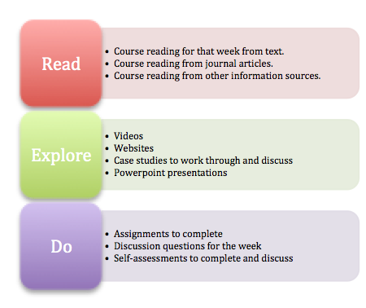
- Modules and Lessons
The course is divided into 5 content modules which each include 3-5 lessons. These modules are:
- Program Quality for Education of Students with ASD
- Instructional Strategies and Programs
- Educational Planning for Specific Competencies
- Educational Considerations Across Age Span
- Program Design

Class Schedule:

Module | Week Starting | Lesson | Content | Chapter in Text | Assignment Due
Program Quality for Education of Students with ASD | August 22 | 1 | Introduction to Course  Introduction to Self  Characteristics of ASD and Program Quality (PQ) | B - 1
 | August 29 | 2 | PQ – Collaboration & Teaming | B - 3
 | Sept 5 | 3 | PQ – Environmental Arrangement | B - 4  H - 8
 | Sept 12 | 4 | PQ – Visual Supports  - schedules  - task aids  - first/then  - self-management  - communication supports | H – 3, 7, 12
Instructional Strategies and Programs | Sept 19 | 5 | Instruction through Focused EBPs | B - 2,5
 |  | 6 | Comprehensive Models for Instruction  - Early Start Denver Model  - Division TEACCH  - LEAP  - Ziggarat | B - 2,5 | Assignment – Visual Support Design – for Peer Feedback
Educational Planning for Specific Competencies | Sept 26 | 7 | Understanding Behavior and Proactive Behavioral Support  - Antecedent-based  - 5 point scale  - Visual Supports | H – 1
 | Oct 3 | 8 | Functional Behavior Assessments & Behavior Intervention Plans  - Process  - Team based  - Ensuring fidelity of implementation  Measuring progress | H - 4 | Final upload of Visual Support Design Presentation to Discussion & Submit to Assignments
 | Oct 10 | 9 | Teaching Communication and Social Skills  - Environments that support communication  - Social narratives  - Comic strips  - Peer supports  - Peer mentoring  - Social Skill Programs (PEERS, SCI) | 6, 7  H – 2, 5, 6, 10
 | October 17 Fall Break - Catch up and Work on your Instructional Plan & Other Assignments
 | Oct 24 | 10 | Teaching Functional Skills & Academics | B - 8, 9 | Assignment – Social Narrative Design
 | Oct 31 | 11 | Teaching to Promote Independence  - Identifying opportunities for independence  - Getting out of the way of learning  - “I need help” | H – 9, 11
Educational Considerations Across Age Span | Nov 7 | 12 | Early Intervention and Early Childhood  - parent implementation of evidence based practices  - play based learning  - structured play groups | B- 10 | Assignment –Functional Behavior Assessment Based on Case Study
 | Nov 14 | 13 | Adolescence & Adulthood  - transition  - sexuality education  - work-based learning  - adult outcomes | B - 13, 14
Program Design | Nov 21 | 14 | Teaching Across the Continuum of Learning Environments  - Accommodations and supports  - School-wide supports  - Assistive technology  - Classroom organizing |  | Assignment – Preference Assessment
 | Nov 28 | 15 | IEP Development & Progress Monitoring  - IEP at a glance  - IEP matrix  - Developing effective goals  - linking goals with instruction  - linking goals with progress monitoring
 | Dec 5 | 16 | Putting it Together | H - 13 | Assignment – Instructional Planning

- Assignments

TIP: Your last assignment is a culminating assignment that synthesizes your knowledge from across the course. You might consider developing this assignment from the beginning of the course. By the due date, you will have a fully developed instructional plan.

Social Narrative Project

Due:

Points: 40

Purpose: The purpose of this assignment is for you to apply your knowledge of using social narratives to support student learning and behavior. Additionally, through the assignment you will practice using valuable resources for implementing evidence-based practices.

Instructions: Choose a child/youth you know, get to know a child/youth with ASD, or a child from 4 provided case studies. Develop the project as described below.

Your project should include the following:
- Description of the child
  - Age, Grade
  - How their autism exhibits itself as related to the characteristics of ASD. Ensure you are providing examples of characteristics of autism specific to the child you are developing the social story for. What are the child’s strengths and challenges?
- What is the purpose of the social narrative (e.g., to decrease a behavior, to teach a new skill, to help student self-regulate).
- Complete the Social Narrative Planning Worksheet (available on AFIRM). Make sure to “show your work”. Be clear about the decisions you are making in developing the social story.
- Describe the steps you would take to teach the social narrative.
- Develop a social narrative.
- Develop a data sheet for progress monitoring of student behavior/learning. Describe what data you would take to measure whether or not the social narrative was meeting its purpose.

Visual Support Design Project

Due:

Points: 40

Purpose: The purpose of this assignment is for you to apply your knowledge of using visual supports for students with ASD. Additionally, through the assignment you will practice using valuable resources for implementing this evidence-based practice.

Instructions: Choose one child of the attached case studies. Develop 3 visual supports for the child you choose. One of these must be a schedule. One of these must be a cue. The last could be a boundary or another visual support of your choice. Ensure you are using the AFIRM Visual Supports Implementation Checklist to develop your visual supports.

Step 1 – Design a plan for 3 visual supports using the implementation checklist from AFIRM. Submit your plan to the discussion board for peer feedback. When giving feedback to peers ensure that it is supportive and offers specific ideas for editing, adding, or reconsidering their plan. If you are in full agreement with the plan make sure you are specific about which elements of the plan are particularly well developed. Consider feedback from peers in finalizing the development of your visual supports as appropriate.

Step 2 - Create a video presentation of your three supports. Videotape yourself through Kaltura as you did for your course introduction. Upload your presentation to the discussion section and submit as assignment. The presentation should include:
- Which child you choose
- Showing and describing the elements of each visual support
  - What is the type of visual?
  - What is the purpose of the visual – make sure to relate to information you pulled from the case study?
  - How did you make decisions about different aspects of visual (form, length, etc)?
  - How would you teach the visual?
  - How would you assess whether the visual support was helping your student progress?

Preference Assessment

Due:

Points: 40

Purpose: The purpose of this assignment is for you to apply your knowledge by doing preference assessments. Additionally, through the assignment you will practice using valuable resources for implementing this evidence-based practice.

Instructions: Identify a child or adult with ASD with whom to complete the assignment. Choose 2 methods of preference assessment (e.g., interviewing family, observations, reinforcer sampling). If you are not sure about the appropriateness of a method for this assignment, please contact your instructor at least 2 weeks prior to the due date.

Ensure you are preparing your data sheets, interview questions, observation forms, and so on as described in your text, readings, lesson, and other resources. All of these should be included in your final upload. Tip – you can take photos of your written notes – make sure these are legible of course.

After completing the assessment, develop a 2-3 page reflection, including:
- description of your process for each assessment
- description of findings
- summary of what you learned about the child or adult
- discussion of how the findings would influence your instructional development

Functional Behavior Assessment

Due:

Points: 40

Purpose: The purpose of this assignment is for you to apply your knowledge of functional behavior assessments.

Instructions: Develop an FBA for the case study of Tommy (case study developed by State of Georgia).

- Read and review the case study (description of Tommy, data sheets, FBA data.
- Fill in the FBA worksheet based on your analysis of the data and description.
- Write 2 behavioral goals related to the data that would be used to develop a behavior support plan. Ensure the goals are measurable and observable.
- Describe 2 proactive strategies
- Describe 2 strategies to instruct student on new/replacement behavior

Instructional Plan

Due:

Points: 50

Purpose: The purpose of this assignment is for you to reflect on and synthesize your knowledge and gathered resources from across this course.

Instructions: Choose one student from the case studies provided. This may be the same student you use for the visual supports assignment or another student. Use the attached Instructional Planning Worksheet to develop a plan for the student. If you need to read into the case study to make decisions for parts of the instructional plan, please note these interpretations with “I assume that” or another notation. Ensure that you “show your work” by clearly linking your knowledge and interpretations with your instructional decisions.

Please note:

Feedback is a critical aspect of this course. Review thoroughly assignment and discussion rubrics to ensure you are providing feedback that is critical, supportive, and specific.
All assignments are due by 11:59pm on the due date indicated on the Class Schedule above. The due date reflects the last day that the assignment will be accepted. Assignments should be uploaded through BlackBoard. Rubrics for many assignments are provided online to guide your development.

All written assignments are to be prepared on a computer or typewriter. Typos, misspellings, and grammar errors will result in a lower grade. APA (6th ed.) format is to be used when preparing and citing materials. For more information concerning the APA format refer to the APA manual 6th edition or use the APA format navigation link on the left menu.

Avoid language that is sexist, cultural biased, reinforcing of stereotypes, or offensive to persons with disabilities (use people-first language). The instructor will assess the content of each chapter and its assigned readings through products and examinations. Products must be submitted by the due date published in the syllabus. Assignments will be completed; otherwise, the student will earn an "F" in the course.

Assignments Possible Points
- Social Narrative 40
- Visual Supports 40
- Preference Assessment 40
- Functional Behavior Assessment 40
- Instructional Plan 50
total 210

Lesson Participation
Points: 10 per week (160 Total)
Each week begins on Monday, please make sure to post your initial discussion responses by Friday and provide feedback and responses to peers by Sunday night.

Each week’s discussion or blog participation is worth 10 points – across 1 or 2 separate activities. To earn full credit, you must provide a thorough answer to the discussion or blog question, post these in appropriate location, and reply to at least two of your colleague’s posts across each question. It is your responsibility to keep up on these posts. All posts and replies MUST be posted by the due date for that set of lessons. Please make sure to seek our support from professor and peers if you need keep.

Feedback is a critical element of discussion. Your responses to peers should evidence helpful reflection on your peer’s post, consideration of critical feedback, support in their growth, and specific ideas. Why did you appreciate their statement? What did you connect with? How might they expand their thinking? What elements may they be missing?

The discussion board and blog posts and your engagement in these are essential to the learning we co-create in this course. Please remember to keep the information we share confidential and only share what you are comfortable with others knowing. Please remember to treat each other and your ideas with care. To that end, please be mindful to ensure your language is respectful of people with disabilities, people from cultures and family structures different from your own, and so forth. Being respectful doesn’t mean we cannot challenge each other’s thinking. We will learn best when we can respectfully question each other and offer alternate perspectives. Building a safe, supportive learning community will be essential to our work together.

Points Per Assignment:
Assignments 210
Weekly Discussions/Blogs 160
Total Points: 370
A (93 – 100%) 344-370
B (85 – 92%) 315-343
C (77 – 84%) 285-314
D (70 – 76%) 259-284
F (0-69%) below 258

- Writing Expectations
All assignments should be completed in a grammatically correct and well-organized manner. If there are numerous grammatical and spelling errors, 5 points will be automatically deleted from the project grade. All assignments should be typed in a 12 pt. font and double-spaced. Students are expected to proofread their papers and use the editing function on their word processing programs. Other helpful sources for clear and professional writing standards are listed below:
- American Psychological Association (APA): www.apa.org
- Purdue OWL (great exemplar for APA): https://owl.english.purdue.edu/owl/
- U of A Library http://libinfo.uark.edu

- Academic Honesty
The application of the University of Arkansas Academic Honesty Policy, as stated in the Student Handbook will be fully adhered to in this course. Grades and degrees earned by dishonest means devalue those earned by all students; therefore, it is important that students are aware of the University of Arkansas Academic Honesty Policy. Academic dishonesty involves acts that may subvert or compromise the integrity of the educational process.

- Accommodations
Students with disabilities requesting reasonable accommodations must first register with the Center for Students with Disabilities. The CSD is located in the Arkansas Union, room 104 and on the web at: http://www.uark.edu/ua/csd/applications.htm.The CSD provides documentation to students with disabilities who must then provide this documentation to their course instructors. Students with disabilities should notify their course instructors of their need for reasonable accommodations in a timely manner to ensure sufficient time to arrange reasonable accommodation implementation and effectiveness. A typical time frame for arranging reasonable accommodations for students who are registered with the CSD is approximately one to two weeks.

- Classroom Behavior
Appropriate online classroom behavior is expected of the instructor and all students. Inappropriate and disruptive classroom behavior (inappropriate language and gestures, class disruptions, disrespect to other students or instructor, and other behavior as determined by the instructor) will not be tolerated and will result in possible removal from the class and /or disciplinary action as per the student handbook. In online classes, the posting of inappropriate communications or inappropriate materials will be considered disruptive behavior.

- Inclement Weather Policy
This section is not applicable for online classes. However, weather can disrupt communications so information concerning Fayetteville “bad weather” can be useful in understanding lapses in online access.
Students in special education classes should use discretion in making the decisions concerning their personal safety. In general, if the Fayetteville School District has closed the schools, classes will not meet. For further information, please call the Special Education Office (479-575-3548) or contact your professor directly. University closing announcements are also made on KAUF Radio, 91.3 as well as local radio and television stations. The University’s inclement weather siteis updated frequently on both UARKINFO and University Online at http://pigtrail.uark.edu/info/weather.nclk.

- Course Resources
University of Arkansas Mullins Library
Computer Laboratories-Graduate Education Building
See Blackboard for other resources for each week’s lesson

- Syllabus Change
The Instructor reserves the right to make changes as necessary to this syllabus. If changes are made, advance notification will be given to the class.

University of Arkansas, College of Education and Health Professions

Department of Curriculum and Instruction

“Research in Inclusive Education and Clinical Programs”

I. Program Affiliation: Curriculum & Instruction
Course Number and Title: SPED 5883 Research in IECP
Catalog Description: Study in the conceptualization, design, implementation, and reporting of case study research
Prerequisites: Admission to Graduate School
Professor: Kathleen M. T. Collins, Ph.D.
Office: 410 Arkansas Ave. #307
Telephone: 575-4218
E-mail address: kxc01@uark.edu

II. Relationship to Knowledge Base:
Advance Level (M.Ed.)
The student at this level will pursue an in-depth study of case study research designs and methods relevant toward conceptualizing, designing, and implementing a case study.

III. Goal
The goal of this course is to provide graduate students with the opportunity to acquire the skills, knowledge, and strategies necessary to develop case study designs, data collection strategies, analytical data techniques, and to critique data relevant to a case study. To meet this goal, students will be taught an array of conceptual strategies and practical techniques for conceptualizing, designing, implementing, analyzing, and critiquing a case study.

IV. Expected Competencies
Upon successful completion of this course, students are expected to:

    - Demonstrate an understanding of conceptual issues involved in designing case study research
    - Demonstrate an understanding of issues regarding case study methodology
    - Demonstrate an understanding of the major steps involved in designing a case study
    - Demonstrate an understanding of the major steps involved in implementing a case study
    - Demonstrate an understanding of the major steps involved in data analysis and data validation within the context of a case study
    - Demonstrate an understanding of how to critique a case study report

V. Content

    - Identification and description of conceptual issues impacting the field of case study research
    - Identification and conceptualization of the major types of case study designs
    - Identification and description of data collection techniques and analytical techniques useful for implementing a case study
    - Identification and description of the major steps involved in designing, implementing, and validating the results of a case study

VI. Evaluation of Course Products
Guidelines per assessment and evaluation rubrics are provided in the weekly folders and the specified appendices. Each assignment is designed to prompt intellectual engagement with the course content. Submission of late assignments requires instructor’s approval.
For small assignments, such as journal entries, expect a grade in 48 hrs, for larger essay papers, such as application assignments and case study critiques, expect a grade in 4-5 days.

Assessment 1: Journal Entries (60 points)
Critical Responses to Yin (2014) Readings (6 x 10 points each = 60 points)
On specific weeks, you will write a response to the assigned Yin chapter exercise assigned for that particular week.

Assessment 2: Application Assignments (100 points)
Application of Concepts in the Yin (2014) Readings (5 x 20 points each = 100 points)
Assessment 3 Critiques: Critique of Published Case Studies (140 points)
Application of Concepts in the Yin (2014) Readings to Published Case Studies (4 x 35 points each = 140 points)
To connect course content to their understanding of case study, students will obtain three specific types of case designs in the published literature in their respective areas of interest, and critique these studies in accordance to the guidelines presented in Yin (2014, p. 191). Additionally, students will conduct one cross-case analysis and synthesis of the three case studies.

Assessment 4: Reflection and Peer Engagement (25 points)
(5 posts x 5 points each = 25 points)
To prompt reflection about course content, a critical component of learning, and to stimulate peer engagement, students will write reflections in response to a series of prompts. The reflections will be posted to the discussion board. Additionally, students will post a response to a minimum of two peer posts. The length of the posts is the student’s individual decision.

VII. Grading Scale:
Assessment 1: Journal Entries (60 points)
Assessment 2: Application Assignments: (100 points)
Assessment 3: Critiques: Critique of Published Case Studies (140 points)
Assessment 4: Discussion Posts – Peer Engagement (25 points)
Total number of possible points = 325
A (90-100%) (292 - 325 points)
B (80-89%) (260 - 291 points)
C (70-79%) (227 - 259 points)
D (60-69%) (195 - 226 points)
F (0-59%) < 195 points

VIII. Text(s)/Readings
Required text:
Yin, R. K. (2014). Case study research: Design & methods (5th ed.). Sage: Thousand Oaks, CA.

IX. University of Arkansas Policies and Services

Academic Honesty:
I am committed to the principle of academic honesty, and I expect each student in my class to maintain a high standard of academic integrity. My commitment to you, the student, is to provide a learning environment that promotes academic honesty in and out of the classroom.
"As a core part of its mission, the University of Arkansas provides students with the opportunity to further their educational goals through programs of study and research in an environment that promotes freedom of inquiry and academic responsibility. Accomplishing this mission is only possible when intellectual honesty and individual integrity prevail. Each University of Arkansas student is required to be familiar with and abide by the University’s ‘Academic Integrity Policy' at honesty.uark.edu. Students with questions about how these policies apply to a particular course or assignment should immediately contact their instructor."
All work that you submit must show your own ideas and current understanding. Assignments must be original work developed by you. Finding applicable materials on the Internet and claiming them as your own is not acceptable. You are welcome to get ideas from other sources and are encouraged to do so. However, you must revise the existing material significantly and cite your source. Contact me if you have any questions regarding this issue.

Academic Appeals

Academic appeals: Students are first encouraged to resolve academic conflicts and complaints informally with the instructor involved, through their department, or through the assistance of the University Ombuds Office, which can provide objective and confidential mediation. Refer to the Graduate Catalog of Studies for appeals structures and formal procedures for academic grievances.

Computer Access Policy

This course is offered as an online course and it is assumed that you have the minimum system requirements to participate (see Minimum Requirements link on left in Blackboard). It is your responsibility to ensure that you can access all course materials, participate in discussions and upload or download materials and software used for this course. In addition, care has been taken to ensure that the software that is used for this course does not require any out of the ordinary system set-ups. But, if your system does not meet the minimum requirements then it is your responsibility to maintain your system to meet the requirements so that you may participate in this course. Technical difficulties on your part will not excuse you from the timely completion of assignments. If you do experience technical difficulties please make sure that you contact me immediately so that proper assistance might be provided.

Netiquette
Netiquette is a set of rules for behaving properly online. It is important that all participants in online courses be aware of proper online behavior and respect each other.
Use appropriate language for an educational environment:
Use complete sentences. Use proper spelling and grammar. Avoid idioms and slang. Do not use obscene or threatening language. Remember that the university values diversity and encourages discourse. Be respectful of differences while engaging in online discussions. For more information about Netiquette, see The Core Rules for Netiquette by Virginia Shea.

CAPS
Academic problems are often related to the non-academic events in your lives. You are welcome to visit with the capable staff at the UA Counseling and Psychological Services (with offices in the North Quadrangle). You can telephone them at 479-575-CAPS. The fact that you telephone is also entirely confidential. Each semester they conduct a variety of support groups dealing with stressful issues.

Accommodations under the Americans with Disabilities Act
University of Arkansas Academic Policy Series 1520.10 requires that students with disabilities are provided reasonable accommodations to ensure their equal access to course content. If you have a documented disability and require accommodations, please contact me privately at the beginning of the semester to make arrangements for necessary classroom adjustments. Please note, you must first verify your eligibility for these through the Center for Educational Access (contact 479–575–3104 or visit cea.uark.edu for more information on registration procedures).

Equal Treatment for All
The UA "Catalog of Studies" reports that the Campus Council supports equal treatment for all. It "does not condone discriminatory treatment of students or staff on the basis of age, disability, ethnic origin, marital status, race, religious commitment, sex, or sexual orientation in any of the activities conducted on this campus. Members of the faculty are requested to be sensitive to this issue when, for example, presenting lecture material, when assigning seating within the classroom, when selecting groups for laboratory experiments, and when assigning student work. The University faculty, administration, and staff are committed to provide an equal educational opportunity to all students."
Our class work will conform to the principle of equal treatment.

Course Content Support
If you have any questions about the course content contact your instructor:
Professor Kathleen Collins.
Contact information is below.
Email: kxc01@uark.edu
All emails sent M-F will be responded to in 24 hours. On weekends, I will respond ASAP, but may not respond until Monday.
Office Hours: By Appointment
Office Phone: 479 575-4218 I am available by appointment to confer with you by telephone for a conference call.
Assignment Feedback: Your submitted assignments will be graded the week that they are submitted.

Inclement Weather or Technical Problems:
In case of inclement weather or technological problems that prevent the University from providing access to course materials you may contact the instructor by phone via the numbers given above in the Instructor section or send the instructor an email inquiry. In addition, the instructor will notify students as soon as possible in such instances and provide instructions on how the course will proceed.
If you notice that the course is experiencing technological problems you should contact Blackboard Support at 479-575-6804 immediately so the issue can be addressed in an expedient manner. Blackboard occasionally schedules "down time"; users will be notified in advance through a system-wide announcement so schedule your online work accordingly. If you are experiencing difficulties with the operation or navigation of Blackboard you can visit the Support tab in Blackboard. Please note that personal technical issues (i.e. computer crashes or lack of knowledge of Blackboard) are considered to be the responsibility of the student and will not excuse the student from assignments or other course responsibilities. While we will do our best to provide technical assistance, it is highly recommended that the student develop a local back-up plan to assist in the event that technical difficulties are experienced during the course.

X. Computer Access and Technological Requirements
Because this is an online class, students will be expected to check their email regularly (several times per week) for important notices, scheduling changes, or any other course revisions. This course is offered as an online course and it is assumed that you have the minimum system requirements and computing skills to participate.

Computing skills required:
You should have an understanding of basic computer usage (creating folders/directories, switching between programs, formatting and backing up media, accessing the Internet).
You must be able to use a word processing program such as Microsoft Word to create, edit, save, and retrieve documents.
You must be able to use a Web browser to open Web pages, open PDF files, manage a list of Web pages (bookmarks/favorites), and search the Internet.
You must be able to use an e-mail program to send, receive, store, and retrieve messages.
You must be able to download and install programs from the Internet.

Hardware required:
You should have access to a reliable computer with sound card and high speed internet connection (DSL or cable broadband) to submit assignments, create products, participate in online activities, and view Internet resources.
Your computer should have sufficient space and processor speeds required by any software used in this course (will vary depending on your software version and operating system, but usually 10 GB hard disk space, 1.5 GHz processor and 1 GB memory will be sufficient).
Care has been taken to ensure that the software that is used for this course does not require any out of the ordinary system set-ups. But, if your system does not meet the minimum requirements then it is your responsibility to maintain your system to meet the requirements so that you may participate in this course. Technical difficulties on your part will not excuse you from the timely completion of assignments. If you do experience technical difficulties please make sure that you refer to the Software & Support tab immediately so that proper assistance might be provided.

Software required:
Please use the Browser Check tab at the top of Blackboard to help determine if your browser is compatible with Blackboard Learn.
Word processing program, such as Microsoft Word, for creating documents
Presentation program, such as Microsoft PowerPoint
ECHO 360 Personal Capture Device (free from UA; you will be provided with instructions later in the course)

College of Education and Health Professions
Department of Curriculum and Instruction
Special Education Program
ABA Graduate Certificate
SPED 6873: Measurement and Experimental Design

I. Program Affiliation: Special Education
Course Number: SPED 6873 Course Title: Measurement and Experimental Design
Credit Hours: 3 Instructional Hours: 45
Catalog Description: Course content includes information on and the development of skills in: (a) the measurement of the multiple dimensions of behaviors; (b) the use of methods of measuring behavior; (c) the experimental evaluation of interventions; and (d) the multiple methods of displaying and interpreting behavioral data. Legal and ethical standards will be reviewed and applied to the course content.
Prerequisites: Graduate Status
Instructor: Elizabeth R. Lorah, Ph.D., BCBA-D

II. Relationship to Knowledge Base
Advanced Level (Graduate Certification)
This course is an advanced course at the graduate level in the specialty studies. The Scholar-Practitioner at this level will demonstrate skills and dispositions for teaching individuals using Applied Behavior Analysis while demonstrating advance learning in the specialty studies and the social and behavioral studies in the substantive areas.

III. Goal & Objectives
This course contains 45 instructional hours on Research Methods in Behavior Analysis, with 25 hours designated to Measurement (including data analysis) and 20 hours on Experimental Design.

The objectives of this course area as follows:
- To know, understand, and demonstrate the ability methods of collecting, displaying, and interpreting, and utilizing behavioral data in the decision-making process

- To understand how measure and collect data on the various dimensions of behavior

- To design, collect, and display behavioral data

- To understand and demonstrate skills in scheduling and collecting data using time sampling

- To know and understand the use of single case methodology as an experimental design for use with in behavioral change procedures.

IV. BACB Task Analysis Competencies: Basic Behavior Analytic Skills

Measurement
A-01 Measure frequency (i.e., count).
A-02 Measure rate (i.e., count per unit time).
A-03 Measure duration.
A-04 Measure latency.
A-05 Measure interresponse time (IRT).
A-06 Measure percent of occurrence.
A-07 Measure trials to criterion.
A-08 Assess and interpret interobserver agreement.
A-09 Evaluate the accuracy and reliability of measurement procedures.
A-10 Design, plot, and interpret data using equal-interval graphs.
A-11 Design, plot, and interpret data using a cumulative record to display data.
A-12 Design and implement continuous measurement procedures (e.g., event recording).
A-13 Design and implement discontinuous measurement procedures (e.g., partial & whole interval, momentary time sampling).
A-14 Design and implement choice measures.

Experimental Design
B-01 Use the dimensions of applied behavior analysis (Baer, Wolf, & Risley, 1968) to evaluate whether interventions are behavior analytic in nature.
B-02 Review and interpret articles from the behavior-analytic literature.
B-03 Systematically arrange independent variables to demonstrate their effects on dependent variables.
B-04 Use withdrawal/reversal designs.
B-05 Use alternating treatments (i.e., multielement) designs.
B-06 Use changing criterion designs.
B-07 Use multiple baseline designs.
B-08 Use multiple probe designs.
B-09 Use combinations of design elements.
B-10 Conduct a component analysis to determine the effective components of an intervention package.
B-11 Conduct a parametric analysis to determine the effective values of an independent variable.
B-01 Use the dimensions of applied behavior analysis (Baer, Wolf, & Risley, 1968) to evaluate whether interventions are behavior analytic in nature.
B-02 Review and interpret articles from the behavior-analytic literature.
B-03 Systematically arrange independent variables to demonstrate their effects on dependent variables.

V. Evaluation and Assignments
- Interteaching
- Weekly Quizzes
- Article Reviews
- Data Analysis Assignment
- Data Graphing Assignment
- Collaborate Sessions Attendance
- Single Subject Design Project

Attendance and Participation
Even though the course is online, you are required to attend online weekly lectures (complete modules) via blackboard learn. Each module will include a 30-minute video lecture that serves as an introduction to the week's topic. Additionally, readings will be assigned within the module, with an accompanying PowerPoint presentation. Students should prepare for Interteaching (see below) and weekly quizzes (see below) by completing assigned readings and reviewing the presentations contained within each respective module. Following the completion of each module a 30-minute video lecture will be posted providing a summary of the week's topic, including correct responses to quizzes, and a review of the topics that posed more difficulty as indicated by the Interteaching record.

Please note all assignments (interteaching records quizzes, article reviews, etc.) are due by Sunday at 12:00, noon at the close of the instructional week. For example, if week one runs from August 28th- September 3rd, all assignments are due by September 3rd. Students can expect the video summary to be posted by Wednesday of the following instructional week. Thus, in the example above, the video lecture summary would be posted no later than September 6th. Late assignments are generally not accepted unless clear and compelling evidence of illness or extreme circumstance is provided. Late assignments will still be given feedback, if the students request it.

Interteaching 15 @ 1 point per week—15% of final grade
Each week you are expected to conduct an interteaching session with a peer. These sessions should be completed via collaborate, telephone, or another Internet based medium (i.e., Facetime, Skype, etc.). During the interteach session you should discus, in groups of two or three, areas of the course content that you enjoyed, found challenging, and agreed or disagreed with. Practical applications of the course content should also be discussed. At the end of the interteaching sessions, you should each complete a “Record of Interteach” and submit it in Blackboard. These interteach records are due by Sunday at noon and are the means by which you will receive credit. Discussion guides will be posted for each week; however, these should just be guides. Discussion should occur beyond the scope of these guides. You are expected to work with a different person each week. Only after you have worked with each of the peer’s in the class is it acceptable to work with a duplicate individual. It is your responsibility to contact classmates and schedule your Interteach sessions. On average, Interteach sessions should last 60- minutes.

Weekly Quizzes 15 @ 1 point per week—15% of final grade
As a means to verify your interaction with the course content, students will complete a quiz due the Sunday following that week’s module based on that week’s course content. Each quiz will consist of fill-in-the-blank, multiple-choice, and true/false questions. There will be 15 quizzes worth 1 points each, for a total of 15 points. You will have 10- minutes to complete each quiz. Please note, quizzes are not open notes/book.

Article Reviews 5 @ 5 points each- 25 points total- 25% of final grade
Students will complete five article reviews (four assigned and one independently selected
article) according to the criteria at the end of the syllabus. Manuscripts will be posted on
the Blackboard site. Each article review will be worth 5 points, for a total of 25 points.

Data Graphing Assignments 1 @ 5 point- 5 points total- 5% of final grade
Each student will be required to graph a data set of their behavior or the behavior of
another individual within their environment. Students will be required to define the
behavior of course and select an appropriate measurement system for that behavior.
Students will be required to used excel for graphing, choose the graph that matches the
design, and use APA guidelines for formatting graphs.

Data Analysis Assignments 1 @ 5 points each- 5 points total- 5% of final grade
Students will use the data set previously graphed and provide a complete data analysis. Visual analysis includes trends of the data in terms of slope, magnitude, and variability (Gast, 2010). The immediacy of the effect (how quickly the change occurs) (Kennedy) and overlap of the data between phases (strength of the change) will also be analyzed to determine the effectiveness of the independent variable (Kennedy; Scruggs, Mastropieri, Cook & Escobar, 1986).

Single Subject Research Project: 50 points total- 50% of final grade

(See below for point distribution)
For this assignment, you will design a single subject research project in an applied setting. The project will be completed in 4 parts so that you receive feedback throughout the project. Given time constraints, simple designs should be selected.

The parts are described below (see syllabus for due dates):

Part 1: Selecting and Defining the Behavior- 5 Points
Submit a short summary of the topographical definition of the behavior you intend to change. Select the appropriate data collection system for this behavior.

Part 2: IOA and Procedural Fidelity- 5 Points
Submit a summary of the means by which you intend to ensure fidelity of your research design. You should include measures of interobserver agreement. Additionally, include the means by which you intend to control for bias and confounds.

Part 3: Research Design and Data Analysis- 5 Points
Submit a description of the research design you selected and the rational for that design choice. Describe how your data do or do not demonstrate experimental effect.

You will present these portions of your assignment to your classmates using the Discussion Board function of Blackboard. You should post your portion of the assignment by copy and pasting these portions into the Discussion Board thread identified for each portion. You are to post comments and questions to your at least two of your peer's work, in order to receive full credit for this portion of the assignment.

Part 4: Rough Draft Workshop- 10 points
During week 14 you will submit a rough draft of your final project. You will then be randomly assigned to work with a peer and your rough draft will be supplied to your peer. You will evaluate your peer's work using the Article Review Template supplied via blackboard. You are to meet with your peer and discuss areas of improvement and commendations regarding the quality of the final project. You are to discuss each final project for one hour, for a total of two hours of synchronous discussion. You may determine how this discussion takes place (via phone, collaborate, Facetime, Skype, etc.). You should submit, for evidence of this discussion your Article Review and notes pertaining to your paper and your classmate's paper in the Final Assignments tab on Blackboard.

Part 5: Final Project Submitted for Grading- 25 Points
Once you have made the necessary adjustments to your final project, as indicated during the Rough Draft Workshop, you should submit your finalized final project for grading. Please note the due date for the final project on the course syllabus.

VI. Syllabus Change
The instructor reserves the right to make changes to the syllabus. In the event changes are made the students will be notified.

VII. Grading Scale
90-100% A
80-89% B
70-79% C
60-69% D
Below 59% F

All written assignments are to be prepared on a computer, using APA formatting. Typos, misspellings, and grammar errors can result in a lower grade. Avoid language that is sexist, culturally biased, reinforcing of stereotypes or offensive to person with disabilities

VIII. Technology
SPED 6873 Measurement and Experimental Design uses technology to deliver instruction in the following ways:

- Blackboard Learn is the Learning Management System (LMS) platform used to provide students with the materials and information needed to participate in this online course.

- Students can view the course via their smart phones, iPads, computers, etc. using Blackboard Mobile.

- Interactive Tools in Blackboard have been used to provide external links to content including YouTube Video content, online videos, pod casts in the field of behavior analysis, videos demonstrating characteristics/strategies/intervention in the area of ABA.

- Other programs such as Skype and Collaborate are used to promote community and as direct communication between the instructor and students.

- Web-based books are sometimes used as supplementary materials.

- The University of Arkansas Distant Education Library (within the Mullins Library) provides students with peer-reviewed materials.

- End of course evaluations are completed online to ensure complete confidentiality

IX. Academic Honesty
As a core part of its mission, the University of Arkansas provides students with the opportunity to further their educational goals through programs of study and research in an environment that promotes freedom of inquiry and academic responsibility. Accomplishing this mission is only possible when intellectual honesty and individual integrity prevail. Each University of Arkansas student is required to be familiar with and abide by the University’s ‘Academic Integrity Policy’ which may be found at honesty.uark.edu. Students with questions about how these policies apply to a particular course or assignment should immediately contact their instructor.

X. Accommodations
Students with disabilities requesting reasonable accommodations must first register with the Center for Academic Access (CEA). The CEA is located in the Arkansas Union, Room 104 and on the web at: cea.uark.edu. The CEA provides documentation to students with disabilities who must then provide this documentation to their course instructors. Students with disabilities should notify their course instructors of their need for reasonable accommodations in a timely manner to ensure sufficient time to arrange reasonable accommodation implementation and effectiveness. A typical time frame for arranging reasonable accommodations for students who are registered with the CEA is approximately one to two weeks.

XI. Academic Appeals
Students are first encouraged to resolve academic conflicts and complaints informally with the instructor involved, through their department, or through the assistance of the University Ombuds Office, which can provide objective and confidential mediation. To assist students in identifying the appropriate contact person, please view this List of Program, Department, and College Contacts. If an informal resolution cannot be reached, there are procedures for students to pursue with complaints of an academic nature. Refer to either the Undergraduate Catalog of Studies (http://catalog.uark.edu/undergraduatecatalog/) or the Graduate Catalog of Studies (http://catalog.uark.edu/graduatecatalog/) for appeals structures and formal procedures for academic grievances.

XII. Classroom Behavior
Appropriate classroom behavior is expected of the instructor and all students. Inappropriate and disruptive online behavior (inappropriate language and gestures, class disruptions, disrespect to other students or instructor, and other behavior as determined by the instructor) will not be tolerated. Review the Computer Code of Conduct. Sending spam or inappropriate emails are part of classroom behavior if the class email list is used. Inappropriate behaviors will result in possible removal from the class and /or disciplinary action as delineated in the University of Arkansas Student Handbook.

XIII. Inclement Weather
Students in special education classes should use discretion in making the decisions concerning their personal safety. Online classes are generally not impacted by the weather, but faculty may not be available when weather is an issue. Therefore, an awareness of the on campus “Inclement Weather Policy” may be helpful and is, therefore, included in the syllabus.
1. See the inclement weather web site at uark.edu
2. Call 479-575-7000 or the University switchboard at 575-2000 for recorded announcements about closings.
3. Check voicemail and email for announcements
4. Listen to KUAF Radio, 91.3 FM or other local radio stations for closing announcements
5. Contact your instructor

XIV. Course Resources
Mullins Library including the Distance Education Library

XV. Required Texts
Gast, D. L. & Ledford, J. R. (2014). Single case research methodology: Applications in Special Education and Behavioral Sciences. New York, NY: Routledge. ISBN-10: 0415827914

SPED 6873: Measurement and Experimental Design
Course Schedule
All dates and assignments are subject to change at the instructor's digression

Week | Topic | Readings | Assignments
1 | Behaviorism and the Historical Foundations for Single-Subject Research in Special Education | G & L  Chapters 1 & 2 | Quiz  Interteach 1
2 | Evidence-Based Practice in Contemporary Special Education  Measurement I | Odom et al. (2005). Research in Special Education: and Evidence-Based Practice  G & L Chapter 5  Pages 85- 93 | Quiz  Interteach 2
3 | Measurement II  Evaluation | G & L Chapter 5  Pages 93-104  Parsons. (1974). What happened at Hawthrone? Science, 183, 922-932. | Quiz  Interteach 3
4 | Dependent Measures and Measurement Systems | G & L Chapter 7  Cooper pages 65-70 | Quiz  Interteach 4  Data Graphing Assignment 1
5 | Visual Inspection of Data I | G & L Chapter 8  Horner et al. (2005) | Quiz  Interteach 5
6 | Visual Inspection of Data II | G & L Chapter 9 | Quiz  Interteach 6  Data Analysis Assignment 1  Final Assignment Part 1 Due
7 | Interobserver Agreement | Cooper pages 81-103 | Quiz  Interteach 7
8 | Procedural Fidelity  IOA II | Kazdin (1977)  Peterson, Homer, & Wonderlich (1982) | Quiz  Interteach 8
9 | Replication and Single-Subject Research | G & L Chapter 6 | Quiz  Interteach 9  Final Assignment Part 2 Due
10 | Reversal Design | G & L Chapter 10  Cooper, Heron, & Heward Chapter on Reversal Design  Article Review:  Neely et al. (2013) | Quiz  Interteach 10  Article Review 1
11 | Multiple-Baseline and  Multiple Probe | G & L Chapter 11  Article Review:  Walton & Ingersoll (2012) | Quiz  Interteach 11  Article Review 2
12 | Comparison Designs | G & L Chapter 12  Article Reivews:  Richardson et al. (2017)  Stokes et al. (2010) | Quiz  Interteach 12  Article Reviews  3 & 4
13 | Combination & Other Designs | G & L Chapter 13  Wolery et al. (2009) | Quiz  Interteach 13  Independent Article Review  Final Assignment Part 3 Due
14 | Writing & Synthesizing Research | G & L Chapters 4 & 14  Scruggs & Mastropieri (2001) | Quiz  Interteach 14  Final Assignment  Submit Rough Drafts
15 | Ethics & Social Validity | G & L Chapter 3  Wolf (1978)  Schwartz & Baer (1991) | Quiz  Interteach 15  Collaborate Session on 12/5 from 5:30-7:00  Rough Draft Workshops
Final Project Due:

ESRM 5393: Statistics in Education and Health Professions

Department of Rehabilitation, Human Resources and Communication Disorders

University of Arkansas

Instructor: Xinya Liang, Ph.D.

Office: 254 Graduate Education

Office Hours: Online and by appointment

Email: xl014@uark.edu

Course Content:
This course introduces students to techniques of basic data analysis and statistical inference. Course content includes concepts and operations for frequency distributions, graphing techniques, measures of central tendency and variation, correlation and simple regression, sampling, and hypothesis testing. Students learn to describe data (quantitatively and graphically), to select and compute statistical estimates and hypothesis tests, to use computer packages to accomplish these tasks, and to interpret and write about the results of the estimates and tests. Knowledge of basic algebra is needed.

Course Goals:
To prepare scholar-practitioners to be educated consumers of research by familiarizing them with descriptive and inferential statistics, and to establish concepts fundamental to advanced statistics and research courses.

Course Web Site and Email:
The Blackboard (Bb) website for this course can be accessed through < https://learn.uark.edu >. Lecture notes, assignments and other resources are available from this web site. As needed, course-related announcements will be posted on the course website. Any course-related email will be sent to the email address listed on the Blackboard system (this is usually your uark account, by default). If you don’t check your uark email often, please set up a preferred alternate address on the Blackboard system or arrange automatic forwarding service from your uark account to a preferred alternate address.

Discussion Board
We will be using Discussion Board on Bb to discuss questions and interact with other class members. ALL course-related questions should be posted on Discussion Board, so everyone can be involved in the conversations. If you click on each forum on discussion boards, there is a “Subscribe” button on the upper left navigation bar. That will set up email alerts for you. If you want to discuss personal information such as requesting an accommodation, please feel free to send me an email.

Textbook:
Coladarci, T., & Cobb, C. D. (2013). Fundamentals of statistical reasoning in education (4th ed.). Hoboken, NJ: John Wiley & Sons.

Data Analysis on Computer Program:
You will learn how to use a computer program to perform statistical analyses. The program we are using is SPSS. Here are several ways you may access SPSS.
- The program is installed on the computers in General Access Computing Labs across campus.
- You will be able to access SPSS through Remote Lab Virtual Desktop on and off campus from your personal computer. The instructions to connect the Remote Lab are here: https://its.uark.edu/services/network-devices/virtual-desktops/. If you encounter any technical issues, please contact Ling Ting via ting@uark.edu or 479-575-7322.
- The basic student version (SPSS Statistics Base GradPack 25) can also be purchased from http://www.onthehub.com/spss/ for $42.99 for 6 months.

Calculator:
You need a calculator that can do square roots at least, although calculators with statistical functions are recommended.

Course Objectives:
This course introduces students to techniques of basic data analysis and statistical inference. Course content includes concepts and operations for frequency distributions, graphing techniques, measures of central tendency and variation, correlation and simple regression, sampling, and hypothesis testing. Students learn to describe data (quantitatively and graphically), to select and compute statistical estimates and hypothesis tests, to use computer packages to accomplish these tasks, and to interpret and write about the results of the estimates and tests. Knowledge of basic algebra is needed.
- Identify and differentiate Measurement scales
- Identify and construct frequency distributions and graphs
- Describe and compute measures of central tendency and variation
- Compute normal distribution and standard scores
- Differentiate and compute correlation and simple regression
- Compute probability
- Utilize sampling for computing interval estimates and tests for hypothesis
- Apply the general hypothesis testing framework for z-tests.
- Differentiate and apply different types of t-tests.
- Differentiate and apply different types of chi-squared tests.

Evaluation Criteria and Policies:

Grading Scale:
This is a criterion-referenced course. Grades are based on the final points earned as a percentage of the total points available. To get the grade, you must meet or exceed the cutoff percentage. The grading scale employed in this course is as follows:
A. 85% of total points or greater
B. 72% - 84.9% of total points
C. 60% - 71.9% of total points
D. 50% - 59.9% of total points
F. less than 50%
Final grades will be based on the following combination of evidence:
Homework Assignments 100 Points (50%)
Midterm Exam 50 Points (25%)
Final Exam 50 Points (25%)
*Total homework points will be converted to a percentage score, then weighted and combined with exam scores to obtain a final overall grade.

Homework:
Worksheets: 6 worksheets worth 5 points each. Print the .pdf file, do the worksheet, then enter the answers on Blackboard. These may be resubmitted unlimited times until full credit is earned. All worksheets are due one day before the final exam.
Assignments: 4 assignments worth 10 points apiece. The goal of the assignments is to make sure that (a) you understand how to analyze data using statistical software, and (b) how to interpret results of the analysis. These will be offered online and may be submitted only once.
Quizzes: 4 short quizzes worth 10 points each. These short quizzes will give you practice using the material and give feedback about your level of understanding. You may use class notes and a calculator. These will be offered online and may be submitted only once. Among the four quizzes, one quiz with the lowest score will be dropped from calculating the final grade.
Homework assignments are due at the time specified on the Class Schedule. All homework assignments must be turned in through Blackboard. Homework assignments turned in via email will not be accepted and may or may not be graded.
Students are encouraged to discuss ideas on homework questions. However, answers MUST be written independently from other students. Any violation to this requirement, including exchanging answers, will be considered as violation of the Academic Honor Code.

Late Homework
No points will be assigned after the answer keys and feedback are made available. You will be allocated a total of 3 "late days" (including weekends) for homework assignments throughout the semester. This late day policy applies to only Assignments and Quizzes which have specific due dates (see Class Schedule). The first late day begins immediately after the end of the due date. If the total number of late days you have accumulated exceeds 3, your grade will be affected in the following way:
Number of late days | Consequences
0-3 | None
4-5 | Final percentage grade reduced by 5%
6-7 | Final percentage grade reduced by 10%
8-9 | Final percentage grade reduced by 15%
Over 9 | Possible failure of course
*For example, if your weighted percentage is 85% and your cumulative late days are 4, your final percentage grade will be reduced to 80% (85% - 5%).

Examinations
The goal of the exams is to ensure that you can still do the work without outside assistance.
- Midterm: 120 minutes, consisting of multiple-choice questions.
- Final: 180 minutes, comprehensive with varying item formats.

For each exam, you may bring a calculator (not a phone), and two 8x11" blank scratch papers. You are allowed to bring one 8x11" reference sheet (front and back) with any text or formula to the midterm exam; and your initial page of notes with a second page of notes covering the new material for the final exam. All needed statistical tables will be provided by the instructor during the exam.

The midterm and final exams will be administered using ProctorU (Complete ProctorU Instructions). A instructional video can also be found on the ProctorU Instructions on the lefthand panel of Bb.
Bonus Exercises
The total of all extra practice items equal a bonus 5 points, that is, 2.5% of the percentage grade. The bonus exercises are located on Bb -> Lessons. Five exercises worth 1 point each. These may be practiced unlimited times until you feel comfortable with the type of questions. When you start a new attempt, a different set of questions is generated. Correct answers will show immediately after the submission. The highest score will be used for assigning the bonus points. The bonus exercises can be completed any time before the final exam.
After you finish the practice, please check the keys carefully. If the Bb incorrectly scores the open-ended questions, please email me for credits for only one attempt that you want to use to earn bonus points. In your email, please include the following information: (1) Name, (2) Exercise number, (3) Question(s) to be credited, and (4) the attempt for which credits should be given.

University Policies and Procedures
Academic Integrity: [from the UA Provost's website] As a core part of its mission, the University of Arkansas provides students with the opportunity to further their educational goals through programs of study and research in an environment that promotes freedom of inquiry and academic responsibility. Accomplishing this mission is only possible when intellectual honesty and individual integrity prevail. Each University of Arkansas student is required to be familiar with and abide by the University’s ‘Academic Integrity Policy’ which may be found at http://provost.uark.edu/. Students with questions about how these policies apply to a particular course or assignment should immediately contact their instructor.
Incomplete Grades: A mark of "I" may be assigned only when a legitimate good cause has prevented the student from completing all course requirements, and the work completed is of passing quality. Prior to the assignment of an "I" mark, the legitimate good cause and conditions for completing course requirements must be documented.
Inclement Weather Policy: Follow the directions of the instructor or emergency personnel, or university notifications.
Disability Accommodation Policy: University of Arkansas Academic Policy Series 1520.10 requires that students with disabilities are provided reasonable accommodations to ensure their equal access to course content. If you have a documented disability and require accommodations, please contact me privately at the beginning of the semester to make arrangements for necessary course adjustments. Please note, you must first verify your eligibility for these through the Center for Educational Access (contact 479–575–3104 or visit http://cea.uark.edu for more information on registration procedures).

Class Schedule
Week | Lesson | Worksheets | Assignments & Quizzes | Points | Due Date
1: 8/20 - 8/26 | Intro, Measurement Scales, Distributions (CH 1-3)
2: 8/27 - 9/2 | Central Tendency (CH 4), Variability (CH 5) | Worksheet 1 |  | 5
3: 9/4 - 9/9 | Standard Scores (CH 6) |  | Assignment 1 | 10 | 9/9 (Sunday 11:59pm)
4: 9/10 - 9/16 | Normal Distribution (CH 6), Sample Quiz 1 |  | Online Quiz 1 | 10 | 9/16 (Sunday 11:59pm)
5: 9/17 - 9/23 | Correlation (CH 7), Regression (CH 8) | Worksheet 2 |  | 5
6: 9/24 - 9/30 | Issues in Correlation and Regression (CH 8) |  | Assignment 2 | 10 | 9/30 (Sunday 11:59pm)
7: 10/1 - 10/7 | Probability (CH 9), Sample Quiz 2 |  | Online Quiz 2 | 10 | 10/7 (Sunday 11:59pm)
8: 10/8 - 10/14 | Prepare Midterm |  | Mid-Term Exam (2h) | 50 | 10/11 - 10/12 (Th-Fr)
9: 10/17- 10/21  (Fall Break: 10/15-16) | Sampling (CH 10), Sampling Distributions (CH 10) | Worksheet 3 |  | 5
10: 10/22 - 10/28 | Hypothesis Testing (CH 11-12), 1-Sample z-test (CH 11), Statistical Power, Effect Size (CH 11)
11: 10/29 - 11/4 | 1-Sample t-test (CH 13), Sample Quiz 3 |  | Online Quiz 3 | 10 | 11/4 (Sunday 11:59pm)
12: 11/5 - 11/11 | Independent Samples t-test (CH 14), t-test Assumptions (CH 14) | Worksheet 4 |  | 5
 |  |  | Assignment 3 | 10 | 11/11 (Sunday 11:59pm)
13: 11/12 - 11/18 | Paired Sample t-test (CH 15) | Worksheet 5 |  | 5
14-15: 11/19 – 12/2  (Thanksgiving: 11/21-23) | Chi-Square Tests (CH 18) | Worksheet 6 |  | 5
 |  |  | Assignment 4 | 10 | 12/2 (Sunday 11:59pm)
16: 12/3 - 12/9 | Sample Quiz 4, Final Exam Review |  | Online Quiz 4 | 10 | 12/9 (Sunday 11:59pm)
17: 12/10-12/13 |  |  | Final Exam (3h) | 50 | 12/10-12/11 (Mo-Tu)
- Worksheets do not have specific due dates. For best practice, please complete them on the designated weeks.
- Exam sign up and administration are through ProctorU (Complete ProctorU Instructions).
- One lowest quiz score will be dropped.

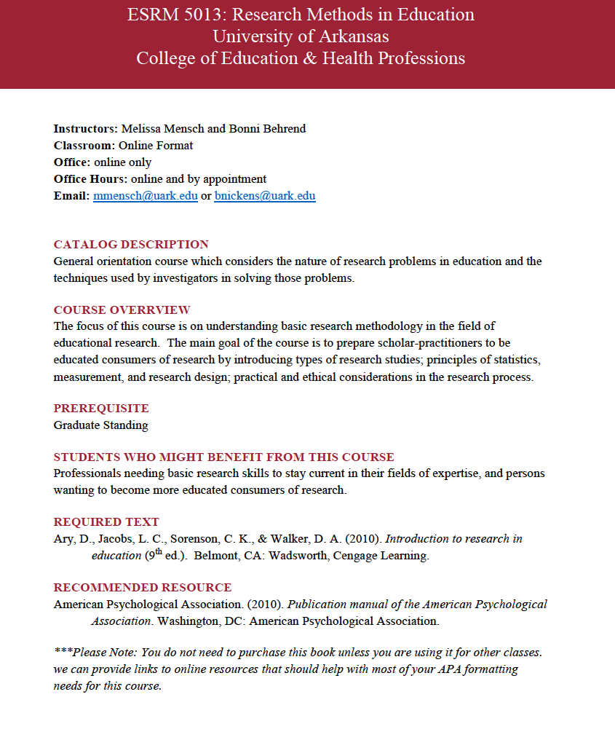

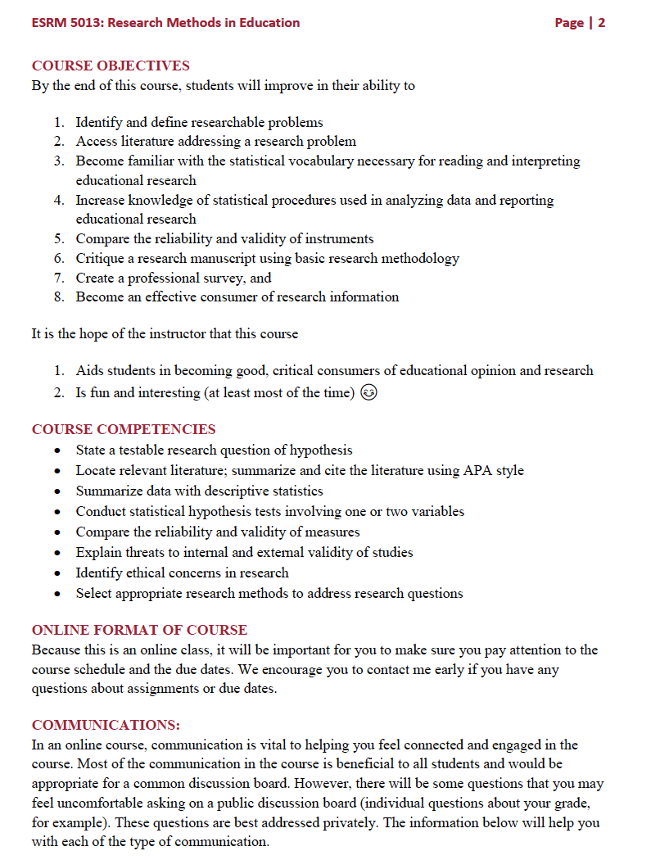

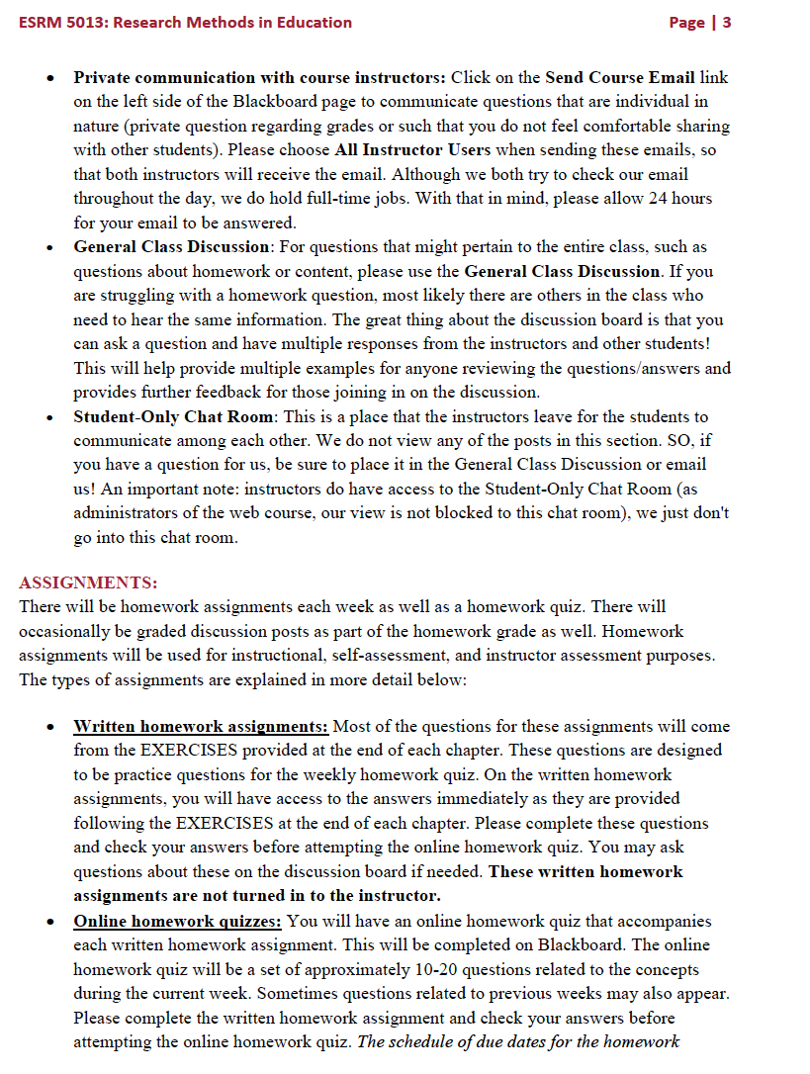
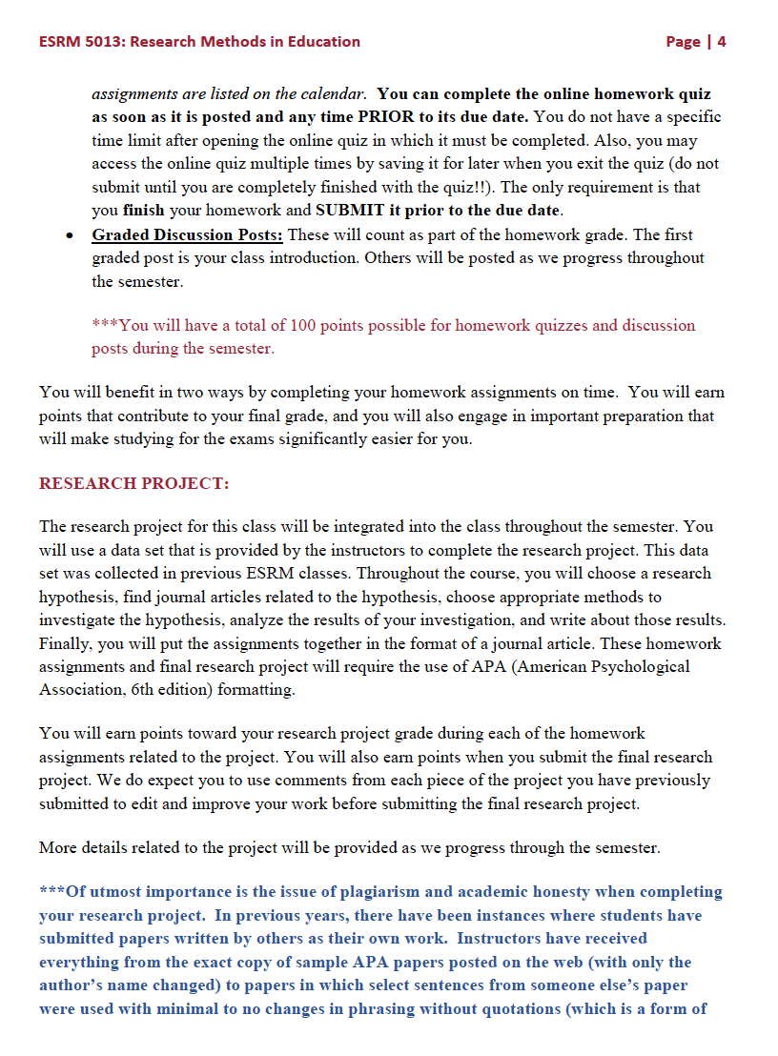
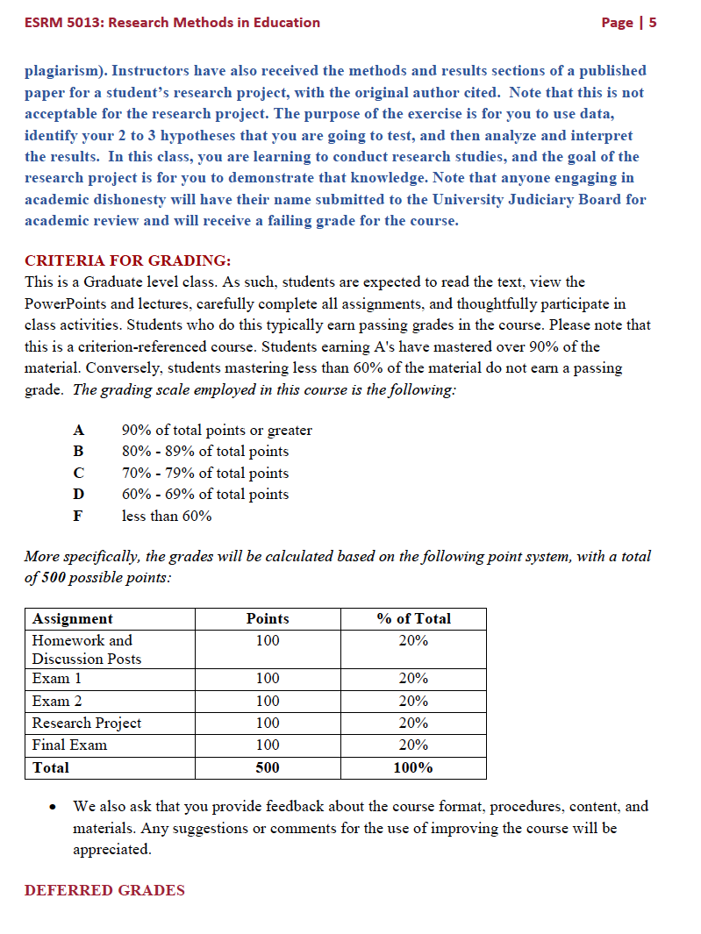

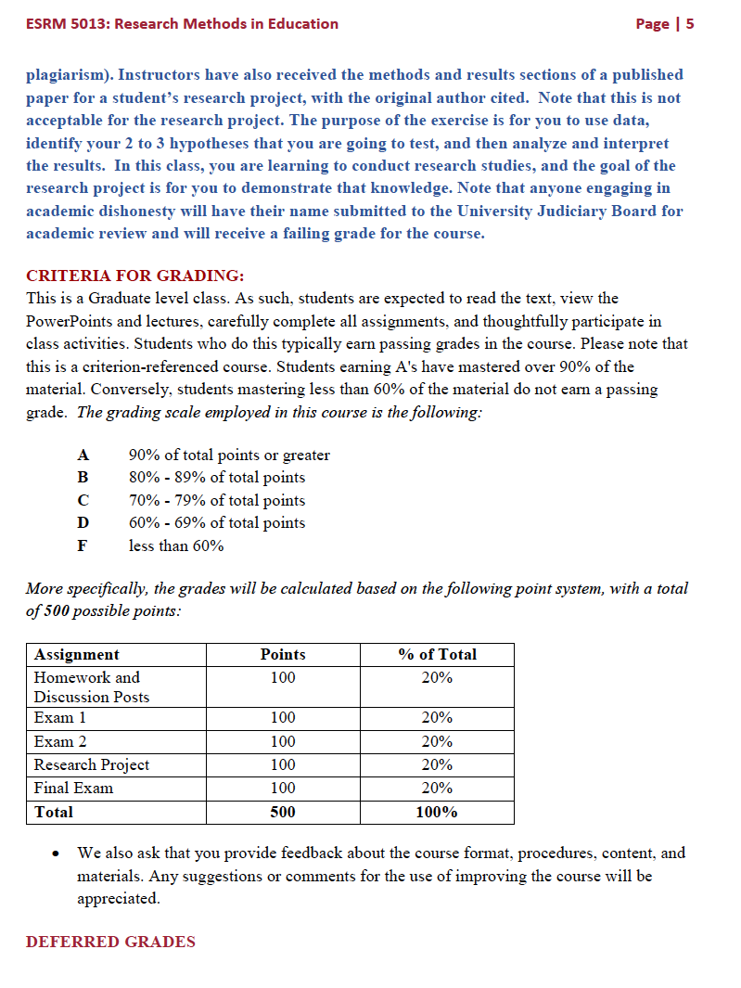

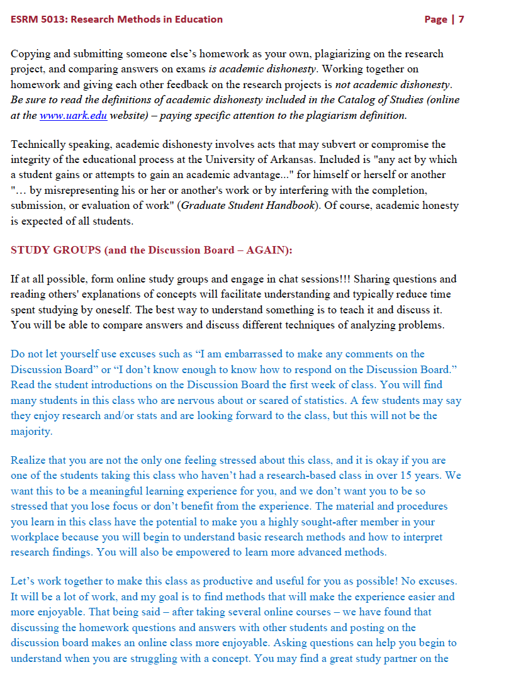

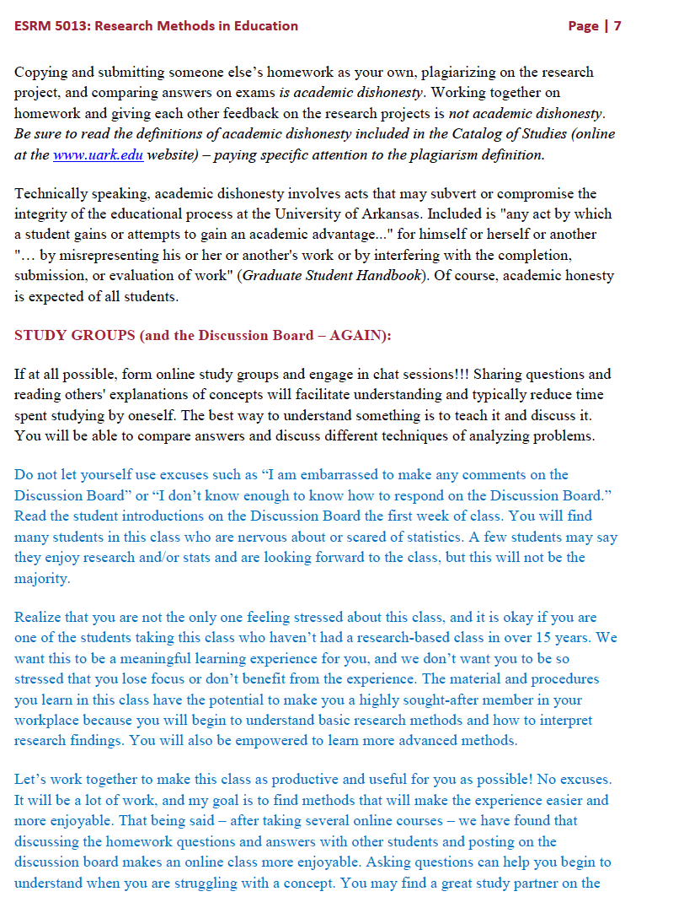
- Changes to common assessments
No changes to common assessments or when state mandated assessments are required.

- Revisions to field experiences
Field Experience | Time | Requirements | Changes
SPED 5413– ABA and Classroom Management for Teachers | 20 hours | Students will be required to collaborate with 2 teachers (one K-6 and one 7-12) experiencing a student with a behavior issue to design, implement and monitor a FBA/BIP and graph progress made and make recommendations for interventions. | none
SPED 5633 – Curriculum Development and Instructional Planning | 20 hours | Students will be assigned to specific inclusion classes at various grade levels. Each student will teach at least 2 lessons that they have developed, one to a K-6 level and one to a 7-12 level classroom, and obtain feedback from the classroom teacher. 20 hours contact is required. | none
SPED 5663 – Teaching Science and Math to Students with Disabilities | 10 hours | Students will be required to observe content course lessons in math or science taught in both K-6 and 7-12 classrooms; note accommodations and modifications used by teachers as well as how the students respond. Students will also design and teach a content course lesson in either math or science to small group of students with similar IEP requirements in a 7-12 classroom. | Merged with SPED 5673
SPED 5673 – Teaching Students with Disabilities in the Content Areas | 20 hours | Students will be required to observe content course lessons in social studies, science, health or math in both K-6 and 7-12 classrooms; note accommodations and modifications used by teachers as well as how the students respond. Students will also design and teach a content course lesson to small group of students with similar IEP requirements in a K-6 or 7-12 classroom. | Merged experiences with those described in SPED 5663 with focus on content in math, social studies, science, or health.
SPED 5683 – Teaching Literacy Skills to Students with Disabilities | 20 hours | Students will be required to work with one student in grades K-6 and one student in grades 7-12 who is identified at-risk and who is reading below grade level to collect CBM data and plan reading instruction based on interpreting the collected data. Students will then teach one reading lesson to each student who is at-risk using strategies based on the CBM analysis. | none
SPED 5763 – Teaching Students with Severe Disabilities | 20 hours | Students will be required to collaborate with a special educator to obtain ten (10) hours of observations/volunteer service in k-6 settings for children with severe disabilities and obtain ten (10) hours of observations/volunteer service in 7-12 settings for children with severe disabilities. | none
SPED 5873 – Assessment and Programming for Students with Disabilities | 25 hours | Curriculum-based Assessment (CBA) - 10 hours contact is required for this field experience  - Develop and administer a Curriculum-based Reading or Writing Assessment (CBA) in an inclusive K-6 classroom-  - Develop lessons based on the information from the CBA with modifications and support for students with disabilities.  - Administer the CBA after teaching the lessons to determine the progress made by the students  Observe a teacher using RtI in a K-6 classroom - 3 hours contact is required for this field experience  Interview a school psychologist or educational examiner to learn their role in the education of students with disabilities in 7-12 classrooms - 2 hours contact is required for this field experience  Examine the tests recommended for use by the Arkansas Department of Education and become familiar with their content. Develop a chart differentiating when you would use which test for K-6 and 7-12 students -- 5 hours contact is required for this field experience  Assist a K – 6 teacher in preparing assessment materials and recommendations for an IEP meeting --3 hours contact is required for this field experience  Observe an IEP meeting for a 7-12 student - 2 hours contact is required for this field experience. | none
SPED 532V – Practicum in Special Education | 420 hours | SPED 532V will be completed twice for 3 hours credit each (6 hours total). Students will spend a minimum of 210 contact hours for each course for a total of 420 total contact hours. One course (210 hours) will be completed in a K-6 setting and the second course will be completed in a 7-12 setting. In each course students will spend time in three different settings: inclusive classroom, resource room, and self-contained classroom. The total amount of time is a minimum of 12 weeks.

- Transition to DLT format
No transition plan is necessary since the proposed course changes are made in already approved DL program. All courses are designed with instructional designers from Global Campus and meet or are in process to meet Quality Matters standards for course design.

- Changes to Policies Overseeing Candidate Quality
No changes to entry, retention, or exit requirements are being made.

