Proposal – Blockchain Center of Excellence (BCoE)

- Name of the College, School, Department, or Unit in which the Center will be housed.

Enterprise Systems; Information Systems Department
Sam M. Walton College of Business

- Name and title of the person(s) proposing creation of the Center.

- Paul Cronan, Professor and M. D. Matthews Endowed Chair in Information Systems
- Rajiv Sabherwal, Professor and Department Chair, Edwin & Karlee Bradberry Chair in Information Systems
- Dean Matt Waller, Dean and Sam M. Walton Leadership Chair, Sam M. Walton College of Business

- The Center type (research, service, or instructional) that is requested.

The focus of the Center will be research, instructional, and service. Specific project aims and activities include -
- Conduct basic, collaborative, industry-university research in blockchain (e.g. proof of concepts, use cases, projects),
- Develop and establish research partnerships and alliances with companies and other universities,
- Promote and enable knowledge dissemination by developing course modules, examples, case studies, problem sets, and solutions that could be used in existing classes and shared,
- Support industry adoption and value identification via our research efforts.
- The unique value of the program to the University, and the distinction to any similar programs in Arkansas.

Vision: To become a premier academic leader in the advocation and education on blockchain
Mission:
- Develop and establish research partnerships, alliances, and standards
- Conduct collaborative industry-university research (e.g. proof of concepts, use cases, projects)
- Promote and enable knowledge dissemination
- Accelerate industry adoption and value identification
The unique value of the Center is its Vision and Mission; no other units have this focus. Blockchain technology offers a secure, verifiable way to maintain an encrypted accounting ledger of business transactions across multinational borders. This could significantly affect the way that ‘business does business,’ accounts for business transactions, and tracks products in multinational supply chains. Other promising applications of blockchain and cognitive analytics include Financial Services, Inter-/Intra-bank Fund Transfers, Insurance, and Healthcare.
The development of shareable blockchains, such as Hyperledger, will provide added enhancement and support for Sam M. Walton College of Business world-class projects and centers such as the McMillon Innovation Studio, Brewer Family Entrepreneurship Hub, The Sustainability Consortium, the Center for Retailing Excellence, and the J B Hunt Innovation Center of Excellence. It offers an opportunity to provide educational materials (course modules, examples, exercises, case studies, problem sets, etc.) as well as significant primary research for practitioners and academics. As a leader in these technologies, the intent is to also share these materials with other universities. This would be similar to how Walton Enterprise Systems has been sharing materials with universities world-wide. Resultant white papers, including fundamental research findings, and published articles will be shared with the industry partners and the academic community via conferences and publications.

- Information on the Director position and the organizational structure.

Dr. Paul Cronan, Co-Director and Professor, Information Systems, Sam M. Walton College of Business
Rajiv Sabherwal, Professor and Department Chair, Edwin & Karlee Bradberry Chair in Information Systems

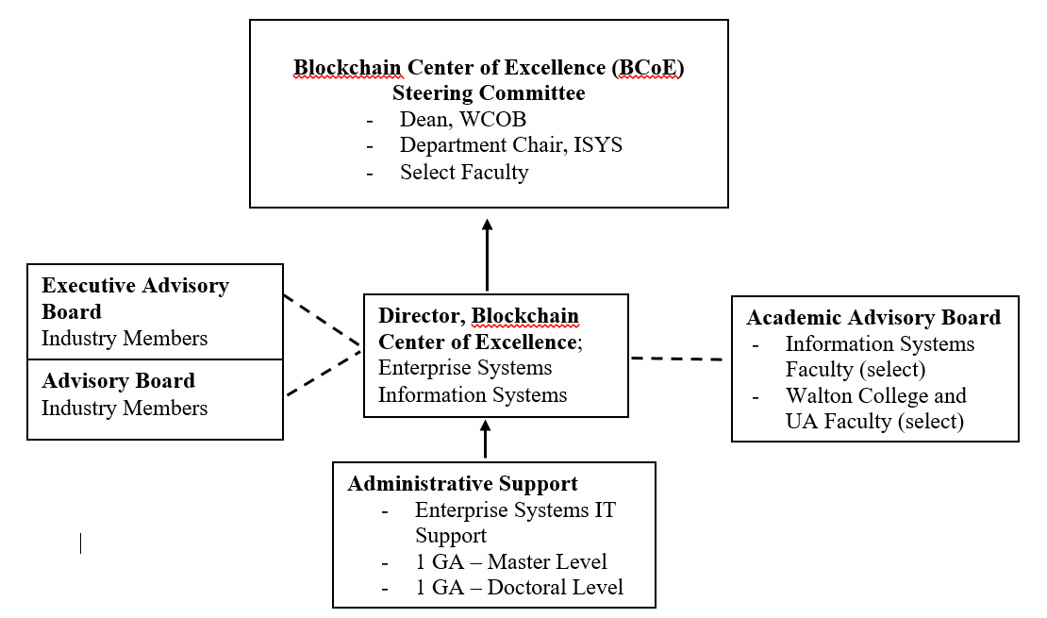
- Identification of faculty (or qualifications of type of faculty), other personnel, and academic units that will be involved with the Center.

The Blockchain Center of Excellence is designed to be inclusive in terms of involvement by faculty across the Information Systems Department, Sam M. Walton College of Business, as well as the university. Faculty (as well as faculty external to UA) who have interest in blockchain research and coursework development will be included. Requests for research are anticipated to be varied and require knowledge and skills from various disciplines. At a minimum, the center will include faculty and students associated with the Information Systems and Supply Chain Departments in the Sam M. Walton College of Business.

- Student involvement, if any.

Center projects will include students at all levels from undergraduates, honors students, masters and doctoral students. Moreover, the Center will support graduate assistants at all times to support ongoing projects and assist in the development of new center proposals.

- Annual budget for the Unit or the estimated expenditures per year. (Estimate)
Salaries: Center Director @50% $125,000
Admin Support Supervisor @50% $ 35,000
IT Support $ 50,000
Two GA’s $ 40,000
Faculty Coursework Development Grants $ 50,000
Faculty Research Grants $ 40,000
Operational/Supplies $ 10,000
Travel $ 25,000
Total $ 375,000

Note: Walton College of Business is providing 50% of the Directors salary

- Estimated fiscal resources and potential sources of funding (e.g., state, private, endowment, grant, contract, or other).

The Center has a target budget of $750,000/year from the following sources: Industry Board memberships, industry-sponsored projects, and contributions.

In the first two years, financial resources will be provided by the Sam M. Walton College of Business (financial resources will not be needed from the central administration.

- Space and equipment needs of the Center and a description of how they will be met.

Space: JB Hunt 404
Equipment: one-time setup expenses of computer, software, office equipment estimated to be $25,000

- Description of administrative control and lines of authority for the Center.

See 5 above

- Description of the advisory board including its size, the method of its selection, and length of terms.

The Industry Advisory Board would consist of two levels – Executive Level and Advisory Level. The target number for the Executive Level will be 5 to 10 members; the target for the Advisory Level members will be 10 to 20 members. Executive members will be industry leaders who bring significant experience and resource support to the Center. Advisory Level members will include project sponsors and donors. Executive Level members will serve for 3 years while Advisory Level members will be selected annually. The Executive and Advisory board members will be nominated by the Center Director and approved by the Dean of the Sam M. Walton College of Business and the Department Chair of the Information Systems Department.

- The metrics to be used to evaluate the Center’s feasibility at its five-year review.

Vision: To become a premier academic leader in the advocation and education on blockchain.
Mission:
- Develop and establish research partnerships, alliances, and standards
- Conduct collaborative industry-university research (e.g. proof of concepts, use cases, projects)
- Promote and enable knowledge dissemination
- Accelerate industry adoption and value identification

Metrics for measuring the Institute’s success include:
- Number of Premier Advisory Board Members
- Number of Participating Advisory Board Members
- Number of blockchain research white papers completed
- Number of courses using blockchain and students in classes using blockchain course materials
- Dollar amount of funds raised (philanthropic gifts)
- Value of solutions to problems
- Dollar amount of funded research projects
- Journal publications as a result Center research

Information within the document includes thoughts and summaries taken from a preliminary meeting of potential Blockchain Center Advisory Board Members.
Blockchains are encrypted data (typically transactions) in which an accounting ledger of verified events are distributed across multiple networked computer systems producing a block of data. These blocks of data are sequenced chains of events which are used to prove that a sequence of events took place in a certain order at a particular time.

